Instructions for Electronic Verification for MSC & SEDF

Roles to Assign to Staff
SSWS Account Managers needs to assign the following roles to staff.

Master Schedule Collection (MSC)
- MSC Approver: Approves or disapproves the MSC verification report. This staff member verifies the MSC data prior to getting the superintendent’s signature.
- CTE Approver: Approves or disapproves the CTE portion of the MSC. This is a required approval. Assign this role to the LEA’s CTE Director.
- Collection Manager: Checks the submitted local approvals status and submits the verification reports for final approval to the Superintendent. Assign this role to the staff member responsible for assuring all required approvals are complete before handing it over for the superintendent’s approval.

Student Enrollment Demographic Form (SEDF)
- SEDF Approver: Approves or disapproves the SEDF verification report. This is a required signature. Assign this role to the LEA’s CTE Director.

Instructional Personnel (IPAL) - Only required for Fall submission
- IPAL Approver: Approves or disapproves the Fall MSC IPAL verification report. This staff member verifies the IPAL data prior to getting the superintendent’s approval.

Step 1
The Collection Manager will upload a data file and correct any errors. Once they agree the data is accurate to the best of their knowledge, the Collection Manger will then click the “Submit for Local Approvals” link from the right-side menu.

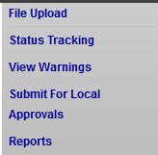

The Collection Manager will click “Submit for Local Approvers” in the center of the page.

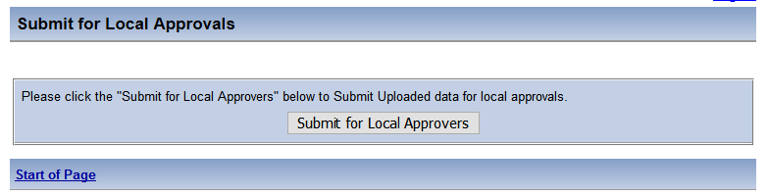

The following message will appear in green:
The uploaded data has been submitted for local approvals successfully.

At this point, an email will be sent to each staff member that has been assigned one of the above roles. The email will advise them that there are reports that to reviewed and accepted/rejected.

CTE Approver Instructions

The CTE Approver will log into SSWS and select the appropriate Master Schedule Collection application link.

From the right-side menu, click the “Local Approval” link

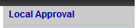

The CTE Approver will click the “Review CTE Verification Report” button to view the report. Once the report generate, this staff member will review the data and click “Approve” or “Reject”.

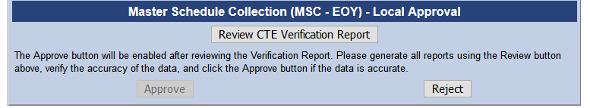

Once “Approve” is clicked, an email will go to the Collection Manager advising that the CTE Verification Report has been approved.

MSC Approver Instructions

The MSC Approver will log into SSWS and select the appropriate Master Schedule Collection application link.

From the right-side menu, click the “Local Approval” link.

The MSC Approver will then need to click the “Review MSC Verification Report” button to view the reports. Once the report generates, this staff member will need to review the data and click “Approve” or “Reject”.

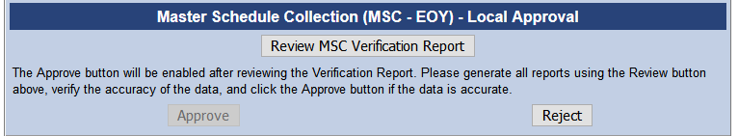

Once “Approve” is clicked, an email will go to the Collection Manager advising that the MSC Verification Report has been approved.

SEDF Approver Instructions

**Note: The SSWS Account Manager needs to assign SEDF roles of Data Entry, Generate Reports and SEDF Approver to the staff member responsible for approving the SEDF.

The SEDF Approver will log into SSWS and select the Student Enrollment Demographic Form (SEDF) application link.

Below are instructions in the CTE Manual for SEDF Approvers to follow:
Phase V. Finalize Submission
Your report will need to be finalized to complete the submission.
This is done by selecting “Send Explanations” in the upper right menu. If there are critical errors that need to be corrected, a red warning will appear at the top of the page. Once all critical errors are resolved in MSC, provide explanations if needed by using the Find Instructors link to enter the explanation, and then select the “Send Explanations” button.
If you still have unexplained threshold(s) or enrollment breaches, an error box will pop up. This will give you another opportunity to enter the explanations for these issues. Click Submit before clicking Send Explanation. (Also check under Find Instructors to send an explanation)
When your submission has been processed, a green message will appear at the top of the page, indicating the data has been successfully submitted.
After the explanation is accepted by VDOE, the Local Approver link will display in the top right corner of the SEDF application.
Once the SEDF Approver has reviewed and accepted the reports, an email will be sent to the Collection Manager (also referred to as the gatekeeper). This person is responsible for selecting the button to submit to the superintendent.
Should a school division determine later that something needs to be corrected; the school division will need to contact VDOE to have their MSC window re-opened. If the MSC is reloaded to VDOE after Phase V, then the school division must return to Phase II and repeat all subsequent steps.

From the right-side menu, click the “Local Approval” link

The SEDF Approver will click the “Review SEDF Verification Report” button to view the report. Once the report generate, this staff member will review the data and click “Approve” or “Reject”.

Review SEDF Verification Report

Once “Approve” is clicked, an email will go to the Collection Manager advising that the CTE Verification Report has been approved.

IPAL Verification Approver Instructions – Fall MSC only

The IPAL Approver will log into SSWS and select Instruction Personnel (IPAL) application link.

From the right-side menu, click the “Local Approval” link.

The IPAL Approver will then need to click the “Review IPAL Verification Report” button to review the reports. Once the report generate, this staff member will need to review the data and click “Approve” or “Reject”.

Review IPAL Verification Report

Once Approve is clicked, an email will go to the Collection Manager advising that the MSC Verification Report has been approved.

Step 3
When all local approvers have completed their section, the Collection Manager can click “Submit for Verification” in the right-side menu. This will send the reports to the Superintendent for verification.

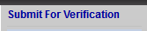

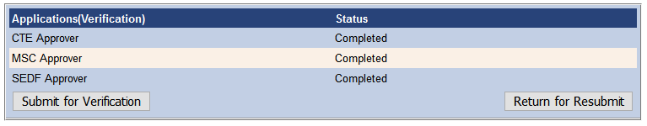
Local MSC Approver Completed
Local CTE Approver Not Completed
Local SEDF Approver Not Completed
Local IPAL Approver Completed

Step 4
The Superintendent can “Approve” or “Reject” the data submission through the Superintendent Data Collection Approval (SDCA) application. If the Superintendent rejects one piece, the Collection Manager will receive an email with a reason for the disapproval. The Collection Manager should then click “Return for Resubmit” if the data needs to be corrected and resubmitted.

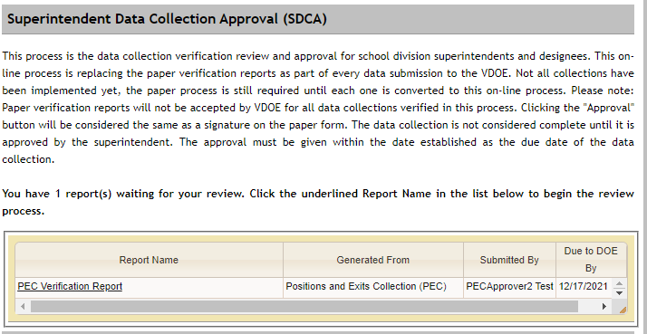
MSC Verification Master Schedule Collection John Smith 12/7/2021

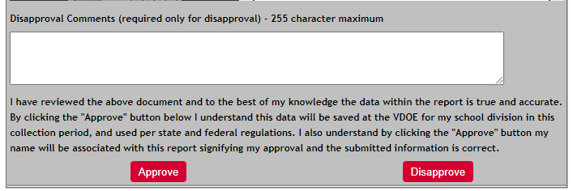

The collection window locks for the division after the Superintendent has approved all reports related to the collection. Contact DOE if the division needs to have the window reopened. After DOE opens the window, the Collection Manager will login and click “Submit for Verification” in the right-side menu then click “Return for Resubmit”. The File Upload link will not be active until this step is completed.

