2026 Virginia Governor’s World Language Academies

Guide for Schools


2026 Virginia Governor’s World Language Academies – Guide for Schools

Table of Contents
Executive Summary 3
Purpose of This Guide 3
Key Dates at a Glance 3
Who Should Use This Guide? 3
Quick Access Links 3
Introduction 4
Data Entry Procedure for Private Schools 4
Table 1 Brief Description of the Process 5
Detailed Process Information 6
1. Dissemination of Information 6
2. Criteria for Eligibility 7
All nominees: 8
Additional requirements: 8
3. Local Selection Process 9
4. Testing 10
Testing Process 10
Technology 11
5. Internal Notification 11
6. Nominee Submission Process 12
Responsibilities of the School-Level Designee 12
Submitting Applications to VDOE 12
SMApply System Notifications 13
Planning for Deadlines 14
Responsibilities of the Central Office Level or Private School Data-entry Designee 14
Submitting the Verification Report 15
7. State Selection Process 15
8. VDOE Notification Process 16
9. Payment Process 16
GWLA Tuition Payments for Students Enrolled in Public Schools 16
GWLA Tuition Payments for Students Enrolled in Private Schools 17
Contact Information 18
Appendix A: Summary of GWLA Application Process 19
Quick Start Guide 20
Appendix B: Instructions for Online Entry of Student Data 21
SSWS Access 21
Accessing the GWLA Data Entry Application 23
Adding Student Nominee Data 24
Submitting Data 25
Verification of Submission 27
Appendix C: Detailed Directions for School and Division Staff 29
Directions for School-level Designee 29
Directions for Private School Designee 30
Directions for School Division/Central Office Designee 30
Appendix D: Data Entry Cover Sheet 32
Appendix E: Selection Committee Evaluation Criteria 33
French, German, Spanish Academies 33
Teacher Recommendations: 33
Application: 33
Latin Academy 33
Teacher Recommendations: 33
Application: 33
Japanese Academy 33
Teacher Recommendations: 33
Application: 33
Helpful Hints 33
Appendix F: Glossary of Terms 35

Executive Summary
The Virginia Governor’s World Language Academies (GWLA) offer immersive summer programs for high-achieving students in French, German, Spanish, Latin, and Japanese. This guide supports public and private high schools in nominating eligible students for the 2026 Academies.

Purpose of This Guide
To provide school-level and division-level staff with:
- A clear overview of the GWLA nomination and selection process
- Step-by-step instructions for application, testing, and data entry
- Key deadlines and responsibilities by role

Key Dates at a Glance
Milestone | Deadline
Disseminate information to students | October 2025
Internal student application deadline | January 17, 2026
Order test codes | January 27, 2026
Submit applications & test results | January 31, 2026
Submit Verification Report | February 16, 2026
VDOE notifies students | April 15, 2026
Tuition invoices sent | May–June 2026

Who Should Use This Guide?
- World Language Department Chairs
- World Language and Gifted Education Coordinators
- School Counselors
- Private School Heads of School
- Testing Proctors
- Division-Level Designees

Quick Access Links
- GWLA Program Website
- Student Application Portal (SMApply)
- Test Code Order Form
- Private School SSWS Request Form

Introduction
Welcome to the nomination process for the Virginia Governor’s World Language Academies (GWLA), which include full-immersion programs for French, German, and Spanish; and partial-immersion programs for Japanese and Latin. The Governor’s World Language Academies are sponsored by the Virginia Department of Education (VDOE).
The availability of any or all the Governor’s World Language Academies is dependent upon local and state funding. Dates and locations for the 2026 programs are listed below:
Governor’s French, German and Spanish Academies
June 20 – July 11, 2026
Washington & Lee University, Lexington
Governor’s Japanese and Latin Academies
June 28 – July 12, 2026
Virginia Commonwealth University, Richmond

Data Entry Procedure for Private Schools
Private schools should select a designee to enter student data directly into a secure website using the same process as the public schools. Each private school that wishes to nominate one or more students must contact the VDOE to establish access to the secure website. To set up initial access to the secure website, the private school Head of School or designee should submit the online Request for SSWS Access.
The selection of nominees for the Virginia Governor’s World Language Academies continues to be conducted by the schools and the VDOE. The VDOE works with the school division’s World Language Supervisor (or designee) as the primary contact for all information. As in past years, schools are encouraged to establish dates for the submission of the various parts of the application in a manner that meets their needs. Each school’s world language chairperson is encouraged to provide the world language teachers in the school with information regarding the application submission process and due dates. The designated contact person with the final authority for problem solving with the VDOE is the private school Head of School or the public-school division World Language Supervisor or Gifted Education Coordinator.
All information, applications, and the testing materials order form are available online. This administrative guide outlines the process from nomination through completion of the summer program.
For questions about the Governor’s World Language Academies application and selection process, please contact Dr. Lisa Harris, Coordinator of World Languages, by phone at (804) 750-8083 or by email at WorldLanguages@doe.virginia.gov.
IMPORTANT NOTE: The Summer Residential Governor's Schools (SRGS) have a separate application process and timeline from the Governor's World Language Academies. The 2026 SRGS applications are available from the Summer Residential Programs website.

Table 1 Brief Description of the Process
# | Component | Description | Timeline
1 | Dissemination of Information | Each school division or private school coordinator is responsible for disseminating the pertinent information from this document as early as possible. | October 2025
2 | Criteria for Eligibility | Each school is responsible for ensuring that all nominees meet the established criteria for application. Principals or Heads of School are required to sign each application to indicate that each nominee submitted is eligible for the program. | October-December 2025
3 | Schools' Selection Process | Schools' selection committees (if necessary) meet to determine which candidates to send forward for the state’s selection process. Students (and their parents) not selected for nomination must be notified in writing by the school. | November 2025-January 2026
4 | Testing | Nominees to the French, German, Latin, and Spanish Academies must undergo testing to determine their language abilities.  The online test codes must be ordered online from the VDOE no later than January 27, 2026.  Schools should order test codes ONLY for students with completed application packets and whom the school selects as a nominee.  Online testing must be completed and submitted by no later than January 31, 2026. | November 2025-January 2026
5 | Internal Notification | Deadline for students to submit completed applications to their schools (Request school nomination). This allows two weeks for schools to complete the local selection process and data entry into the VDOE’s secure Single Sign-on for Web Systems (SSWS) website, (Schools may set earlier deadlines.)  Local school designees or chairpersons notify division Gifted Education Coordinators or division contact persons of the names of all nominees. | January 17, 2026
6 | Application Submission Process | Deadline for student submission of completed online applications.  Deadline for completion of student language testing.  Deadline for all public and private schools to enter student data on the VDOE's secure website. | January 31, 2026
7 | Verification | Deadline for public school Superintendents and private school designees to submit the Verification Report via SSWS. | February 16, 2026
8 | VDOE's Selection Process | The VDOE verifies completeness of application packets and prepares materials for the statewide selection committee. | January-March 2026
9 | VDOE's Student Notification Process | The VDOE sends notices to students concerning the status of their applications. Regional and division coordinators will receive lists indicating the status of individual nominees about one week prior to student notification. | April 15, 2026
10 | Payment Process | Students notify the VDOE of their acceptance of the invitation through the online application portal.  Invoices are sent to public and private schools in late May. Revised invoices, if applicable, will be sent after the first day of the program. | May-June 2026

Detailed Process Information

1. Dissemination of Information
Each public-school division's World Language Supervisor or Gifted Education Coordinator is encouraged to provide all high schools with information regarding the application submission process. For private schools, this may be done by the Head of School or the regional coordinator already responsible for the student application process to the Summer Residential Governor’s Schools.
Schools should publicize information about the Governor’s World Language Academies to all tenth and eleventh-grade world language students during the fall, including home school and virtual program students. Students do not need to be identified as gifted or be enrolled in a gifted education program to qualify for the World Language Academies.
High schools submitting nominations may not engage in discrimination in the provision of public services based on race, sex, color, national origin, religion, sexual orientation, gender identity, age, political affiliation, disability, or veteran status.
Public school divisions are responsible for the local share of the tuition costs for any enrolled student nominated and accepted to the Governor’s World Language Academies. Home-school students, who must be nominated by the public school they are zoned to attend, should confirm with the local school division how its share of the tuition will be handled. Tuition costs will not exceed $3,300. The local share for the public school division is based on its current composite index of local ability-to-pay up to 50 percent of the total tuition. The state pays the remaining share. Information about the current composite index of local ability-to-pay for each public school division is available on the Virginia Department of Education Website.
The local share for private schools is 50 percent of the tuition cost. The state pays the remaining share. For more information on the payment process for private schools, see the section on GWLA Tuition Payments for Students Enrolled in Private Schools in this guide.
If public health conditions or a Governor’s emergency declaration prevents the face-to-face Academies from taking place at their scheduled time and location, they will most likely be offered virtually and the local share of tuition will be waived. If the Academies are offered virtually there will be no deferral for acceptance.
IMPORTANT NOTE: Students who are residents¹ of Virginia but attend private schools within or outside of the Commonwealth may be nominated by their schools following the same general process as public schools if they meet all other eligibility requirements. Home-school students must participate in the nomination process through the public school they are zoned to attend.
¹For information regarding residency, please refer to the Enrollment in Virginia Public Schools page of the Virginia Department of Education website.

2. Criteria for Eligibility
The school shall consider for nomination any student who meets the eligibility criteria listed below. However, schools are strongly encouraged to review the selection criteria with students and to assist them in recognizing the competition they face at the state level. Links to the online applications are available on the Governor’s World Language Academies page of the VDOE website.

All nominees:
- must be genuinely interested in attending the Academy and have the emotional maturity, stability, stamina, and self-discipline to live away from home for an extended period;
- must be neither a current applicant to a 2026 Summer Residential Governor's School (SRGS) nor another GWLA, nor a former participant in these programs; (A student may attend only one program during his or her high school career.)
- must be juniors or mature sophomores during the current school year, 2025-2026, and must not have graduated before the opening of the Academy;
- must be nominated by a public high school from a Virginia public school division or by a private school accredited by one of the approved accrediting constituent members of the Virginia Council for Private Education;
- must be recommended by two teachers, or a teacher and another individual, who know the academic ability and strengths of the student in the selected area; and
- must be eligible to attend public school in Virginia tuition-free. (For information regarding residency, please refer to the Enrollment in Virginia Public Schools page of the VDOE website;)
- must serve as ambassadors to their home school and local school division.
IMPORTANT NOTE: Students do not need to be identified as gifted or enrolled in a gifted education program to be eligible.

Additional requirements:
Nominees for the Latin Academy:
- must have completed at least level two of Latin prior to the beginning of the Academy.
Nominees for the Partial-Immersion Japanese Language Academy:
- must have successfully completed at least level two of ANY world language prior to the beginning of the Academy (but may also be students of Japanese); and
- must not be fluent or proficient speakers of Japanese.
Nominees for the Full-Immersion French, German, and Spanish Academies:
- must have completed at least level three of the language (or an equivalent preparation) prior to the beginning of the Academy;
- must not be native speakers of the Academy language;
- must have developed good proficiency in using this language; and
- must be willing to use the target language for all social and academic interactions.
IMPORTANT NOTE: The Full-Immersion Academies are not designed for students with native or near-native fluency in the target language.
The full-immersion Academies are designed to provide an immersion setting for students who have learned the Academy language in a traditional school setting. The focus is on the development of oral fluency and ease of expression. Students who have already experienced equivalent immersion opportunities or who are already proficient speakers of the Academy language should not apply.
A statewide selection committee will make the final determination about the appropriateness of an applicant’s participation in this regard. Nominees will be rated on a point system that considers a range of factors, including time spent abroad or in an immersion language camp, frequency of language use, and whether the student is a heritage speaker of the Academy language. The following could cause an applicant to be eliminated during the selection process:
- Prior residence in a country where the language of the Academy is spoken, especially since the age of 12;
- Extensive travel experiences in a country where the language of the Academy is spoken, especially with regard to frequent opportunities for using the language;
- Extensive full-immersion experiences (24 hours/day) with the language of the Academy, such as home-stay or travel/study programs in a country where the Academy language is spoken; or
- Residence in a family where the language of the Academy is spoken in the home, or regular contact with members of the extended family where the Academy language is used for communication.
“Extensive” is defined as equivalent to an Academy in length and intensity, i.e., three or more weeks in a full-immersion setting. Students with highly developed oral language skills do not find the rigors of the Academy as challenging or rewarding as students of lesser proficiency who, for the most part, have learned the language entirely in a classroom setting. Furthermore, it is difficult for staff to accommodate students whose language skills are already sufficiently developed. It is suggested that such students consider application to the Governor’s Japanese Academy.
Participation in elementary, middle, and/or high school dual language immersion programs within a U.S. school setting does not eliminate students from consideration. These are not considered to be 24-hour per day full-immersion settings.

3. Local Selection Process
Each secondary school may select nominees for the Academies and may convene a committee to consider applicants from the school. Schools should consider including school counselors, educators, and/or other professionals knowledgeable in each of the program languages as members of the committee.
A chart summarizing the application process is located in Appendix A. Schools may nominate a maximum of two students per language academy.

4. Testing

Testing Process
The nominees for French, German, and Spanish must complete an online test of their speaking and writing abilities in those languages. Latin nominees must take an online Latin reading comprehension test and write a composition in English on a Roman theme. The language test will be counted as part of the total application score. Nominees for Japanese who have taken one or more years of Japanese language courses should take the Japanese test for placement purposes only.
The world language department chairperson must order the testing codes from the VDOE by no later than January 27, 2026. Schools are asked to order codes only for students who have completed an application packet and will be nominated by the school. The link to the online Test Code Order Form is available on the GWLA page of the VDOE website. Schools should arrange suitable testing locations and appropriate proctors. Proctors may not be speakers or scholars of the language(s) being tested.
Students with an Individualized Education Program (IEP) or 504 Plan must be provided with testing accommodations as outlined in the IEP/504 Plan. The student application includes a section for parents/guardians to grant permission for the school to send a copy of the relevant page(s) of the IEP/504 Plan with the student’s application. This information will be kept confidential and is not available to the selection committee.
We strongly recommend that students have opportunities to practice with the sample tests ahead of time to familiarize themselves with the process and reduce anxiety on the day of testing.
For Applicants to the French, German, and Spanish Academies
- Practice tests are available online at the Avant Assessment website. Scroll to the section for the STAMP test and select the appropriate language to see a sample test.
- Immersion students should be advised that their speaking and writing samples carry the most weight in the selection process.
For Applicants to the Latin Academy:
- Additional information, including a sample of the Latin test, is available on the Avant Assessment website.
- The required composition may be completed at home and does not need to be proctored, although the student should not receive any help. The essay topic is included in the student application.
For Applicants to the Japanese Academy:
- Japanese applicants who have experience with the language should take the STAMP test to determine class placement if accepted. Test results for Japanese will only be used to determine class composition and will not be counted in the application scoring.
- Applicants to the Japanese Academy with no prior experience in Japanese should not take the STAMP test and will automatically go into the beginner course if accepted.
- The required essay in English may be completed at home and does not need to be proctored, although the student should not receive any help. The essay topic is included in the student application.

Technology
Proctors should also be thoroughly familiar with all requirements and equipment used. Instructions for preparing and proctoring each type of test will be included with the testing codes. In the event of a testing irregularity, please email a written explanation of the incident to WorldLanguages@doe.virginia.gov.
Proctoring Requirements
The assessments must be administered in a proctored setting as part of the Academies application process. If schools are in a remote operating status, testing may be administered using the remote proctoring option available from the vendor. The required equipment includes: a PC, Mac, or Chromebook; headset with microphone; keyboard and mouse. Technical information related to computers and networks for administering the assessments is available online at the Avant Tech Check website.
IMPORTANT NOTE: The vendor does not have a time limit for the STAMP test, however; when used for the purpose of selecting student applicants, VDOE requires that the test be administered in a timed and proctored environment to ensure that all students are being scored using the same criteria.

5. Internal Notification
It is recommended that students submit completed applications to the school and request nomination no later than January 17, 2026, to allow time for chairpersons to verify the completeness of the applications and notify their coordinators of the names of all nominees. This also allows two weeks for all public and private schools to complete data entry from the student application cover sheets into the SSWS online system, and for designees to generate the Verification Report from the SSWS and obtain the necessary approvals from the division Superintendent or Head of School.
Schools may set earlier deadlines if they wish. Ideally, data entry should be completed at the school level by the world language chairperson. Local data entry increases accuracy and shortens the application review process. For information about the data entry process, see below under “School Nominee Submission Process” and refer to Appendix B.
IMPORTANT NOTE: Students who complete an application and whose applications are not sent forward for state-level consideration will receive an email notification indicating that the student was not selected by the school as a nominee. Divisions must include a list of local selection committee members on the school nomination decision form if a local committee is convened.

6. Nominee Submission Process
In addition to the information below, step-by-step directions for each role are summarized in Appendix C.

Responsibilities of the School-Level Designee
Each student's application should indicate the names and titles of the school’s selection committee members on the School Nomination Form. This form, which acknowledges that the nominee is worthy of representing his or her school, is included as the final step of the online student application.
The School Nomination Form should be completed before the student is scheduled for testing whenever possible. This form is generated electronically by the student as part of the application process. The school-level designee should ensure that the student nominees have the correct name and email address for the Principal/Head of School or designee who is authorized to complete the nomination form. Only students who are chosen as nominees should complete the language test.
The public school world language department chairperson may be asked to assist with data entry into a VDOE secure website, especially in larger public school divisions. If so, this must be done prior to submitting the applications and before the Verification Report is sent to the Superintendent for approval. For details about the data entry process, please see the section entitled “Entering Student Data” in the next section of this guide.

Submitting Applications to VDOE
The application submission process is completed electronically through the SMApply system. The link to the electronic student application portal is available from the GWLA Applications website.
The electronic application includes steps for the student to invite others to complete their section of the application. Schools should assist students in locating the name and email addresses of each of the following to aid in completion of this task:
- Name and email address of the school designee for coordinating the GWLA application process;
- Name and email address of current or most recent world language teacher;
- Name and email address of second recommender;
- Name and email address of school counselor or person who will upload a copy of the student transcript; and
- Name and email address of the Principal/Head of School or the designee who will approve or deny the nomination on behalf of the school.
Schools will use the Student Application Planning Form to note any internal deadlines that are earlier than the state deadlines. The form includes a place for applicants to record names and emails of collaborators on the first page. The second page is a chart of state deadlines for tasks in the electronic application, with space to write in any local deadlines. The Student Application Planning Form is available to download from the GWLA page of the VDOE website and is linked in Task 2 of the student application.

SMApply System Notifications
If you are having trouble receiving emails from the Survey Monkey Apply site:
- Check to see if noreply@mail.smapply.net has been added as a safe sender on your email inbox.
- If you have an email address that is hosted under your organization or school, we recommend reaching out to your IT department to ensure the emails are not being blocked on a domain level.
You can provide your IT department with the following details:
Email addresses to be allowlisted/added to safe sender lists:
noreply@smapply.net
noreply@mail.smapply.net
noreply@fluidreview.com
noreply@mail.fluidreview.com
wish@surveymonkey.mail.e.sparkpost.com
Mail Servers:
Server: smtp3.chide.it IPs: 72.55.140.81
Server: mta-81-40.sparkpostmail.com IPs: 192.174.81.40
Server: mta-81-59.sparkpostmail.com IPs: 192.174.81.59
Server: mta-87-232.sparkpostmail.com IPs: 192.174.87.232
Server: mta-87-233.sparkpostmail.com IPs: 192.174.87.233
Server: mta-81-57.sparkpostmail.com IPs: 192.174.81.57
Server: mta-81-60.sparkpostmail.com IPs: 192.174.81.60
Server: mta-91-147.sparkpostmail.com IPs: 192.174.91.147
Server: mta-216-97.sparkpostmail.com IPs: 147.253.216.97
Server: mta118a.mail.e.sparkpost.com IPs: 34.216.54.168
Server: mta119a.mail.e.sparkpost.com IPs:34.216.245.73
Once emails have been allowlisted from SMApply, you should no longer have any issues receiving emails from the site.

Planning for Deadlines
Please plan for deadlines and consider the possibility of school closings for weather or other emergencies. Submission deadlines have been moved to the latest possible date and will not be extended past this time.
It is the joint responsibility of the student and the nominating teacher or world language chairperson to ensure that applications have been completed and submitted to the VDOE by January 31, 2026.

Responsibilities of the Central Office Level or Private School Data-entry Designee
The data-entry designee will enter the names and language for each nominee into the SSWS system. Based on the information entered, this system will produce a Verification Report that the division Superintendent or private school Head of School will electronically approve. Please do not type using all caps. Data is pulled exactly as typed into the system.
- Public Schools: Nomination information will be submitted to the VDOE via a secure website. Public school division World Language Supervisors or Gifted Education Coordinators should contact their division's Single Sign-On for Web Systems (SSWS) account manager for access. The VDOE cannot give public school personnel this access; it may only come from the division's SSWS account manager.
- Private Schools: Nomination information will be submitted to the VDOE via the same secure website as the public schools. Private schools will need to select a designee to enter student data directly into a secure website using the same process as the public schools. The private school Head of School will also need an account to approve the nominees. To set up initial access to the secure website, the private school Head of School should complete the online Request for SSWS Access. Questions about SSWS account access can be sent to Dr. Lisa Harris at WorldLanguages@doe.virginia.gov.
Schools may use the optional Data Entry Cover Sheet in Appendix D to report nominee names to the local data entry designee.
Authorized users will be able to access the Governor’s World Language Academies data reporting application through SSWS to enter data and generate the Verification Report. The first screen, after successful login, will give general instructions and show options based on user level. Please see Appendix B for further details about SSWS data entry.
Users will have the ability to edit or delete data for nominees after they have been entered. However, the window will be locked as soon as the coordinator submits the data to VDOE and generates the Verification Report. If additional entries or edits must be made after that time, but before the deadline of February 16, 2026, the coordinator should notify the VDOE. The VDOE will reopen the window for the division, and the coordinator may edit the student data. The Superintendent or designee will then need to resubmit the Verification Report.
Division coordinators may prefer to have this data entry completed by the world language department chairperson of each school. The division’s SSWS account manager would have to grant school-level access to each chairperson.

Submitting the Verification Report
Both public school divisions and private schools should follow all remaining instructions in this section and in Appendix C. Once the designee has verified with chairpersons that all nominee information has been entered, the designee should generate the Verification Report following directions shown on the SSWS screen. This report requires Adobe Acrobat to be read, which may be downloaded at no charge from the Adobe website.
Once the designee has submitted the data, the Superintendent or private school Head of School will receive a notice to confirm the information and submit the Verification Report via SSWS to indicate the correct number of students for whom the division or private school is guaranteeing tuition. Public school divisions are also certifying that no tuition will be charged for students enrolled in a public school.
If the user has an interruption in the online submission process, the data will not be lost. Step-by-step instructions are included in Appendix B of this document. The division Superintendent or private school Head of School must submit the Verification Report to the VDOE via SSWS no later than February 16, 2026.

7. State Selection Process
The VDOE receives and processes all required materials submitted by January 31, 2026. Selection of program participants is made by a statewide selection committee and will be based on the strength of the student's application and language abilities (where applicable). Nomination does not guarantee acceptance.
The selection committee will consist of world language teachers, supervisors, and other experts nominated by their school divisions. Many of the selection committee members are former teachers or directors of Governor’s World Language Academies. Selection committee members follow strict guidelines and evaluate all materials according to pre-established rubrics. Each student’s overall application, transcript, and teacher recommendations as well as online test results, and/or compositions are evaluated independently by two committee members of that language group in a double-blind scoring process. In cases where the assigned points differ by a greater than acceptable margin, a third committee member will evaluate the materials in question. See Appendix E for an overview of selection criteria.

8. VDOE Notification Process
Each nominee will be sent an email notification regarding his/her acceptance status in mid-April. Prior to sending the notice to all nominees, the private school regional coordinators and/or heads of school, public school division Gifted Education Coordinators, and world language coordinators will receive status lists indicating “invited,” “alternate,” or “declined” for individual nominees. Each student's notice will be sent to the email used to create the application. Students invited as participants or alternates must indicate by April 26, 2026, whether they intend to accept the invitation to participate or remain on the alternate list. After April 26, qualified students from the alternate list will be chosen to replace any students that have declined or failed to respond to the invitation.
After May 1, all participants will receive or access online additional information relating specifically to their Academy. This information will include a variety of forms that must be returned to the Academy director in early June as well as detailed information about what to bring and what to expect.

9. Payment Process
Public school divisions and private schools will be invoiced in late May for students who have accepted the invitation to attend as of May 20, 2026. Divisions and private schools may receive a revised invoice after the first full day of the program, indicating students who declined or accepted after the May invoices. Only divisions and private schools with changes will receive revised invoices.

GWLA Tuition Payments for Students Enrolled in Public Schools
The cost of tuition, room and board, instructional materials, academic field trips, and other activities planned for the program will be paid from state and local funds. The 2026 per-student cost is expected to be no more than $3,300. The school division that nominates a student stipulates that it will pay its share of the per-student cost as determined by the school division's current composite index of local ability-to-pay up to 50 percent of the total tuition.
The state Appropriations Act requires public school divisions to contribute the local share of the tuition only for students enrolled in public school. The current Appropriations Act states:
Chapter 725. Item 125. C.27. Governor's School Payments:
b.1) Out of the amounts for Governor's School Payments, the Department of Education shall provide assistance for the state share of the incremental cost of summer residential Governor's Schools and Foreign Language Academies to be based on the greater of the state's share of the composite index of local ability-to-pay or 50 percent. Participating school divisions must certify that no tuition is assessed to students for participation in this program if they are enrolled in a public school.
Public school divisions may decide how to handle reimbursements for home-school students nominated through a public school. Information about the current composite index of local ability-to-pay for each public school division is available online on the Virginia Department of Education website.

GWLA Tuition Payments for Students Enrolled in Private Schools
The funding formula for the GWLA tuition consists of two separate parts. One part of the tuition is paid with state funds appropriated by the General Assembly, as noted in the above-mentioned appropriations act. The state share of tuition is paid for all accepted students, regardless of whether they are enrolled in a public school, private school, or home school. The remaining portion is the local share.
Regulations require all participating public schools to certify that they will not charge tuition to participating students and that they will pay for the local share per the above appropriations act. This regulation is not binding on private schools; therefore, it is up to the individual private school to determine if they will participate in the nomination process, and how they will handle the local share of tuition, which is 50 percent of the $3,300 tuition amount ($1,600) per student.
VDOE requires participating private schools to submit the local share of the tuition payment to VDOE following receipt of the tuition invoice. Each private school decides whether they will require parents to pay any part of the local share of tuition. VDOE does not invoice parents and payments will not be accepted directly from parents.
Other Fees
Participants are expected to pay a materials and activities fee for take-home items produced by and for the students during the Academies, including an Academy t-shirt, digital memory book, and other Academy-specific memorabilia. These items become valued keepsakes for Academy participants. Each student must also provide his/her own spending money and transportation to and from the program. The materials and activities fee is $90 per student. In the event a student cannot afford these expenses, the school division or private school is encouraged to assist the student with these expenses.
These extracurricular activities fees may be waived or reduced for economically disadvantaged students and those students whose families are undergoing economic hardship and are financially unable to pay. Fee Waiver Application forms are included in the host-site welcome packet for students who are accepted to one of the Academies.
Notes regarding tuition and fees
- The availability of these programs is contingent upon the provision of state funds by the General Assembly.
- If public health conditions prevent in-person programs from taking place during their scheduled times and the Academies are held virtually, student activity fees may be reduced or waived, and all Academy materials will be mailed to the student’s home address listed on the Academy application.

Contact Information
If you have questions regarding the applications, student selection process, submission of the nomination data, or the invoice process, please contact Dr. Lisa Harris, VDOE Coordinator of World Languages at WorldLanguages@doe.virginia.gov or 804-750-8083.

Appendix A: Summary of GWLA Application Process
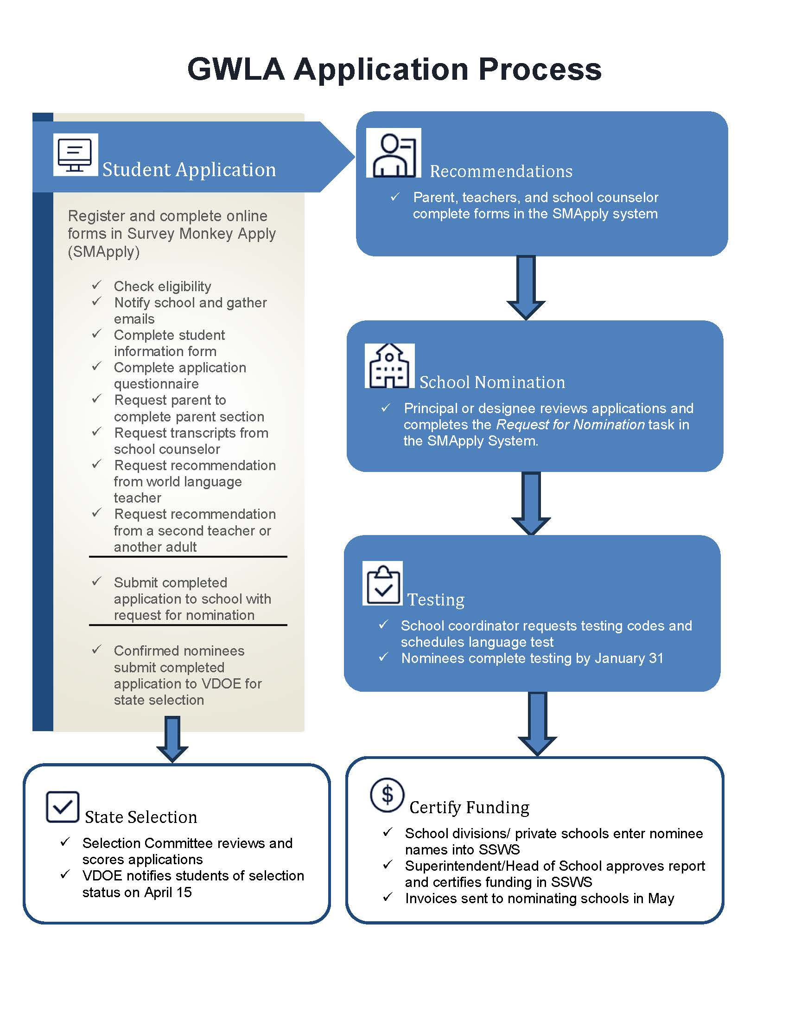

Quick Start Guide
1. Prepare & Promote
- Confirm your school/division is participating.
- Share GWLA info with all 10th and 11th grade world language students.
- Post flyers or send announcements (include homeschool and virtual students).
- Direct students to the GWLA website.
2. Support Student Applications
- Help students gather:
- Recommender names/emails
- Transcript uploader contact
- Principal/designee contact for nomination approval
- Encourage use of the Student Application Planning Form.
3. Nominate Students
- Convene a local selection committee (if needed).
- Select up to 2 nominees per language.
- Ensure nominees meet eligibility criteria (see guide).
- Complete the School Nomination Form in SMApply.
4. Testing
- Order test codes by Jan 27 (only for selected nominees).
- Schedule and proctor tests (no language experts as proctors).
- Ensure all tests are completed by Jan 31.
- Provide accommodations per IEP/504 if applicable.
5. Submit Data
- Complete the Data Entry Cover Sheet.
- Submit nominee info to your division Superintendent or head of private school via SSWS.
- Confirm that the Verification Report is submitted by Feb 16.

Reminders
- Students may only apply to one Governor’s summer program (GWLA or SRGS).
- Students must not be native or near-native speakers of the target language.
- Use the SMApply portal for all student application steps.

Contact Dr. Lisa Harris at WorldLanguages@doe.virginia.gov with questions.

Appendix B: Instructions for Online Entry of Student Data
Student data may be entered by the division World Language Supervisor or Gifted Education Coordinator, or by a world language department chairperson or designee at the school level. This individual will enter the Academy selection and name of each student nominee directly into the VDOE’s Single-Sign-on for Web Systems (SSWS) Educational Information Management system through a secure website.

SSWS Access
- Request an SSWS account with access to the GWLA data entry application (new users); or request re-activation of a lapsed account.
  - PUBLIC SCHOOLS: Contact your school division’s SSWS account manager to obtain a username and password or reactivation. These cannot be assigned by the VDOE for public school employees.
  - PRIVATE SCHOOLS: Submit the online form to request a new SSWS account. Email Lisa.Harris@doe.virginia.gov to request reactivation of a lapsed account.
Task Description | SSWS Screen Shot
Navigate to the SSWS page and log in. | SSWS Login Screen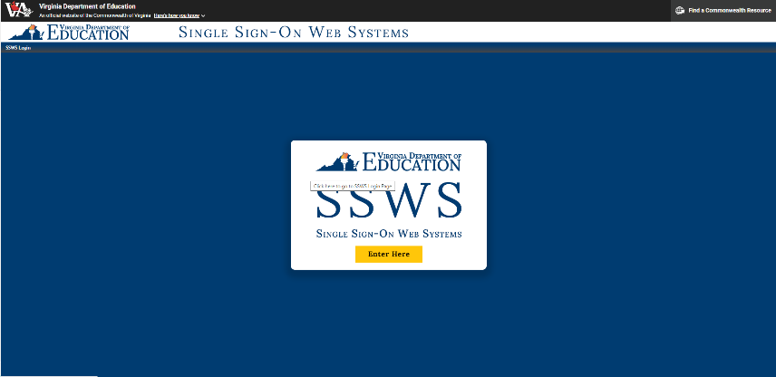
Enter your Username on the first screen.  Your Username is case sensitive. | SSWS Username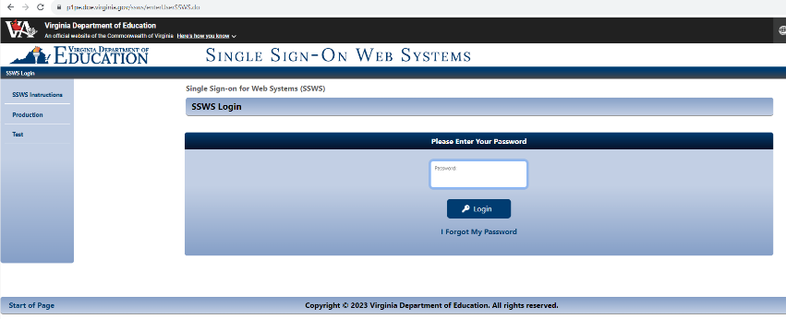
Enter your password. The password is case sensitive. | SSWS Password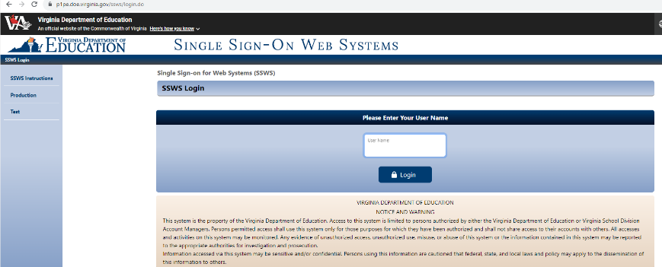
If you get the verification screen, click the Send Token button. | Send Token Screen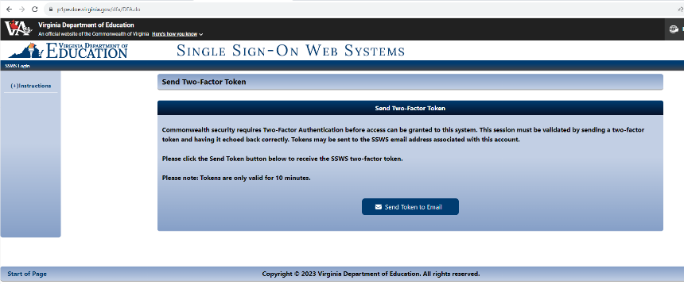
Enter the number from the email or text message into the text box. | Enter Verification Number from Token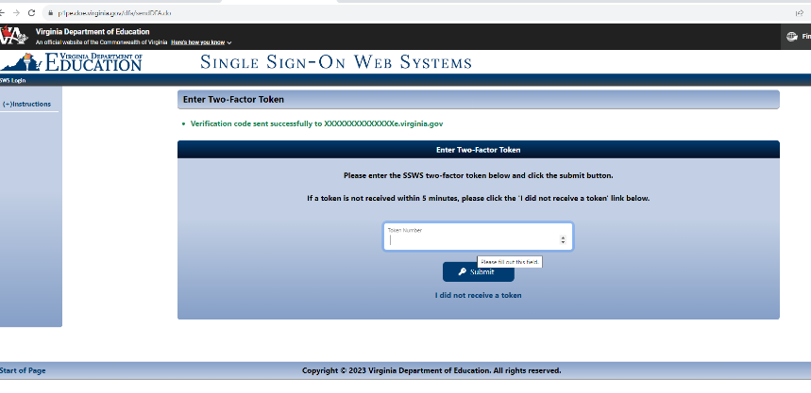

Accessing the GWLA Data Entry Application
Once in the SSWS system, locate the application for the Governor’s World Language Academies in the central white section of the page. There may or may not be additional applications listed, depending on your role and access in the SSWS system.
From this page, which may be titled Governor’s World or Foreign Language Academies (GWLA) or (GFLA), look to the upper right corner and click on “Nominee Submission” or “Submission by Division,” whichever is available to you, to begin the data entry process.

Task Description | SSWS Screen Shot
Choose “Governor’s World Language Academies” data entry application from the menu of options. | SSWS Applications Menu  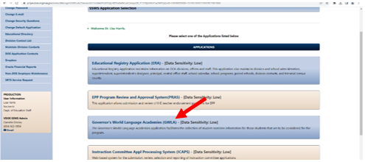
Select “Nominee Submission” or “Submission by Division” | GWLA Data Entry Link 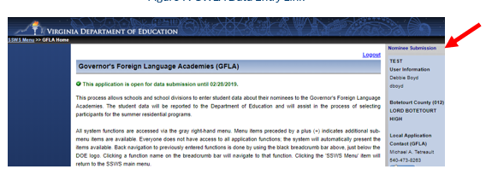
Message Note 1: Note shows the submission window is open and the date the window will close. Be sure to enter all data in time for the Superintendent or Head of School to complete their part before the window closes. | Message 1: Data Submission Window Open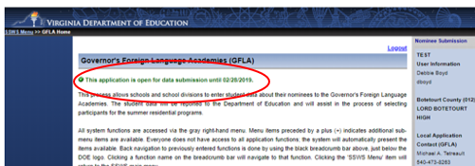
Message Note 2: Note shows the submission window for nominations has been closed by the division designee and names have been submitted to the Superintendent for approval. Email the VDOE Coordinator of World Languages if you need to have the submission reverted to allow for editing. | Message 2: Data Submitted to Division Superintendent  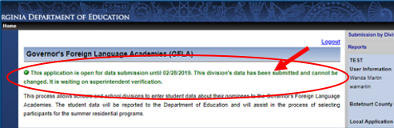
Message Note 3: Note shows the Superintendent or Head of School has signed off on the nominations and the data has been submitted to VDOE. Email the VDOE Coordinator of World Languages if you need to have the window re-opened. | Message 3: Data Submitted to Division Superintendent  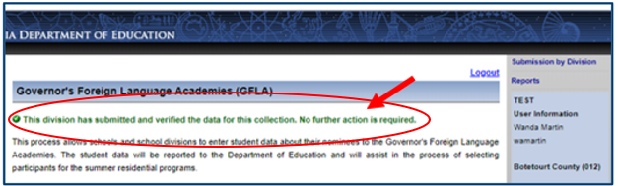

Adding Student Nominee Data
The Add Nominee option will remain open until the nominees are submitted to the Superintendent for approval. If you don’t see the Add Nominee button, check the green message status shown above to see if your division data has been submitted to the Superintendent for verification.
NOTES for this step:
- If individual school-level staff are entering data, start with bullet (a), then move on to the next step. Skip bullet (b).
- If the division-level staff member is entering all data, start with bullet (b), then move on to the next step. Skip bullet (a).
Task Description | SSWS Screen Shot
(a) Add Nominees at the School-Level: Click the “Add Nominee” button to add student names.  If you don’t see the Add Nominee button, check the Message Notes in the previous section to see if your division data has been submitted to the Superintendent for verification. | School Level Data Entry Screen  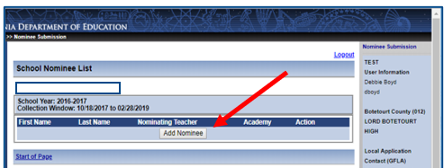
(b) Add Nominees at the Division-Level: Use the drop-down list to select a school, then click “Add Nominee” to add student names. | Division Level Data Entry Screen  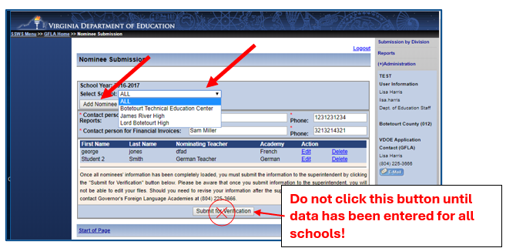
Choose the appropriate Academy from the drop down menu and enter the student's name. Do not use all caps when typing and pay careful attention to accuracy. Click the Submit button to save the entry. | Enter Nominee Names  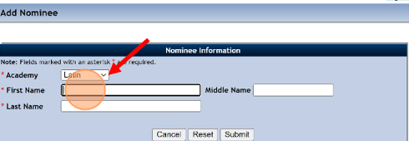
You will see a green confirmation message if a student has been added or updated successfully. Choose “Add Nominee” to add more students, as necessary, and log out when finished.  If you are adding nominees for more than one school, return to item (b) above and repeat until all nominees have been entered for all schools. | Nominee Confirmation Message  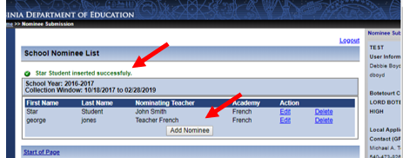

Submitting Data
Before submitting data to the Superintendent or Private School Head of School for verification, the division-level data entry designee should complete the following steps to confirm the data and provide contact information. Once Submit for Verification has been clicked the collection window will be locked and no further entries or edits will be allowed.
If further edits must be made after clicking Submit for Verification, please contact the VDOE Coordinator of World Languages at WorldLanguages@doe.virginia.gov to reopen the window.
If the Superintendent or Designee has already submitted the Verification Report to the VDOE, a new email notice will be sent to them requesting review and submission of the updated report.
Task Description | SSWS Screen Shot
(a) School Level: Notify your division’s designee (Gifted Education Coordinator or World Language Supervisor) when you have completed and double-checked all data entries. | You may come back to the SSWS to edit the information or add/delete nominees at any time UNTIL your division’s designee has submitted the information to the Superintendent for approval.  This ends the school level data entry for public schools.  Private school designees should proceed with the following steps to review and submit data to the Head of Schools.
(b) Division Level: Verify the accuracy of all entries and enter contact information.  To view all nominees listed, select “all” from the school list.  When you have verified all entries are accurate and all names have been entered, enter the name and contact information for the person to receive the status reports and the person responsible for paying invoices. | Verify Data and Enter Contact Information  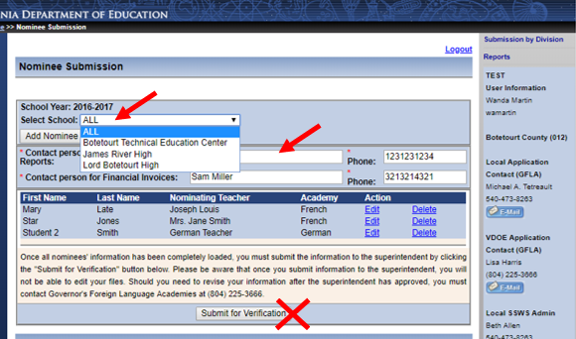  Do not click the Submit for Verification button until after all nominees for all schools have been entered.

When data entry is complete for all schools in the division, the Gifted Education Coordinator or World Language Supervisor will click the Submit for Verification button. This will lock the submission window and generate a Verification Report for the Superintendent or Head of Schools to approve. | Submit for Verification  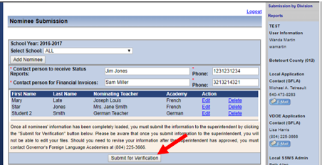
The collection window is now locked for editing.  Choose “Report” on the right-hand menu to generate a copy of the Verification Reports for your records.  It is not necessary to submit a paper copy of this report to the Superintendent unless they require one as part of local protocols. See the section on Verification of Submission for additional information. | Viewing entries after submission for verification  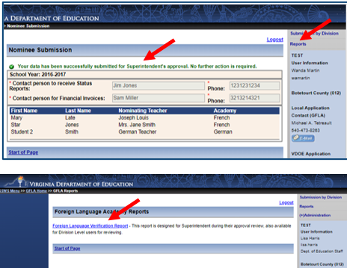

Verification of Submission
The Superintendent or Head of Schools must verify and submit the public school division or private school nominee Verification Report.
- When the Submit for Verification button is clicked, a Verification Report for the division or private school will be created automatically in SSWS and a notification will be generated to the Superintendent or Head of School.
- The Superintendent or Head of School will receive an email asking them to view and approve the report in SSWS.
- When the Superintendent or Head of School logs in to SSWS, they will see the request to approve the report. The Superintendent or Head of School must confirm and submit the Verification Report to VDOE via SSWS by February 16, 2026.
- Once the data have been submitted to VDOE and the Verification Report has been generated, the data entry Collection Window will be closed and locked. Please contact the Coordinator of World Languages at WorldLanguages@doe.virginia.gov if the window needs to be reopened.

Task Description | SSWS Screen Shot
To approve the submission, the Superintendent or Head of School will click on the “Approve” button. This will submit the data to DOE and close the window for the school division or private school.  To disapprove the submission, the Superintendent or Head of School must write the reason for the disapproval in the comment box and then hit the “Disapprove” button. This will reopen the window and revert to the person who generated the report for corrective action and resubmission. | Verification and Submission to VDOE  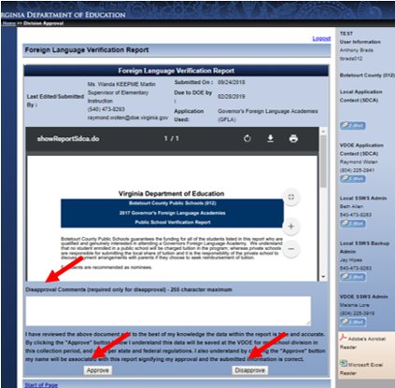

Appendix C: Detailed Directions for School and Division Staff

Directions for School-level Designee
(World Language Department Chair, Guidance Counselor, Lead Teacher, or designated administrator)
- Public school designees should contact the local school division/central office designee to verify your division is participating in the program. (The school division/central office designee could be the world languages supervisor, Gifted Education Coordinator, or another central office administrator appointed by the Superintendent as the designee for the Governor’s World Language Academies. In some smaller divisions, the school designee may also serve as the school division/central office designee.
- Determine if the school Principal will approve student nomination requests in the SMApply system, or if they will appoint a designee (assistant principal, school counselor, world language chair, etc.) to serve as the approver for the school. Note this information for item 5(d) below.
- Advertise the opportunity as widely as possible to eligible students.
- Share links to websites and application portals with interested students.
- Assist the student in gathering the following information to assist in completing their application:
  - Name and email address of current or most world language teacher
  - Name and email address of second recommender
  - Name and email address of person who will upload a copy of the student transcript
  - Name and email address of the Principal/Head of School or the designee who will approve or deny the nomination on behalf of the school
- Convene a school or local selection committee if needed. Provide results to the person who will approve nomination requests for your school listed in 5(d) above.
- Order testing codes and schedule a proctor to administer the test. The school designee for each school may obtain a link to the order form for these items online starting in October from the GWLA web page. Please order testing materials by no later than January 27, 2026. Order test codes only for those students who have completed an application and whom the school will nominate.
- Administer the language tests. All nominees (except for Japanese applicants with no experience in the language) must take and submit the proctored online test no later than January 31, 2026.
- Complete a Data Entry Cover Sheet with the names of all students the school will submit for nomination and submit this form by January 25, 2026, to the person responsible for entering the names in the SSWS system. Do not send this form to VDOE, the names must be entered by the school or division data entry designee.
- Optional: Some school divisions may ask the school designee to submit student data into the SSWS secure data system. Check with your school division/central office designee for questions about entering data for your school division.

Directions for Private School Designee
- For First Time or Change in Access Only: Complete and submit a Request for SSWS Access and submit to Head of School for signature. The link to this form is available on the GWLA page of the VDOE website.
- Follow all directions in numbers 4 - 8 as listed below in the Directions for School Division Central Office Designee, and all items in the Directions for the School-level Designee in the previous section.

Directions for School Division/Central Office Designee
(World Languages Supervisor, Gifted Education Coordinator, or designated central office administrator. In some smaller divisions, the school designee may also serve as the school division/central office designee.)
- (Public Schools only) Confirm participation in the 2026 Governor’s World Language Academies with your school division/county administration.
- Share information about the program with local schools, including any school division/county nomination restrictions.
- Provide assistance to local school designees as needed in completing the student nomination process.
- Collect Cover Sheets from each school with names of all local school nominees in time to allow for data entry, submission, and verification by Superintendent or Private School Head of School in advance of the submission deadline.
- Enter data from the cover sheets into the secure SSWS system. If this task has been delegated to the school department chairs, verify that all data have been entered by the internal deadline.
- Once all data have been entered and verified, submit the data to VDOE by clicking on the Submit button on the SSWS data entry screen. This will lock your screen and no further data can be entered without first contacting VDOE to unlock the screen.
- Print a copy of the Verification Report for your records.
- The Superintendent or Head of School will receive a notification from SSWS that the Verification Report is ready for review. The Superintendent or Head of School will submit the form electronically.

Appendix D: Data Entry Cover Sheet
Directions: Public and private school designees will use this information to complete data entry into an online database that will be used to contact students, parents, and schools, and produce invoices. Names and other information will appear exactly as typed into the system. We thank you in advance for your careful attention to detail and accuracy. Both public and private schools are requested to enter information into the online system.
Do not send this form to VDOE. It is for local use in sharing information with the person at your school or division who will enter the names into the SSWS system.
- School-level Program Contact
  - Insert names of all nominees from the school on one form.
  - Submit the list to the school or central office designee responsible for entering data
- Data-entry Designee
  - Enter student names into the SSWS system.
  - Submit the report in SSWS to the Superintendent or Head of School for approval.

School Name:
Nominee Information
Academy | First Name | Middle Name | Last Name
French
French
German
German
Japanese
Japanese
Latin
Latin
Spanish
Spanish

Appendix E: Selection Committee Evaluation Criteria

French, German, Spanish Academies

Teacher Recommendations:
- Average of points given by the two teachers recommending
- Teachers’ general comments and answers to specific questions

Application:
- Student answers to questions; honors, activities
- Academic status (Principal’s form and transcript with emphasis on target language)
- Language travel/experience (0 points if extensive, i.e., equivalent to the Academy)
- Language Assessment Results

Latin Academy

Teacher Recommendations:
- Average of points given by the two teachers recommending
- Teachers’ general comments and answers to specific questions

Application:
- Student answers to questions; honors, activities
- Academic status (Principal’s form and transcript with emphasis on Latin)
- Language Assessment Results
- Essay in English on a Roman history topic

Japanese Academy

Teacher Recommendations:
- Average of points given by the two teachers recommending
- Teachers’ general comments and answers to specific questions

Application:
- Student answers to questions; honors, activities
- Academic status (Principal’s form and transcript with emphasis on language)
- Essay in English on a language or culture topic

Helpful Hints
Avoid common errors and make sure:
- Each application is submitted on or before January 31, 2026.
- Follow the general procedures and check that:
- All sections of the application are complete/ no missing information.
- The second recommender is not a world language teacher.
- The Principal/Head of School or designee has completed Nomination Form.
- Follow all testing procedures and protocols:
  - Testing proctor is not a speaker/scholar of the language being tested.
  - Testing codes requested and tests completed before the posted deadlines.

Appendix F: Glossary of Terms
Term | Definition
GWLA | Governor’s World Language Academies – Summer residential programs for high-achieving students in French, German, Spanish, Latin, and Japanese.
VDOE | Virginia Department of Education – The state agency that oversees public education and administers the GWLA.
SSWS | Single Sign-on for Web Systems – A secure VDOE portal used by schools to enter nominee data and submit Verification Reports.
SMApply | Survey Monkey Apply – The online platform used by students to complete and submit their GWLA applications.
STAMP Test | STAndards-based Measurement of Proficiency – An online language proficiency test used for GWLA applicants in French, German, Spanish, and Japanese.
Composite Index | A formula used by the state to determine a school division’s ability to pay for educational programs, including GWLA tuition shares.
Nominee | A student selected by a school to be considered for participation in the GWLA.
Applicant | A student who has submitted an application but has not yet been nominated or selected.
Verification Report | A document generated in SSWS that confirms the list of nominees and commits the school/division to tuition payment.
IEP/504 Plan | Individualized Education Program or 504 Plan – Documents outlining accommodations for students with disabilities, including testing supports.
Proctor | A staff member who supervises the administration of language tests. Must not be a speaker or scholar of the language being tested.

