Fundraisers 101 and Smart Snacks

“Fundraiser" means a school-sponsored activity where food or nonfood items are sold on the school campus during regular school hours by the school-sponsored organization to raise money for a school-related program or activity. Planning a fundraiser can be challenging, especially when you are not sure which school policies exist around fundraisers. School Nutrition Programs are overseen by the U.S. Department of Agriculture. This organization creates nutrition guidelines for schools to follow during school hours. With child obesity on the rise, schools are incorporating more nutritious foods at school to promote healthy eating habits. Research has shown that when students eat healthy, balanced meals at school they are more likely to have better grades, focus more in schools and have a decreased risk of developing chronic diseases. Federal and state policies are requiring that any school-sponsored fundraiser in which food or beverages are sold to students shall follow the Smart Snacks in School guidelines.
Exemptions to the nutrition standards for school-sponsored fundraisers
Virginia Administrative Code 8VAC20-740-35
- Each public school shall be permitted to conduct, on the school campus during regular school hours, no more than 30 school-sponsored fundraisers per school year, during which food or beverages that do not meet the nutrition standards established by the U.S. Department of Agriculture, may be sold. (Virginia Administrative Code 8VAC20-740-40A)
- School divisions are not required to allow exemptions to the nutrition standards for school-sponsored fundraisers and may implement more restrictive guidelines as part of the local wellness policy requirements.
- One fundraiser is defined as one or more fundraising activities that last one school day. If multiple school-sponsored organizations conduct fundraisers on the same day, the combined activities shall be counted as one fundraiser. If a fundraising activity lasts more than one school day, each subsequent day's activity shall be considered as one fundraiser and shall count toward the 30 exempt fundraisers total per year.
- Any fundraiser that sells food or beverages, whether the items meet the nutrition standards or are exempt from the nutrition standards in this chapter, may not be conducted during school meal service times. Any food or beverage item cannot be sold in competition with the National School Lunch Program and School Breakfast Program from 6 a.m. until after the close of the last breakfast period and from the beginning of the first lunch period to the end of the last lunch period. Food or beverage sold to students during these times shall accrue to the nonprofit School Nutrition Program account.
- Local educational agencies and school food authorities must retain records to document compliance of their fundraisers for each school year. The attached Tracking Record is provided for documentation of the fundraisers.
- An exemption is not required for nonfood fundraisers or for fundraisers that sell food or beverage items that meet the nutrition standards in this chapter.
Schools and school-sponsored organizations and activities are encouraged to consider non-food fundraisers first. Non-food fundraisers, such as a 5K walk/run, dance marathon, or read-a-thon, can support healthy lifestyles and academics while generating higher profits for the organization. If foods or beverages are sold as a fundraiser by any organization other than the school nutrition program, those items should adhere to the federal Smart Snacks in School regulations and the state nutritional guidelines.
Listed below are the steps to take to find out if the food or beverage items are Smart Snacks compliant.
- Gather all nutrition facts labels for the foods that are being considered.
- Click on the link provided below to use the Smart Snacks Compliance Calculator.
Smart Snacks in School Compliance Calculator
- Decide whether the food is a snack, entrée, side or beverage.
Tip: When the calculator asks this first question about which category the product is, you can hover your mouse over the blue circle with the letter “I” to see what classifies as a snack, side, entrée or beverage.
  - Entrée means 1) combination foods of meat or meat alternate and whole grain rich food, 2) combination food of vegetable/fruit and meat/meat alternate, or 3) meat alternate alone with the exception of yogurt, low-fat or reduced fat cheese, nuts, seeds, but butters and meat snacks (i.e. jerky)
- Decide what the first ingredient of the list is. If water is the first ingredient, the second ingredient must be one of the food items listed in the previous section.
- Answer the questions in the calculator by looking at the food label. On the last question in the calculator, you will be asked to fill in various nutrient components.

Smart Snack Standards
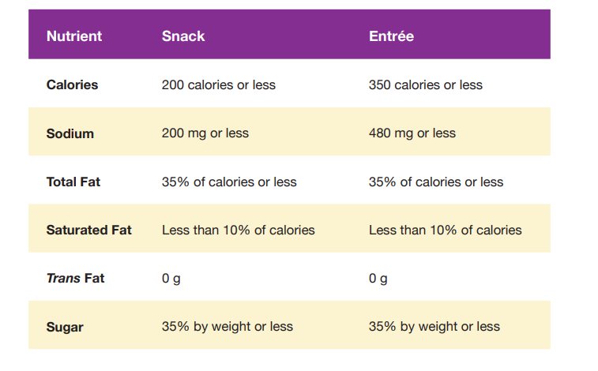
How to Find Information on the Nutrition Facts Label

  - Use the resource below to help guide you when trying to read a Nutrition Facts Label.

  - Double check the serving size to ensure that the information provided is based on accurate information.
- For example, you are planning to sell a bag of chips. One serving is one ounce, but the whole bag weighs 2 ounces and is equal to 2 servings. The calories and other nutrition information are compliant per serving, but when comparing the whole bag (2 servings), you realize it will be over the allowable nutrition standards.
- In this case, it is best to find another product that has one serving per bag or a different item to meet the nutrition standards.

