Attachment A
Superintendent’s Memo #061-22
March 18, 2022

VIRGINIA DEPARTMENT OF EDUCATION
Individuals with Disabilities Education Act (IDEA)
Excess Costs Guidelines and Procedures Manual

Overview

The Virginia Department of Education (VDOE) is required by federal regulation to ensure that all local educational agencies (LEAs) are in compliance with the requirements of the Individuals with Disabilities Education Act (IDEA) Part B concerning Excess Costs. Regulation §300.16 of the IDEA defines “excess costs” as those costs that are in excess of the average annual per-student expenditure in an LEA during the preceding school year for an elementary school or secondary school student, as may be appropriate, and that must be computed after deducting specific expenditure amounts.

The Department of Special Education and Student Services (SESS) will continue to utilize the Special Education Excess Cost (Speced-Excess) web-based application, which is available through the Single Sign-on for Web Systems (SSWS) portal. This web-based application will assist the local educational agency (LEA) with determining the amount of funds it must spend for costs that are attributable to students with disabilities before it is eligible to spend its IDEA Part B funds.

Typically, the LEA should use information available in its audited general ledger at the end of the fiscal year to determine if the LEA is compliant. For fiscal year (FY) 2020–2021, the LEA should use actual expenditures for the fiscal year ending June 30, 2021. For specific instructions concerning expenditures, refer to page 10.

Background

The purpose of the federal requirement for excess costs calculation is to enable LEAs to determine the amount of regular education funds being expended on the basic education of its students with disabilities. An LEA meets the excess cost requirement if it has spent at least a minimum amount for the education of its children with disabilities before funds under Part B of the Act are used. The excess cost requirement does not prevent an LEA from using Part B funds to pay for all of the costs directly attributable to the education of a child with a disability in any of the ages 3, 4, 5, 18, 19, 20, or 21, if no local or state funds are available for nondisabled children of these ages. However, the LEA must comply with the non-supplanting and other requirements of this part in providing the education and services for these children as stated in §300.202, paragraph (ii). Guidance concerning the calculation and expenditure types is included within this document.

Appendix A, Part 300 of the IDEA Federal Regulations

Except as otherwise provided, amounts provided to an LEA under Part B of the IDEA (Act) may be used only to pay the excess costs of providing special education and related services to children with disabilities. Excess costs are those costs for the education of an elementary school or secondary school student with a disability that are in excess of the average annual per-student expenditure in an LEA during the preceding school year for an elementary school or secondary school student, as may be appropriate. An LEA must spend at least the average annual per-student expenditure on the education of an elementary school or secondary school child with a disability before funds under Part B of the Act are used to pay the excess costs of providing special education and related services.

Section 602(8) of the Act and §300.16 require the LEA to compute the minimum average amount separately for children with disabilities in its elementary schools and for children with disabilities in its secondary schools. The LEAs may not compute the minimum average amount it must spend on the education of children with disabilities based on a combination of the enrollments in its elementary schools and secondary schools.

The following example shows how to compute the minimum average amount an LEA must spend for the education of each of its elementary school children with disabilities under section 602(3) of the Act before it may use funds under Part B of the Act.

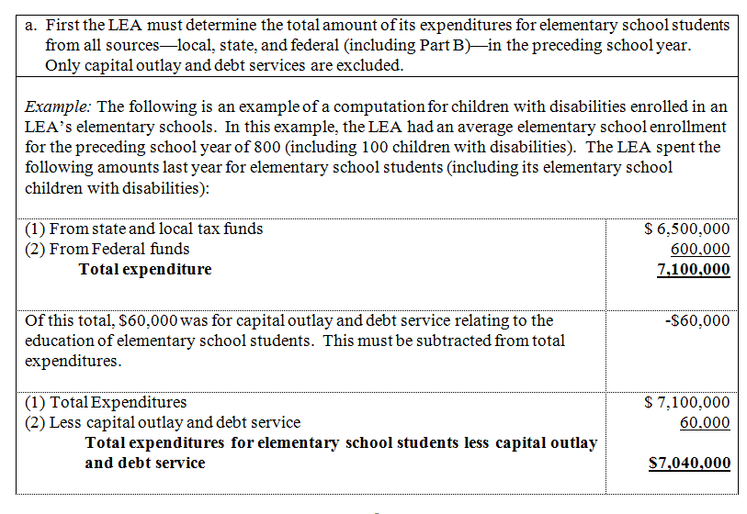

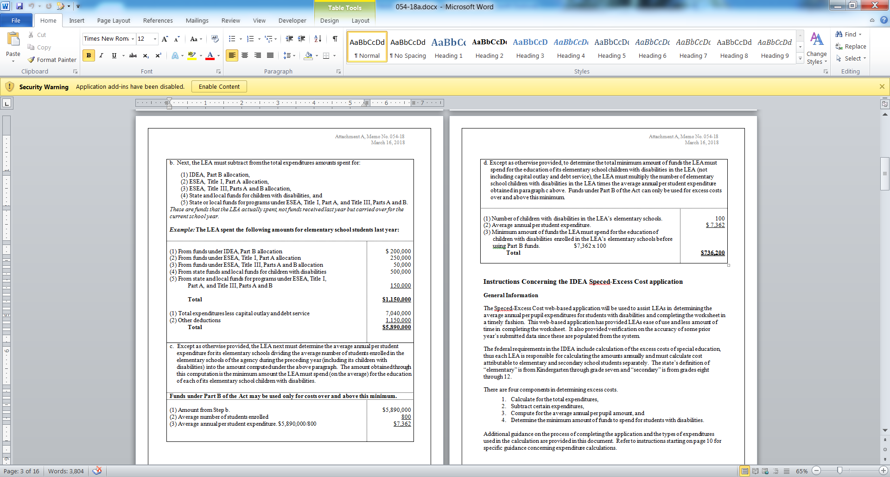
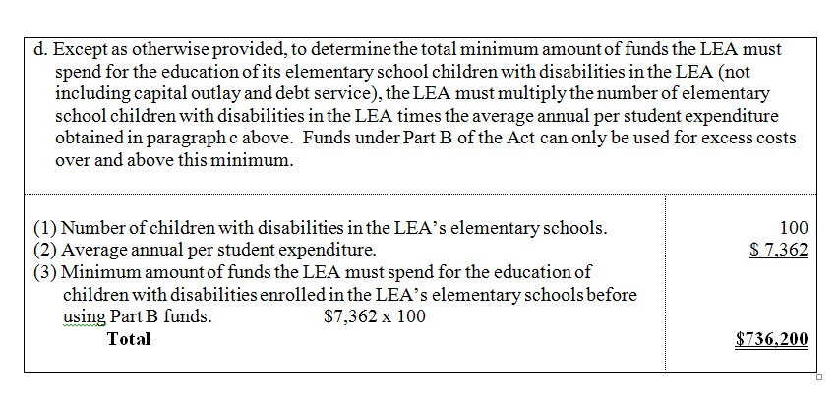

Instructions Concerning the IDEA Speced-Excess Application

General Information
The Speced-Excess web-based application will be used to assist LEAs in determining the average annual per-pupil expenditures for students with disabilities and completing the Excess Cost Calculation worksheet in a timely fashion. This web-based application has provided LEAs ease of use and less amount of time in completing the worksheet. It also provided verification on the accuracy of LEAs’ prior year’s submitted data since these are populated from the system.
The federal requirements in the IDEA include calculation of the excess costs of special education, thus each LEA is responsible for calculating the amounts annually and must calculate cost attributable to elementary and secondary school students separately. The state’s definition of “elementary” is from kindergarten (K) through grade 7 and “secondary” is from grades 8–12.
There are four components in determining excess costs:
- Calculate for the total expenditures
- Subtract certain expenditures
- Compute for the average annual per-pupil amount
- Determine the minimum amount of funds to spend for students with disabilities

Additional guidance on the process of completing the application and the types of expenditures used in the calculation are provided in this document. Refer to instructions starting on page 10 for specific guidance concerning expenditure calculations.

Accessing and Using the Application

The application is available through the VDOE’s SSWS portal. The person responsible for submitting the excess cost calculation worksheet to VDOE will need to have an SSWS login ID and a password to gain access to the Speced-Excess application. If access is not available within the user’s menu, contact the division’s SSWS administrator to gain full access rights.

- To access the SSWS portal, click on the “SSWS Login” which is located on the lower right side of the VDOE’s home page shown in Figure 1.

Figure -1-
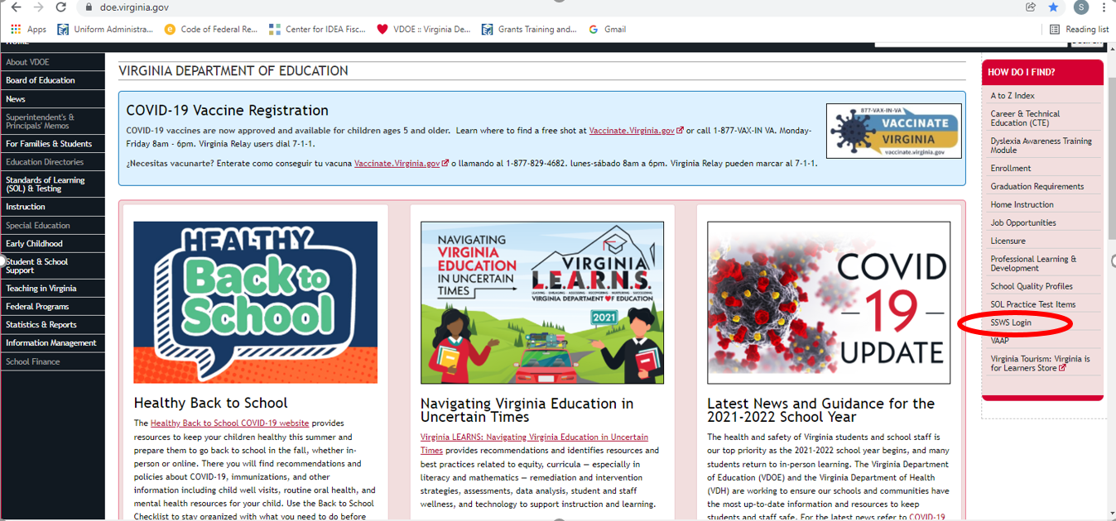

- Figure 2 displays the SSWS login screen. Users must have an assigned SSWS login ID to
access the application. The local SSWS administrator should be contacted to obtain a login ID.

Figure -2-
-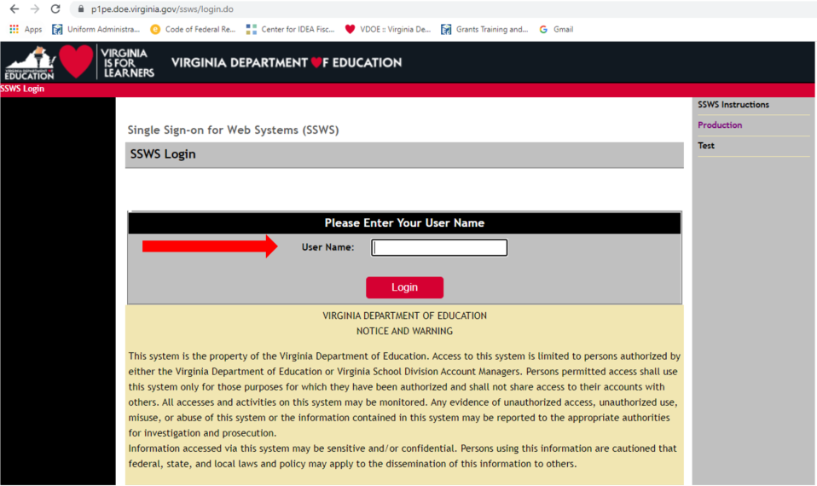
- Figure 3 displays the password screen. Users will need a password to access the application. Passwords will be determined upon receiving access rights from the local SSWS administrator.

Figure -3-
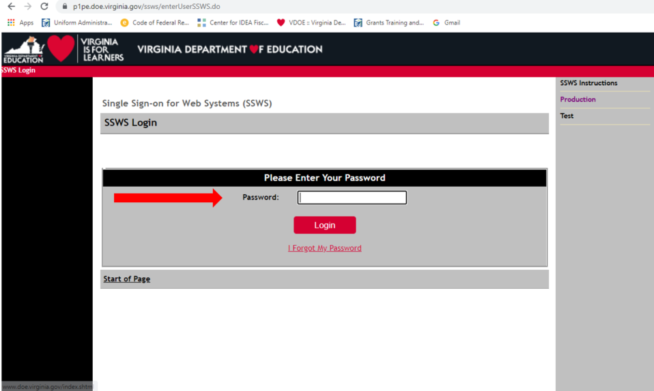

- Figure 4 displays the screen after successfully logging into the application. Select “Special Education Excess Cost (Speced-Excess)” from the list of applications displayed. If the application is not available in the user’s menu, contact your local SSWS administrator to secure full access rights.

Figure -4-
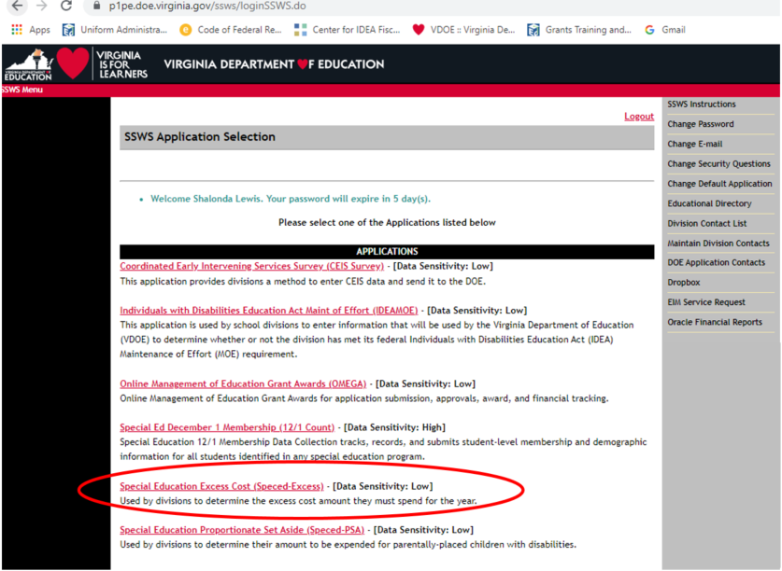

- Figure 5 displays the screen after selecting the Special Education Excess Cost (Speced-Excess) application. The screen should show that the collection window is open for data submission.
There are two options located on the right side of the screen that are available for the user to select.

- Worksheet - Selecting this menu will show the screen displayed in Figure 6. The user should select the “Worksheet” option when ready to enter data. Figure 7 on page 9 shows an illustration of the worksheet with sample information entered for elementary and secondary school students.

- Reports - Selecting this menu will display the screen where the Verification Report is generated. Division superintendent or designee will approve and certify Verification Reports through the Superintendent Data Collection Approvals (SDCA) application. As such, school divisions are no longer required to submit paper verification reports to VDOE.

Figure -5-
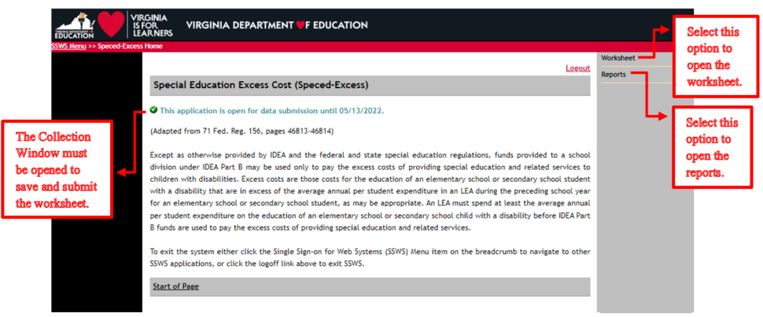
- Figure 6 displays the worksheet screen. The worksheet has a column each for “Elementary School Students” and “Secondary School Students” to comply with the federal requirement that LEAs must calculate the excess cost separately. School divisions must enter data under Elementary School Students for those expenditures that are applicable to elementary school students only and under Secondary School Students for those expenditures that are applicable to secondary school students only. Users are required to enter valid numbers in all blank input fields; otherwise, division users cannot submit the worksheet. Use the “tab” key after each entry to proceed to the next field. Do not use the “enter” key as it will erase all entries and will not allow users to proceed to the next field. Also, refrain from using the web browser’s “back” button when returning to the previous screen; instead select the options from the menu on the left side of the application.
Figure -6-
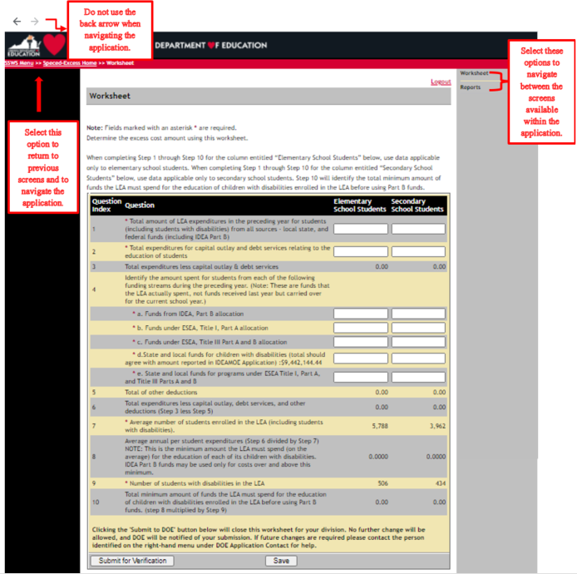

- Figure 7 illustrates a worksheet with one input field left blank and a user clicks the “Submit for Verification” button. As a reminder, the worksheet can only be submitted when it is fully completed and all boxes are filled with valid numbers.

- The numbers entered in the illustration for both elementary and secondary columns are for information purposes only. Division users must be reminded that data entered under elementary school students are those that are applicable to students in grades K–7 and data entered under secondary school students are those that are applicable to grades 8–12. Prior to entering information, refer to the guidance and line item instructions starting on page 10.

Figure -7-
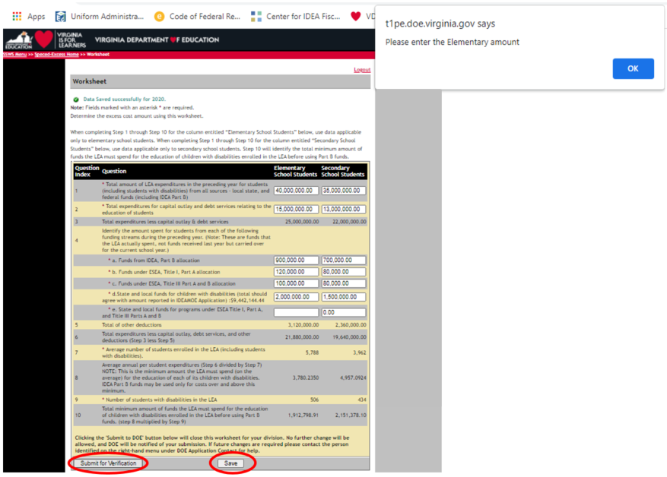

General Guidance for Expenditures
The process for computing excess cost has been established in Appendix A to 34 CFR Part 300, and it requires the LEA to determine the total amount of its expenditures for elementary and secondary school students from all sources—local, state, and federal (including Part B) in the preceding school year and only capital outlay and debt services can be excluded. The LEA must include all expenditures for elementary and secondary school students; however, the LEA should not include expenditures that it did not make or that are made for purposes other than for elementary or secondary school students (i.e., adult education, pre-school).

The LEAs should not apply the combination of students’ enrollment as the basis for calculating the costs between elementary and secondary school students when computing the average per-pupil costs for children with disabilities. It is important to remember that there are distinct and separate costs associated with these levels that will make the calculations inaccurate. For example, school programs at the secondary level typically include things such as career and technical education, athletic, and music programs, including marching bands, while these programs are often not applicable within elementary schools. As such, the costs of these separate programs must be computed separately.

New for 2020–2021. Divisions must also include all new funding or expenditure categories that may have been created as a result of the pandemic. Review Superintendent’s Memo
193-21A for account codes.

A system enhancement has been made to the Excess Cost Application for Line 9 which will be covered on page 11.
In cases where it is difficult to determine a distinct and separate cost to elementary or secondary school students, it is recommended that those costs be allocated in accordance with work assignments (i.e., pupil transportation when on same routes, custodial costs, and some central office personnel costs). In any case, the LEA shall not exclude these costs from the excess cost calculation worksheet. The methodology for calculating the costs that are not distinctly identified as elementary or secondary school expenditures should be retained by the LEA for audit purposes. Please note that this information may be reviewed during VDOE-SESS fiscal monitoring.

Line 1 – After considering the guidance provided in the section above, enter the total amount of expenditures from all sources—local, state, and federal funds including IDEA Part B for elementary school students and secondary school students separately in the preceding year. When computing costs associated with elementary school students and secondary school students, please be reminded that the LEAs may not base it on a combination of enrollment of students. There are distinct and separate costs associated with these levels that may potentially make the calculations inaccurate and misleading. Note: Only K–12 expenditures must be reported in this line. Pre-school and all other non K–12 expenditures must be excluded.

Line 2 – Enter the total capital outlay from all functions (i.e., 61100–6800) and debt services expenditures that are applicable to elementary school students and secondary school students. Capital outlay means expenditures for the acquisition of capital assets, such as equipment, buildings and land, or expenditures to make improvement to capital assets that materially increase their value or useful life. The capital outlay and debt services expenditures are non-operational costs and should be excluded from the calculation of the average per-pupil cost. Note: Do not use the capital outlay expenditures reported in Schedule G of the Annual School Report since this is used for a different purpose.
Line 3 – This line is auto-calculated and shows the total expenditures minus capital outlay and debt services (Line 1 minus Line 2).

Line 4 – Enter the amount spent for elementary school students or secondary school students from each of the following funding streams during the 2020–2021 school year. Please note that these are funds that the LEA actually spent, and not funds received in the prior year, but carried over for the current school year.
- Funds spent from the IDEA Part B allocation for elementary and secondary school students should be entered in Line 4a. Note: Only K–12 expenditures must be reported in this line. Pre-school and all other non K–12 expenditures must be excluded.

- Funds spent from the Elementary and Secondary Education Act (ESEA), Title I, Part A allocation for elementary and secondary school students should be entered in Line 4b. Note: Only K–12 expenditures must be reported in this line. Pre-school and all other non-K–12 expenditures must be excluded.

- Funds spent from ESEA, Title III, Part A and B allocation for elementary and secondary school students should be entered in Line 4c.

- Funds spent from state or local funds for children with disabilities for elementary and secondary school students should be entered in Line 4d. The expenditures reported on this line should match the expenditures reported in the IDEA MOE application for the reporting year (auto-amount in parenthesis) minus the pre-school expenditures.

- Funds spent from state or local funds for programs under ESEA Title I, Part A, and Title III, Parts A and B for elementary and secondary school students should be entered in Line 4e. Note: This part is only applicable if the LEA uses additional local or states funds to support the programs under Title I and/or Title III. Usually, this would be in the form of a local matching requirement.

Line 5 – This line is auto-calculated and shows the total of other deductions reported under Lines 4a, 4b, 4c, 4d, and 4e.

Line 6 – This line is auto-calculated and shows the total expenditures less capital outlay, debt services, and other deductions (Line 3 minus Line 5).

Line 7 – This line is populated from the Spring 2021 Student Record Collection (SRC) report the school division submitted to VDOE. This number cannot be changed or edited.
Line 8 – This line is auto-calculated and shows the average annual per-student expenditures (Line 6 divided by Line 7). The amount obtained through the calculation is the minimum amount the LEA must spend for the education of each of its elementary school students and secondary school students with disabilities. Funds under Part B of the Act may be used only for costs over and above this minimum.

Line 9 – New System Update: A system upgrade was made to reflect new guidance from the United States Department of Education’s Office of Special Education Programs (USED-OSEP). The child count data used coincides with the expenditure year. This line is pre-populated from the LEA’s December 1, 2020, child count submission, which has been duly certified by the division’s superintendent. As such, it cannot be changed or edited.
Line 10 –This line represents the total minimum amount of funds the LEA must spend for the education of children with disabilities enrolled in the LEA’s elementary schools and secondary schools before using the IDEA Part B funds (Line 8 multiplied by Line 9).

- Figure 8 displays the screen after the user has completed the worksheet and is ready for submission. Once the worksheet is submitted, the collection window automatically locks for edits so it is recommended that users verify the accuracy of the data entered before submitting the worksheet. If the division user is ready to submit, click the “Submit for Verification” button for the division superintendent’s electronic approval via the Superintendent Data Collection Approvals (SDCA) Application in SSWS.
- If the user is not ready to submit, click the “Save” button and the worksheet will remain open for edits.

Figure -8-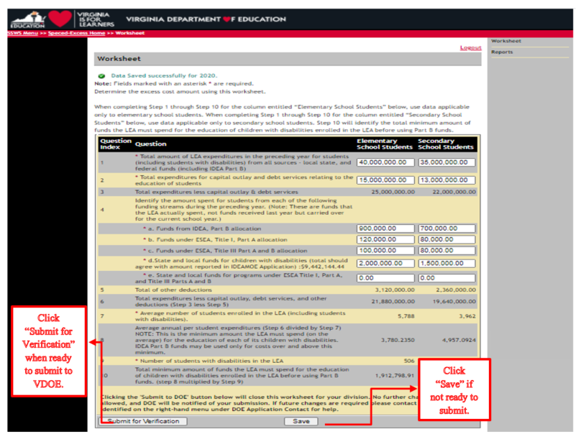
- Figure 9 displays the screen after the worksheet is completed and submitted for the division superintendent’s approval. For revisions after submission but prior to the division superintendent’s approval, notify the division superintendent to disapprove the worksheet to unlock the collection window. For revisions after the division superintendent’s approval, contact the VDOE to re-open the collection window prior to the due date of May 13, 2022.

Figure -9-
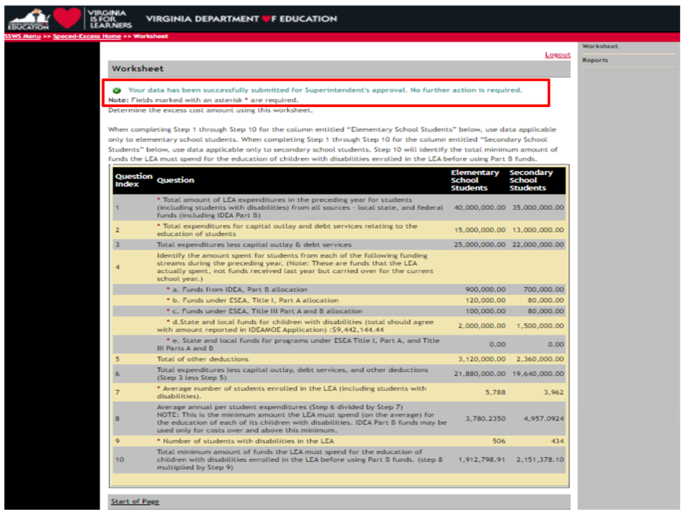

- Figure 10 displays the screen after the worksheet is submitted and waiting for the division superintendent’s approval using the Superintendent Data Collection Approvals (SDCA) Application (refer to Figure 11 on page 14).

Figure -10-
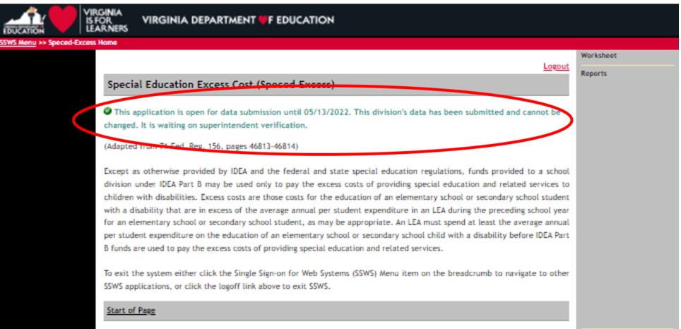
- The division superintendent or designee will be notified via email of the data submission request for approval. This email notification includes a link to log in to SSWS to launch the SDCA Application as shown in Figure 11. If the SDCA is not available in the division superintendent’s menu, contact the local SSWS administrator to secure access rights.

Figure -11-
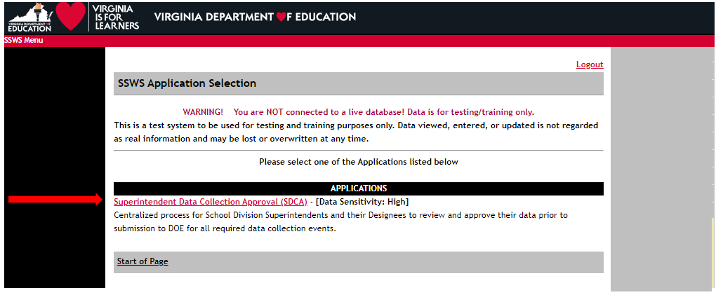

- Figure 12 displays the screen after the “Superintendent Data Collection Approval (SDCA)” is clicked open. The SDCA screen will show the name of the report, submitter’s name, and the due date.

Figure -12-
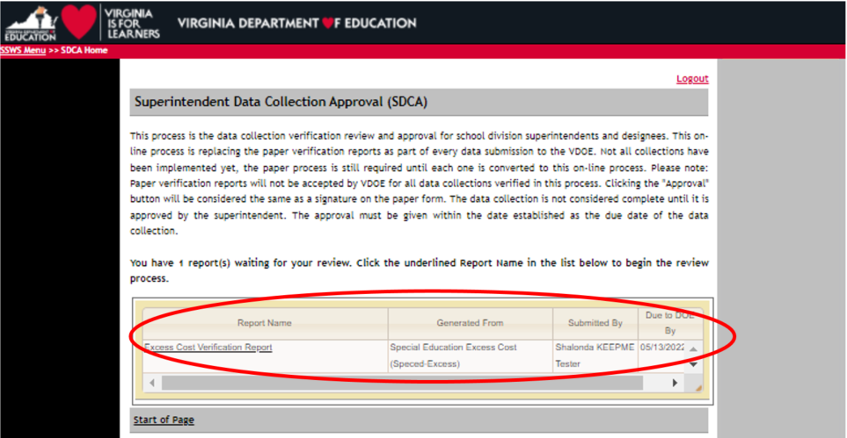

- Figure 13 displays the screen after the division superintendent or designee selects the Excess Costs Verification Report from the list of reports available. The screen also displays the “Approve” and the “Disapprove” selections and a fillable comment box that is required for disapproved selections.

Figure -13-
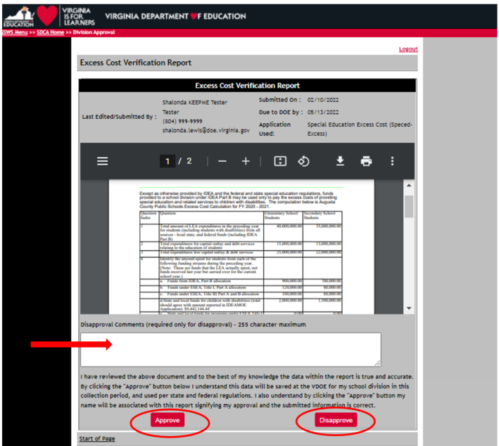

- Figure 14 displays the screen once the division superintendent or designee selects the “Approve” option. This option is a representation of the division’s superintendent or designee that the submitted data are accurate and in compliance with state and federal regulations. In lieu of the electronic signature, divisions do not need to submit a manual copy of the verification report to the VDOE.

Figure -14-
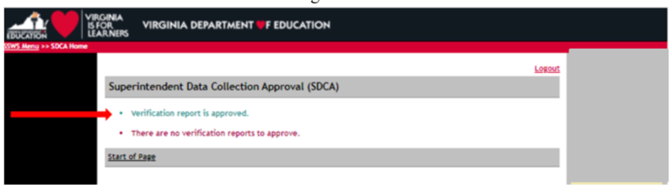

- Figure 15 displays the screen after the division superintendent or designee selects the “Disapprove” option. The collection window will automatically open for resubmission. In the event the disapprove selection is made after the due date, the division user must contact VDOE to re-open the collection window in order to resubmit the worksheet.

Figure -15-
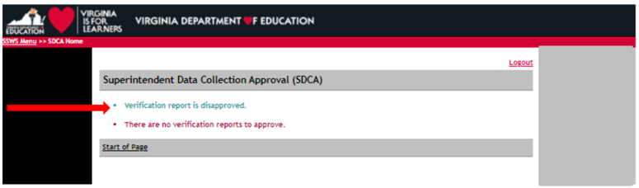

- Figure 16 displays the screen after the Excess Cost Calculation Worksheet is completed. The message also indicates that no further action is required.

Figure -16-
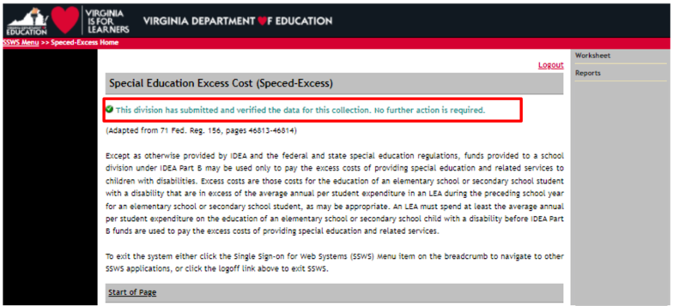

Please note that the collection window will open on March 21, 2022, and will close on May 13, 2022. Divisions not submitting the Excess Cost Calculation Worksheet prior to the due date will be contacted individually and will be required to follow a protocol to re-open the collection window. This protocol will be shared with those specific school divisions. Late submissions and inaccurate reporting of information will affect the school division’s Local Determination Accountability Matrix and may prompt a fiscal monitoring review by the VDOE. In addition, please remember to retain documentation that outlines the methodology, processes, and procedures used to create or calculate this data for monitoring and audit purposes.

