Attachment B
Superintendent’s Memo #265-22
November 18, 2022

VIRGINIA DEPARTMENT OF EDUCATION

Individuals with Disabilities Education Act (IDEA)

Local Maintenance of Effort (MOE)
IDEA MOE Application User’s Manual

Table of Contents

Introduction………………………………………………………………1

How to Access the Application…………………………………………..1

Components of the IDEA MOE Application………………………..…...4

Entering Expenditures…..………………………………………………..6

Initial MOE Determination – Meets all Four Tests………………………7

Submission of Data/Access of Data after Submission....................……...8

Access to Reports Menu after Approval.……………………………….11

Illustrations of an LEA with Multiple Failed Tests…………………….17

Option Selections and Different Scenarios of 300.204(b) ……………..20

Allowable Exceptions 300.204(a)………………………………….…...23

Allowable Exceptions 300.204(c)………………………………….…...27

Allowable Exceptions 300.205………………………………………....28

Allowable Exceptions 300.204(d)…………………………………….. 29

Summary Page after Allowable Exceptions……………….………….. 30

Submitting Data after Entering Allowable Exceptions...….……………31

Appendix A Maintain Exceptions Report (Example)………………………..……33

Appendix B Verification Report (Example)……………………………….……...34

Introduction

This user’s manual is provided to help school divisions with entering information into the Virginia Department of Education’s (VDOE’s) Individuals with Disabilities Education Act Maintenance of Effort (IDEAMOE) web-based application. Information entered into the application will be used to assist VDOE with determining whether the division has met its IDEA maintenance of effort requirement. This requirement is for school divisions to spend at least the same amount of local or local plus state dollars for the current school year on the delivery of special education and related services, as were spent the prior year the division met its MOE requirement using the same method. If you have not read Attachment A, do not proceed to entering data.

The MOE Tests and a review of any possible allowable exceptions will be conducted using the IDEAMOE web-based application. Please refer to Attachment A for regulatory guidance and the process which the VDOE will use to determine whether a division has met its IDEA MOE requirement. The information below is intended to assist the user with navigating through and entering information into the IDEAMOE web-based application.

Accessing and Using the Application

The IDEAMOE application can be accessed through the VDOE Single Sign-on for Web Systems (SSWS) portal. The division’s local SSWS administrator must be contacted to obtain an SSWS login ID and password to access the application. If the IDEAMOE application is not available within the user’s menu, please contact your local SSWS administrator to assist with obtaining full access rights.

- Figure 1 displays the VDOE home page. The IDEAMOE application can be accessed by the SSWS link on the right side of the VDOE home page.
Figure -1-
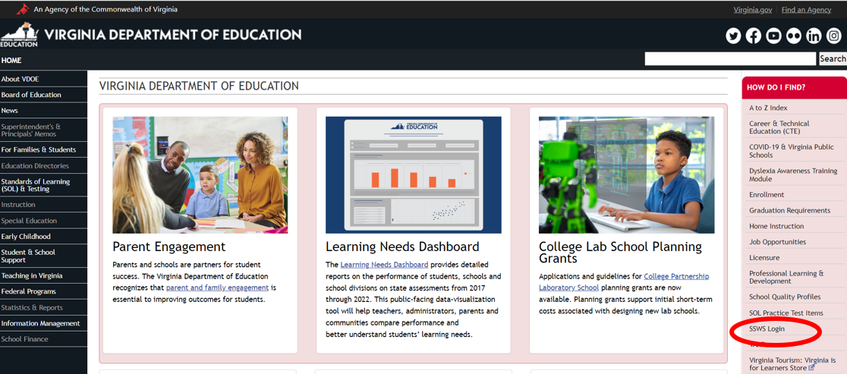

- Figure 2 displays the SSWS login screen. The person responsible for entering and submitting the IDEA MOE information must have a login ID and password. The division’s local SSWS administrator should be contacted to obtain an SSWS login ID and password.

Figure -2-
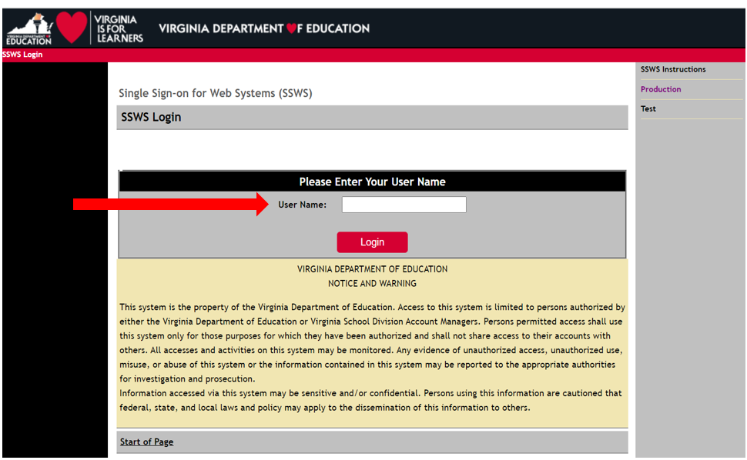

- Figure 3 displays the password screen after the login ID is entered.

Figure -3-
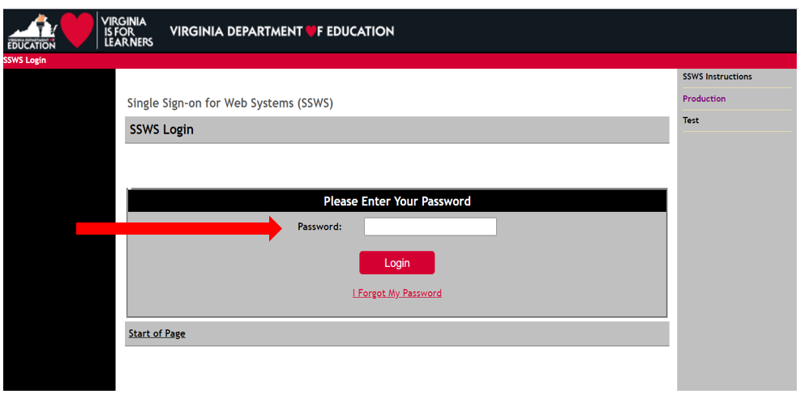

- Figure 4 displays the application menu after a successful log-in into SSWS. Select “Individuals with Disabilities Education Act Maint of Effort (IDEAMOE)” from the list of applications displayed. If the application is not listed, please contact the division’s local SSWS administrator to obtain full access rights.
Figure -4-
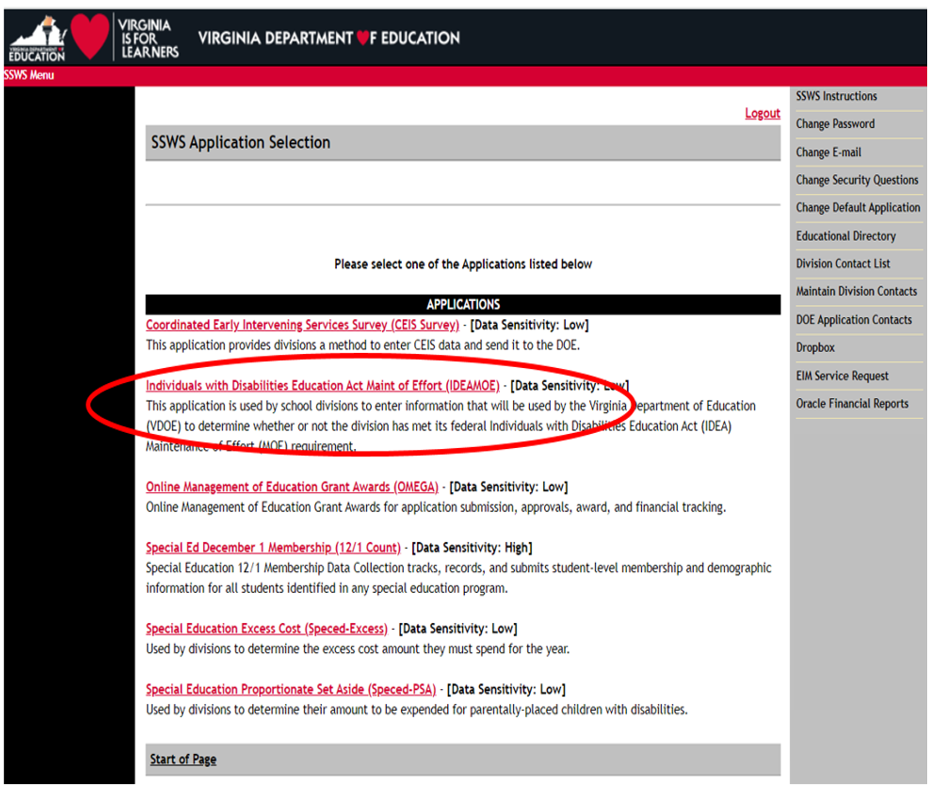

- Figure 5 illustrates the screen that will display after selecting the IDEAMOE option. The screen will indicate that the collection window is open. When the collection window is closed, the application is available for the division to use as a calculator.
The user will have three options available in the menu area on the right side of the application. To return to the previous screen, the user should select the options available at the top of the screen and refrain from using the ‘back’ button. The information below will help the user with determining which option to select to navigate through the application:

- Instructions – Selecting this option will display the link to the IDEA MOE Guidance Document, IDEA MOE Web Application Guidance Document and MOE Allowable Exceptions and MOE Technical Assistance Videos. The links, when clicked, will open and download the respective document files available.
- Enter Expenditures – Selecting this option will display the window where the user will enter state expenditures and local expenditures for state fiscal year (SFY) 2021-2022. It also displays the previous year’s (i.e., SFY 2020-2021) submitted MOE expenditures (refer to Figures 6 and 8). Last year’s expenditures may not be used as the basis for the initial determination of meeting the MOE. Refer to Attachment A for guidance concerning which expenditures should be included or excluded.
- Reports – Selecting this option will display the window where two types of reports are available for the user (refer to Figure 7). Note: Both reports can only be generated after approval of the submitted expenditures by the VDOE for the current year.
  - Maintain Exception Report – This type of report is for the division’s use only and need not be submitted to the VDOE.
  - Verification Report – This type of report is for the VDOE’s use and must be submitted electronically certified and signed for accuracy by the division’s superintendent or a designee.
- Resources – Selecting this option will display all available technical assistance webinars for IDEA Maintenance of Effort.
Figure -5-
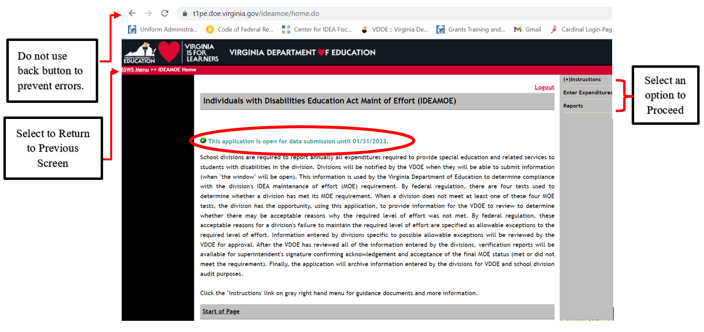

- Figure 6 displays the screen when the user selects the “Enter Expenditures” option from the menu. The screen shows the auto-generated SFY 2020-2021 reported state and local expenditures and the current year (i.e., SFY 2021-2022) that are open for entries. Please note that the previous year expenditures are for information purposes only and may not be used as the comparison year expenditures for determining the division’s MOE compliance due to the subsequent years rule. For additional guidance concerning comparison year due to the subsequent years rule, refer to Attachment A.

Figure -6-
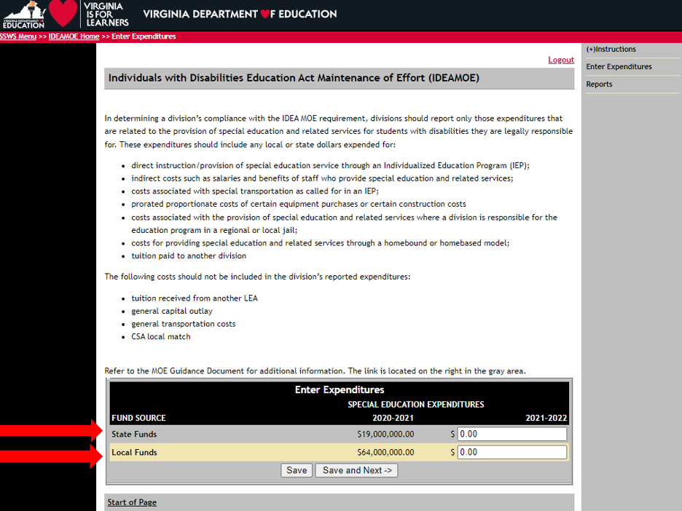

- Figure 7 displays the screen when the “Reports” option is selected. Please refer to page 11
for details.
Figure -7-
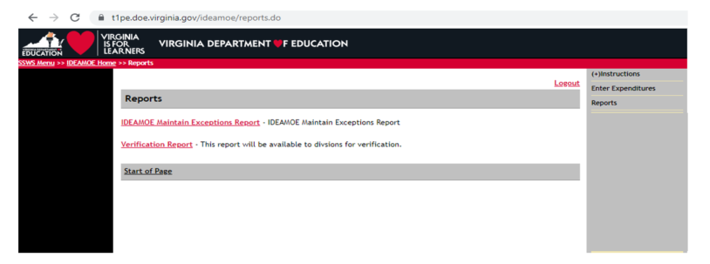

- Figure 8 displays the screen after the state and local expenditures for special education and related services for the current year (i.e., SFY 2021-2022) are entered. Each entry must represent actual expenditures and must be consistent with federal and state regulations and guidance as outlined in Attachment A. After the state and the local expenditures are entered, the user can either select the “Save” button to save the information or the “Save and Next” button at the bottom of the screen to navigate to the next screen of the application.

Figure -8-
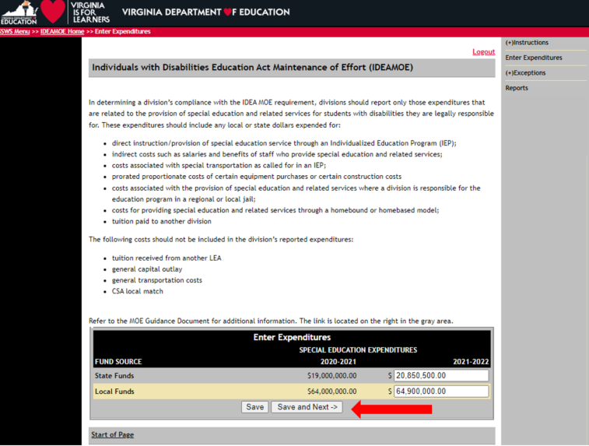

- Figure 9 displays after the user selects the “Save and Next” button in the previous screen. The IDEAMOE application will automatically display if the division meets its IDEA MOE in all the four (4) tests based on the state and local expenditures entered and the comparison year based on the subsequent years rule. Please note that the comparison year is the last fiscal year in which the division met MOE (refer to illustration below), regardless of whether the division is seeking to establish its compliance based on local funds only, or based on state plus local funds.
In Figure 9, the division has met all of the four tests available under §300.203b of the IDEA regulations (refer to Attachment A for additional information concerning the four tests available). Since all four (4) tests are met, the user will not need to enter any additional information.
After the entered local and state expenditures have been verified for its accuracy, the user can submit the data by selecting the “Submit to DOE” button located at the bottom of the screen.

Figure -9- 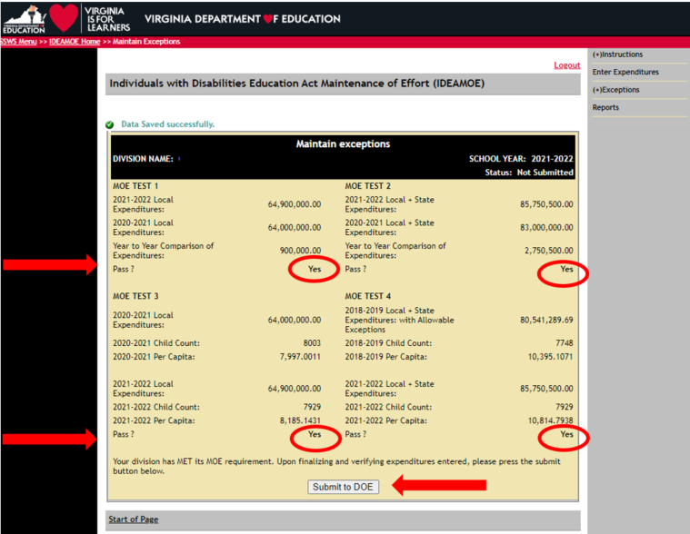

- Figure 10 illustrates the screen that displays after selecting the “Submit to DOE” button. If the user is ready to submit, select “OK,” otherwise click “Cancel.”

Figure -10-

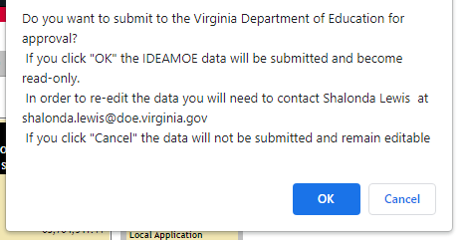

- Figure 11 displays the screen after the user selects the “OK” option in Figure 10. Once submitted, the collection window closes and the division cannot make changes. However, the division can view information submitted by selecting the menu options located on the upper right side of the screen. Note: The web message in green only refers to the users’ verification of data entered after submission and should not be interpreted as being completed. All data submitted are subject for review and approval by the VDOE.

Figure -11-
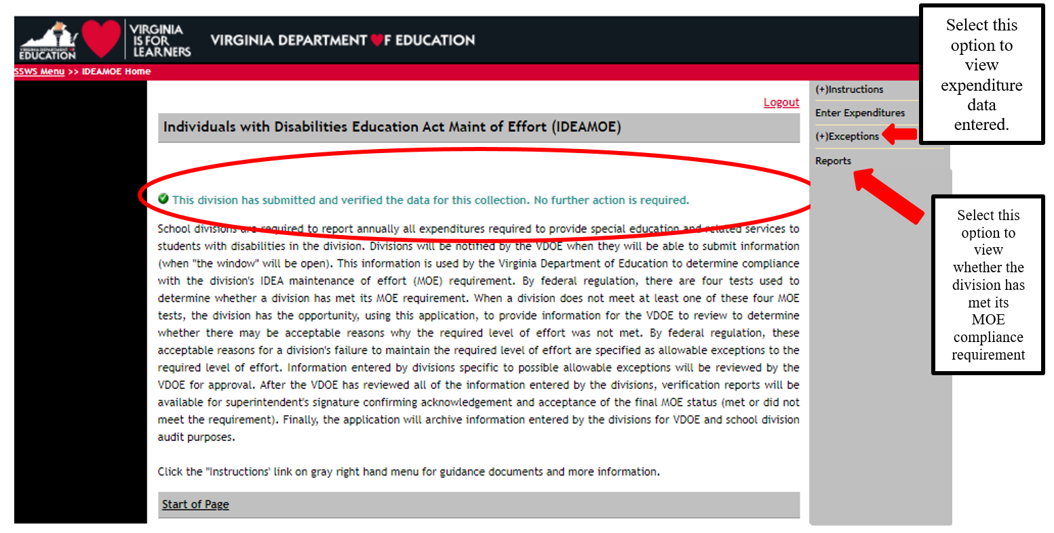



If the division meets one or more of the four “tests” available, the division can choose to stop entering data and submit its IDEA MOE information and the division will not need to perform any additional steps to consider allowable exceptions or the adjustment provision. If the division chooses to submit its IDEA MOE data, return to page 8.


If the division meets less than four of the “tests” available, and the reasons for the reduced spending can be attributed to the Allowable Exceptions in §300.204, the division can provide additional information within the IDEAMOE Application. Refer to print screens starting on page 17 for each of the scenarios that may be applicable to your division. Refer to Attachment A concerning the four “tests” and the Allowable Exceptions available in §300.204. The division can choose to submit if only one of the four tests are met. If the division chooses to submit without considering allowable exceptions for the 2021-2022 year, the division will not be able to revise or submit allowable exceptions from the 2021-2022 school year in future years.



If the division has not met any of the four “tests” available as outlined in Attachment A, the user can proceed to page 17 to determine which scenario may be applicable.
- Figure 12 illustrates the screen that displays when the user clicks the “Maintain Exceptions” option from the menu. This screen can be used to track the division’s status. Note that the window displays the status as “Pending Approval.” The status will change either to “Approved” or “Revisions Required” after VDOE’s review and approval. Note: The VDOE may require some clarifications or additional information about the data submitted as part of the review process.
Figure -12-
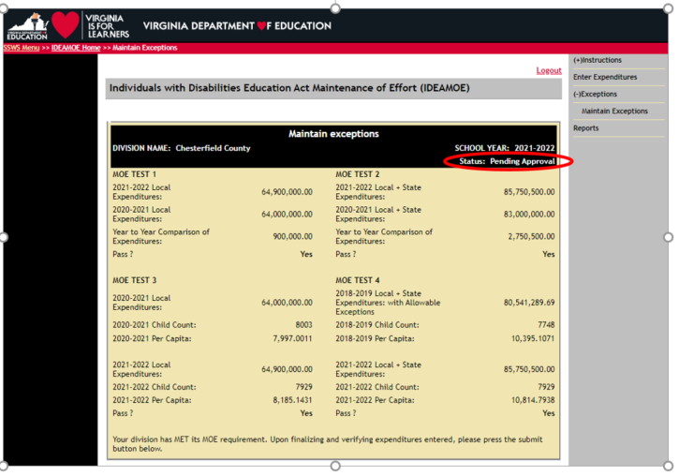

- The submitter of the IDEA MOE information will receive an email notification when the division’s data has been approved or if revisions are required.
- If the division has met its IDEA MOE requirement and the data submission has been “Approved,” the division will receive an email notification advising the submitter to “Submit for Verification.”

- If revisions are required, the submitter will receive an email indicating “Revisions Required.” The submitter will need to make revisions within the IDEAMOE application and re-submit the data.
  - If the division has met its IDEA MOE requirement after revising and re-submitting, and the data submission has been “Approved,” the division will receive an email notification advising the submitter to “Submit for Verification.”
  - If the division has not met its IDEA MOE requirement after revising and re-submitting, the division will need to follow the steps starting at page 21 of this document to identify possible allowable exceptions.

- The Verification Report cannot be accessed for current year or prior year and printed until a notice of approval is received.
- Once approval is received, the division will have access to the two types of reports. Figure 13 displays the screen after the user selects the “Reports” option from the menu located on the right side of the screen. The two types of reports a division user can select are:
  - IDEA MOE Maintain Exception Report (Refer to Example in Appendix A, page 33) This type of report shows the four MOE tests and the division’s MOE status for the particular year selected. The report can be generated only after the submission has been approved. This report is for LEAs’ use only and need not be submitted to VDOE.
  - Verification Report (Refer to Figure 16 and Example in Appendix B, page 34) – This report shows the division’s initial and final MOE status, as well as the required level of effort for the next fiscal year. The report can only be generated after the data submission has been approved by the VDOE. After approval, the division will be notified via email that the verification report can be generated and must be certified by the superintendent or a designee.

Figure -13-
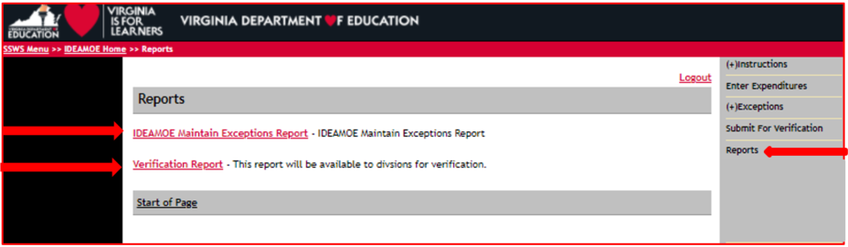

- Figure 14 illustrates the screen that will display after selecting the “Verification Report” option. Select the appropriate “School Year” from the drop down menu as illustrated below. Once the applicable school year is selected, the user should select the “View Report” button at the bottom of the screen.

Figure -14-
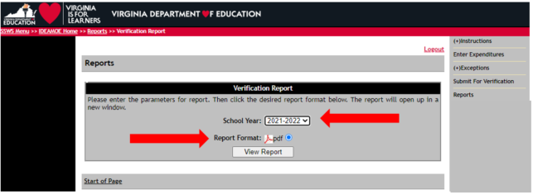

- Once the “View Report” button is selected, a pop-up window may prompt the user to save or open the file as illustrated in Figure 15. Click the “Open” option to display a PDF version of the verification report. If the pop-up window does not prompt the user but the report opens, this is not an issue. If the user is not using Internet Explorer as the browser, the pop-up may not appear.
Figure -15-
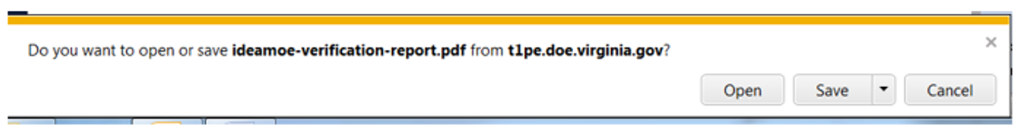

- Figure 16 illustrates the Verification Report when a division has met the IDEA MOE requirement using one or more of the tests available based on the subsequent years rule. This format includes language referencing the implementation of the final regulations and the division’s required level of effort for the next fiscal year. (Refer to Appendix B page 34, for another example).
Figure -16-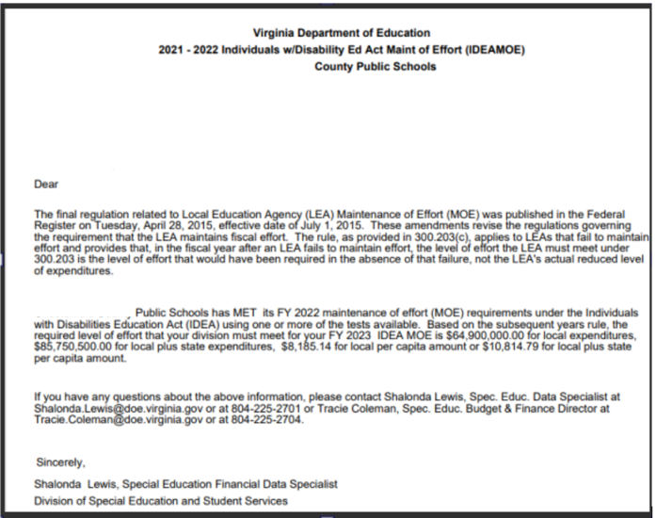

Figures 16.1 through 16.8 displays the screens the submitter and the Superintendent or Designee will see to certify the submission. (This is a new process for this application).

- Figure 16.1 illustrates the screen that will display after the submission has been “Approved,” by the VDOE and, an email notification has been received. The user must select “Submit for Verification.”

Figure -16.1-
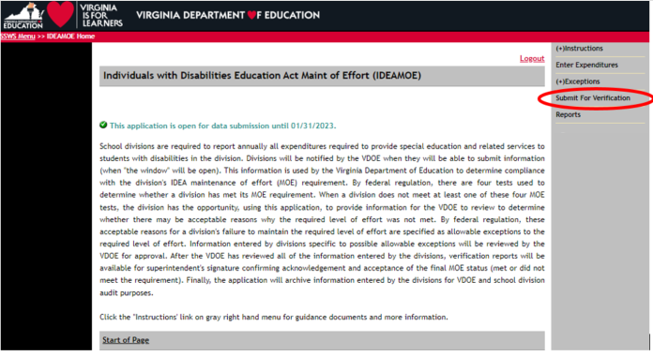

- Figure 16.2 illustrates the screen that will display after the “Submit for Verification” has been selected. The submitter will now select “Review IDEAMOE Verification Report.” The submitter will then have the option to select “Submit for Verification” or “Return for Resubmit.”

Figure -16.2-
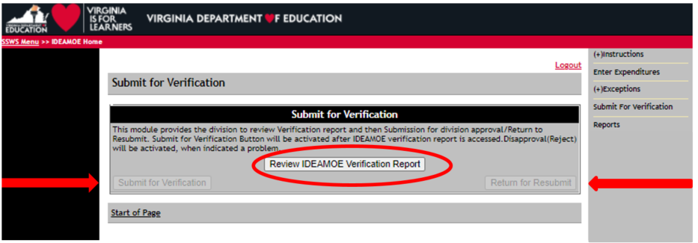

- Figure 16.3 displays the screen after the worksheet is submitted. Superintendents or Designees are required to sign the certification reports in electronic form using the Superintendent Data Collection Approvals (SDCA) Application (refer to Figure 16.4, page 14).
Figure -16.3-
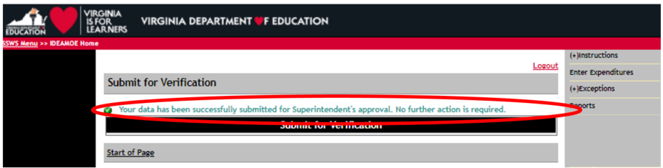
- Figure 16.4 illustrates the screen for SDCA after the Superintendent or Designee has successfully logged in to SSWS. A user’s ID and password are required to access the SDCA which can be obtained through the division’s local Administrator if the application is not available in the Superintendent’s or Designee’s menu.
Figure -16.4-
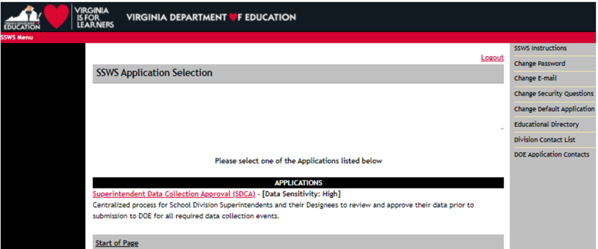

- Figure 16.5 displays the screen after the SDCA menu is clicked. The Superintendent or Designee must select the “IDEAMOE Verification Report” in the list of report names for approval to access the verification report.

Figure -16.5-
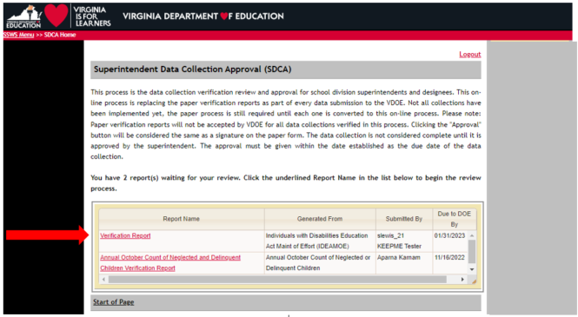
- Figure 16.6 displays the MOE Verification Report with two functions added, the “Approve” and “Disapprove” buttons. The Superintendent or Designee must choose one function after review of the submitted data to proceed to the next screen. If the “Approve” function is selected, the submission is completed and the collection window will close. If the “Disapprove” function is selected, the collection window is re-opened and resubmission is required. A data note is required for disapproved submissions.
Figure -16.6-
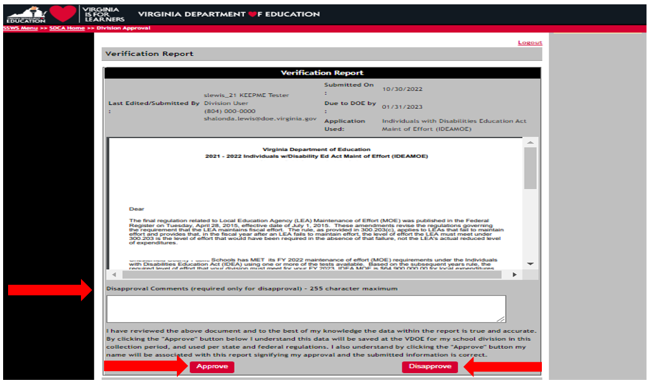
- Figure 16.7 displays the screen after the approve button is clicked. The approval of the verification report represents the Superintendent’s or Designee’s electronic signature and indicating accuracy and completeness of the submitted data. If a revision is needed after the approval is completed, or if the Superintendent did not electronically sign the verification report after the due date, the division must contact VDOE to re-open the collection window to complete submission.
Figure -16.7-

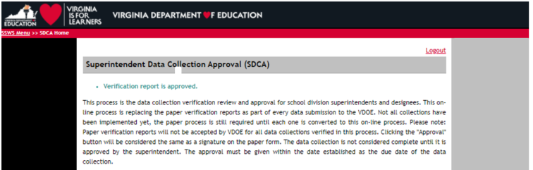

- Figure 16.8 displays the screen after the disapprove button is clicked. All disapproved submissions requires a data note in the comments box so the system can process the request. Once the disapproved submission is processed, the collection window will automatically re-open and edits are permitted. If the Superintendent did not electronically sign the verification report before the collection window close date, the division must contact VDOE to re-open the collection window and complete submission.
Figure -16.8-
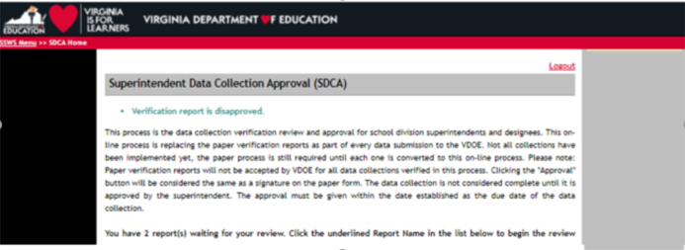

Figures 17.0 through 17.2 displays the various screens the users may see when the division did not meet any of the four IDEA MOE tests or when the division has met one, or less than four of the IDEA MOE tests.

- Figure 17.0 illustrates the screen that displays when a division has not met any of the four tests. The user will need to click the “Save and Next” button to navigate to the next available screen. The screen in Figure 18.0, on page 20 will then display. Do not attempt to click on the allowable exceptions (i.e., 300.204a – 300.204d) located on the right side of the screen. The user MUST click the “Save and Next” button first to avoid calculation errors.

Figure -17.0-
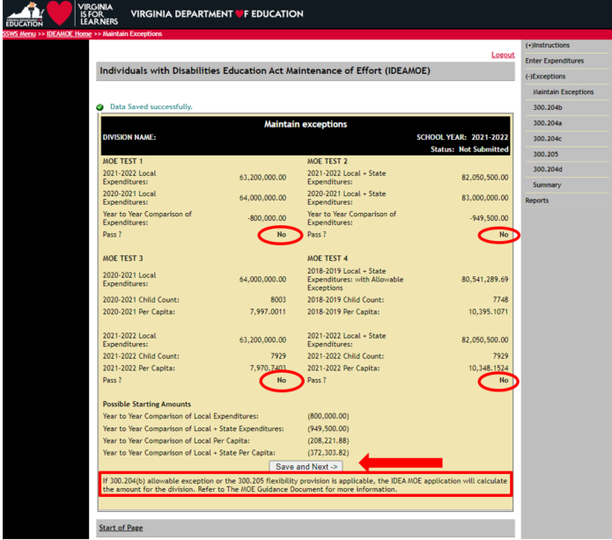

- Figure 17.1 displays when a division has met only one of the four tests available. The user will need to click the “Save and Next” button to navigate to the next available screen. The screen in Figure 18.1, on page 21 will then display. Refer to page 21 for further instructions.

Figure -17.1-

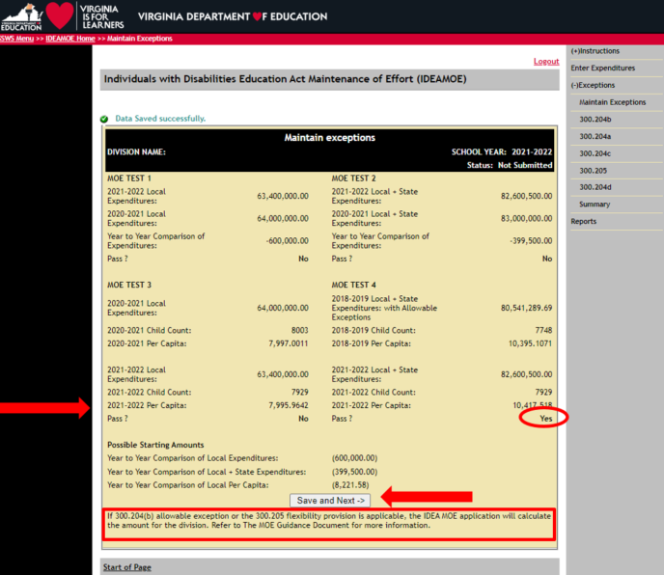

- Figure 17.2 displays when a division has met two of the four tests available. The user will need to click the “Save and Next” button to navigate to the next available screen. The screen in

Figure -17.2-
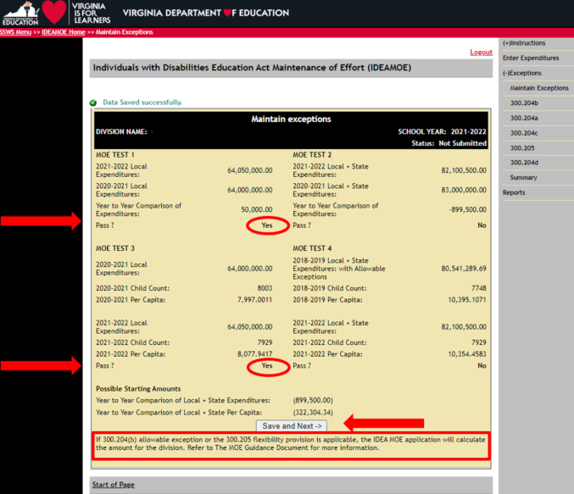

- Figure 18.2, page 22 will display after the user clicked the save and next button. Please refer to page 22 under Figure 18.2 for further instructions.

- Figures 18.0 through 18.2 reflects the different screen shots that may appear based on whether the division has met one, two, three, or four of the tests available; as previously illustrated in Figures 17.0 through 17.2.

- The number of options available will depend on the number of failed tests the division has after the initial determination (refer to Figures 17.0 through 17.2). “Option 1” indicates the local funds expenditure shortfall (i.e., Test 1); “Option 2” indicates the state plus local funds expenditure shortfall (i.e., Test 2); “Option 3” indicates the local per capita amount shortfall (i.e., Test 3) and “Option 4” indicates the state plus local per capita amount shortfall (i.e., Test 4).
- The user should refer to the applicable instructions and print screens based on the types of tests failed as illustrated in Figures 18.0 through 18.2. The user must first select one of the options available and must click the “Save and Next” button for the application to function correctly. Do not use the Allowable Exceptions menu on the right side of the screen as it will cause calculation errors.

Figure 18.0 illustrates an example of the screen that will appear when the division has failed all four tests and the §300.204(b) allowable exception is applicable (i.e., decrease in the enrollment of children with disabilities) for Options 3 and 4. This illustration shows the amount of the 300.204(b) reduction and the availability of four options based on the four failed tests. For illustration purposes, Option 3 has been selected. After a selection is made, click the “Save and Next” button to save the option selected and to proceed to the next screen.

Figure -18.0-
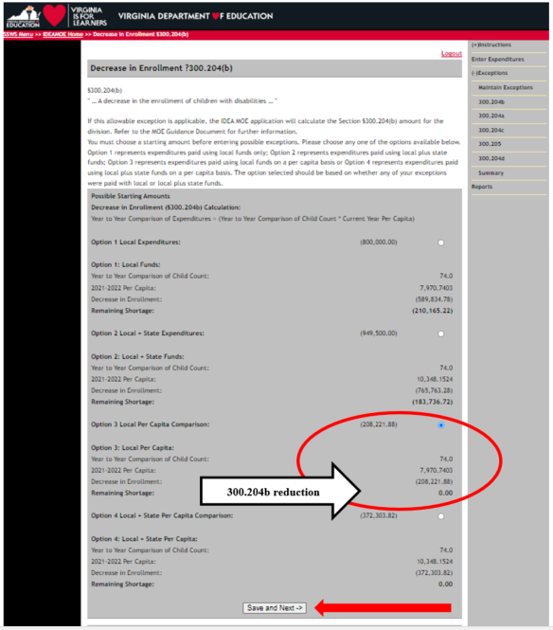
- Figure 18.1 illustrates the screen that will appear when the §300.204(b) allowable exception (i.e., decrease in enrollment) is not applicable and the division has passed one, but not all four tests. The user can select one of four options available:

  - Option 1 – No Allowable Exceptions; select this option when the division chooses not to use any of the allowable exceptions available. If this option is selected, user can proceed to the Summary section to submit the data. Note: Do not select this option if a decrease in enrollment (i.e., §300.204b) is applicable to the division since the reduction will not automatically reduce the shortfall.

  - If any of the following options below is selected, proceed to instructions starting on page 22: Option 2 – Failed Test 2, Local and State Expenditures; Option 3 – Failed Test 3, Local Per Capita; and Option 4 – Failed Test 4, Local and State Per Capita.

- After an option has been selected, click the “Save and Next” button to save the selections made and to proceed to the next screen.

Figure -18.1-

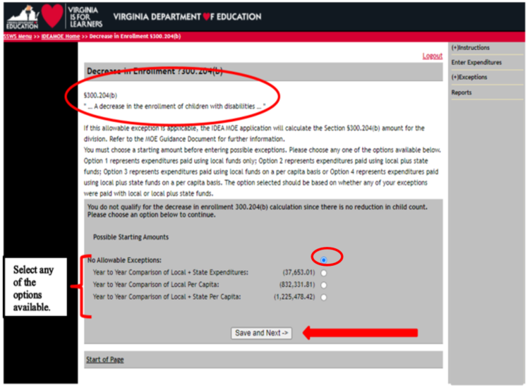

- Figure 18.2 displays when the §300.204(b) allowable exception is not applicable (i.e., decrease in enrollment) and the division passed two, but not all four tests. The user can select one of four options available.
  - Option 1 – No Allowable Exceptions; select this option when the division chooses not to use any of the allowable exceptions available. If this is selected, user can proceed to the Summary section to submit the data. Note: Do not select this option if a decrease in enrollment (i.e., §300.204b) is applicable to the division since the reduction will not automatically reduce the shortfall.
  - If Option 2, 3 or 4 is selected, proceed to instructions starting on page 23: Option 2 – Failed Test 2, Local plus state Expenditures; Option 3 – Failed Test 3, Local Per Capita; and Option 4 – Failed Test 4, Local and State Per Capita.

- After a selection is made, click the “Save and Next” button to save the option selected and to proceed to the next applicable allowable exceptions.

Figure -18.2-
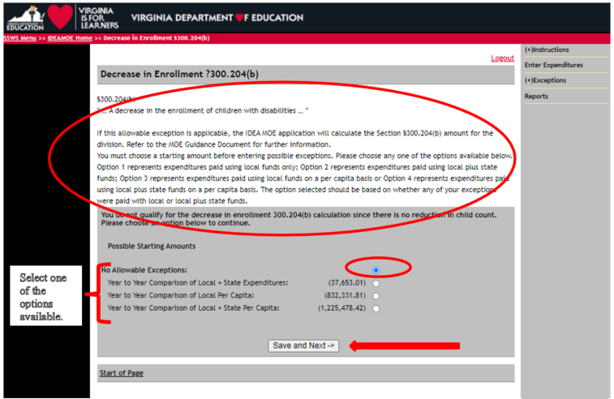
NOTE: The division user can change options prior to submission, but will need to click the “Save and Next” button to save the new option selected. Not clicking the “Save and Next” button will result in a calculation error. Once the data are submitted, option changes are not permitted. If the division user needs to make changes in the options available after it has been submitted, the user will need to contact VDOE to re-open the collection window prior to the due date.

- Figure 19 displays after the division user selects an option and the “Save and Next” button is clicked from the previous screen. The §300.204(a) allowable exception is used when the
school division has identified personnel that have left the school division’s employment through their own choice, over the course of the previous school year. Refer to Attachment A for guidance concerning each allowable exception.

- If the §300.204(a) is applicable for the division, click “Add New Personnel” to enter personnel expenditures. If it is not an applicable option, the user should click “Next” at the bottom of the screen to proceed to the next allowable exception (i.e., 300.204(c)).
Note: Should a calculation error occur (e.g., remaining shortage displays incorrectly), the user must go back to the “300.204(b)” screen and click the “Save and Next” button to update the calculation.
Figure -19-
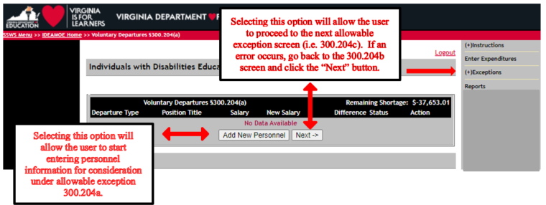

- Figure 20 displays after the user clicks the “Add New Personnel” button. The user must enter personnel information in all fields marked by an asterisk (*) for all voluntary departures. Refer to page 24 for instructions defining each of the fields below.

Figure -20-
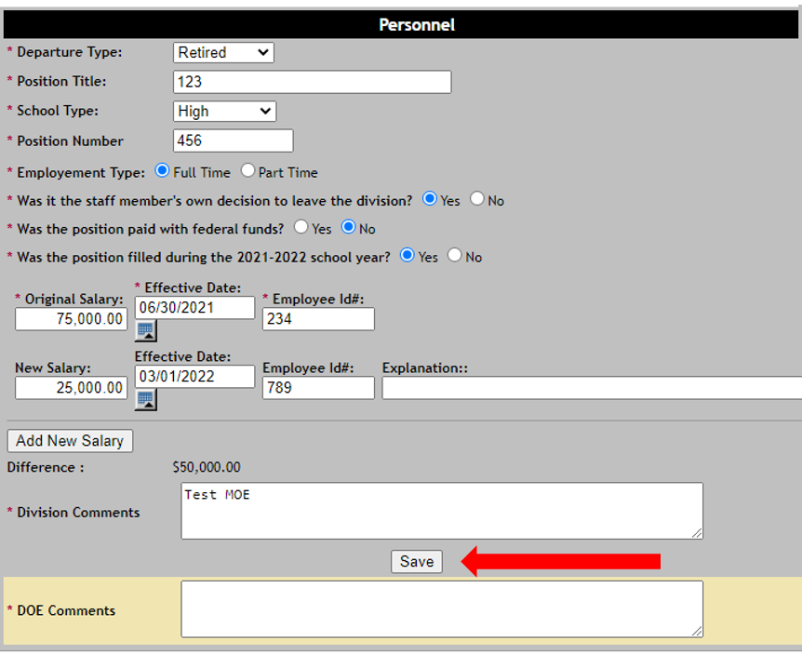
- The following information provides a brief explanation about the fields that will be populated or considered when the user is at the screen displayed in Figure 20.
  - Departure Type – Three options are available for the user to select; retired, resigned, moved/left. Note: The departure must be voluntary to qualify under this allowable exception.
  - Position Title – User will need to provide a title (i.e., teacher, paraprofessional, etc.).
  - School Type – Four options are available for the user to select; elementary, middle, secondary, combined.
  - Position Number – User should provide this information.
  - Employment Type – User should select the radio button next to the “Full-Time” option or “Part-Time” option.
  - Was it the staff member's own decision to leave the division? – User should select the radio button next to “Yes” or “No.” If “No” is selected, the division cannot use this position under allowable exception 300.204(a).
  - Was the position paid with federal funds? – User should select the radio button next to “Yes” or “No.” If “Yes” is selected, the division cannot use this position under allowable exception 300.204(a).
  - Was the position filled during the current school year? – User should select the radio button next to “Yes” or “No.”
  - If the staff member resigned or moved are they still working in the division? – User should select the radio button next to “Yes” or “No.”
  - Original Salary – User should provide the amount (salary and benefits) the employee was paid when the employee left the division or position.
  - Effective Date – User should provide the date the employee left the division or position. Note: The effective date field is validated to be within the school year range (i.e., between 7/01/21 and 6/30/22) to prevent data entry errors. If the date entered is not within the school year range, the system will prompt the user for the correct permissible dates. Divisions are not allowed to submit expenses paid in a prior year.
  - Employee ID# – User should provide a unique identifier for this employee. This number should not be the employee’s social security number.
  - New Salary – User should provide the amount (salary and benefits) the new employee received in payment during the reporting period. If a new employee was not hired, the cost of the substitute employee should be entered or a “0” if no costs were incurred for this position.
  - Effective Date – User should provide the date the new employee was hired or placed in the position. Note: The effective date field is validated to be within the school year range (i.e., between 7/01/21 and 6/30/22) to prevent data entry errors. If the date entered is not within the school year range, the system will prompt the user for the correct permissible dates.
  - Employee ID# – User should provide a unique identifier for new employee. This number should not be the employee’s social security number.
  - Explanation – This field is optional.
  - Add New Salary – The user will select this option to add additional employees that may have filled the same position during the school year (i.e., employee left, new employee hired and also left, and substitute was also hired for the remainder of the school year).

- Once the division user has completed entering information as outlined in Figure 20, the user should select the “Save” button.
  - To add additional positions due to multiple voluntary departures, select the “Add New Personnel” button. A new screen that is identical to Figure 20 will display.
  - If no additional positions will be entered, select the “Next” button to save the information entered and the summary screen as shown in Figure 21 will display.
  - If user determines the information is incorrect after saving the data entered, click the “View” button in the summary screen shown in Figure 21. The screen in Figure 20 will display and user can either click the “Delete” button to remove the information entered or revise the information entered then click the “Save” button.

- Figure 21 displays a summary of each personnel related item entered under allowable exception §300.204(a). This screen also displays the “Remaining Shortage” amount.
  - If the “Remaining Shortage” amount is a positive number, the application will not allow the user to submit the data and will need to adjust the allowable exceptions entered. If the positive amount is a result of the §300.205 adjustment, the user must contact VDOE to reduce the amount in order to submit.
  - If the “Remaining Shortage” amount is a negative number, the application will allow the user to submit the data but the negative amount will reflect in the verification report if §300.204(a) is the only allowable exceptions available. If there are additional allowable exceptions, click “Next” to proceed to the next allowable exceptions (i.e., §300.204(c)). If 300.204(c) is not applicable, click “Next” to proceed to the §300.205 adjustment. The §300.205 adjustment amount will automatically reduce the remaining shortage, if applicable. There are limitations and restrictions when using the §300.205 adjustment to reduce the expenditure shortfall. As such, further review and discussion will be required if the division decides to take this provision. Refer to the Figure 25, page 28 for additional guidance concerning this adjustment.
  - If the remaining shortage is ‘$0,’ no additional information is needed and the user can click the “Summary” option from the menu on the right side of the screen.

- Clicking the “Next” button saves the data entered and will also take the user to the next allowable exception available (i.e., 300.204c). If the “Remaining Shortage” shows a “$0,” and the user is ready to submit, click the “Summary” menu located on the right side of the screen. The summary page (refer to Figure 29, page 30) displays the division’s MOE status as meeting the MOE requirement after allowable exceptions, but pending approval.

Figure -21-

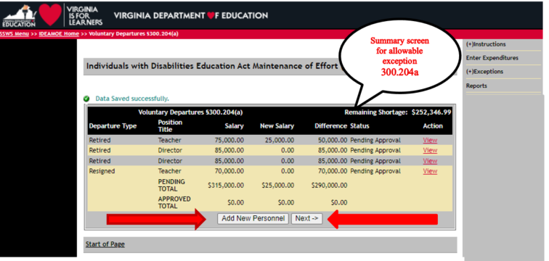
- Figure 22 displays the screen for allowable exception §300.204(c). This allowable exception is used when the school division has a termination of services to students. Refer to Attachment A for guidance concerning this allowable exception.

- If §300.204(c) is applicable, the user can click the “Add New Student” button to enter expenditures. Refer to Figure 23 for instructions for entering data. If not applicable, the user should select the “Next” button to proceed to the next allowable exception screen (i.e., 300.205).
Figure -22-
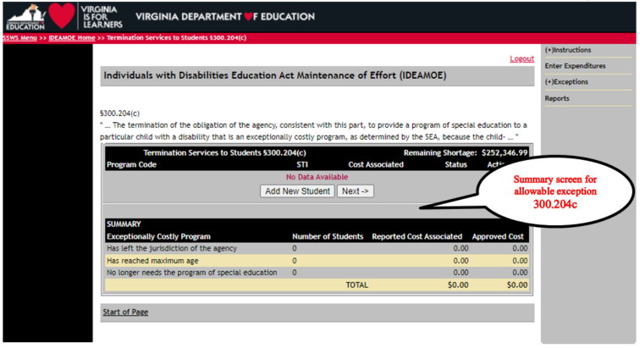

- Figure 23 displays when the “Add New Student” button is selected within the 300.204(c) screen. The user will need to enter data specific to the student or students that no longer requires a costly service or program. Information entered will include:
  - Program Code – The user will need to select the reason for the termination of services:
    - The student has left the jurisdiction or agency,
    - The student has reached the maximum age, or
    - The student no longer needs the program of special education.
  - State Testing ID – The ID number will represent the student’s state identification number.
  - Cost Associated – The amount will be the costs associated with providing this program or service during the previous school reporting year (2020-2021) that were not included as an expense during the current school reporting year (2021-2022). The cost can only be considered allowable if it is two to three times more than the average per pupil cost for the applicable school division.

- Once information is entered, the user will click the “Save” button to return to the 300.204(c) summary page (i.e., Figure 24).
Figure -23-

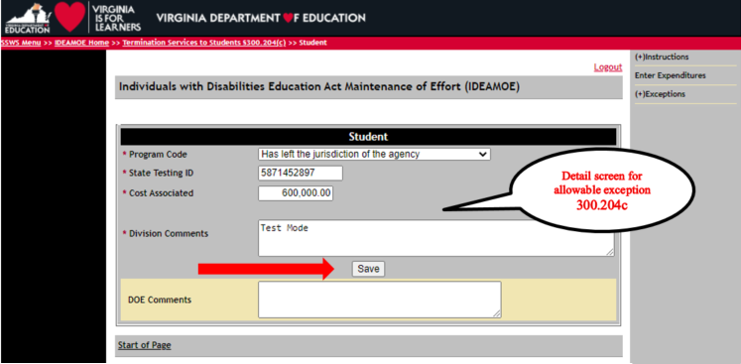
- Figure 24 displays the summary screen for §300.204(c) entries.
  - If the “Remaining Shortage” amount is a positive number, the application will not allow the user to submit the data and the user will need to adjust the allowable exceptions entered. If the positive amount is a result of the §300.205 adjustment, the user must contact VDOE to reduce the amount in order to submit.
  - If the “Remaining Shortage” amount is a negative number, the application will allow the user to submit the data but the negative amount will reflect in the verification report if §300.204(c) is the only allowable exceptions available. If there are additional allowable exceptions, click “Next” to proceed to the §300.205 adjustment. The §300.205 adjustment amount automatically reduced the remaining shortage, if applicable. There are limitations and restrictions when using the §300.205 adjustment to reduce the expenditure shortfall. As such, further review and discussion will be required if the division decides to take this provision. Refer to the Figure 25, page 28 for additional guidance concerning this adjustment.
  - If the remaining shortage is “0,” no additional information is needed and the user can click the “Next” button or the “Summary” option from the menu on the right side of the screen if the division user is ready to submit.

- Refer to the instructions in Figure 29, page 30 of this document if this is the last allowable exception to be entered and the remaining shortage shows either a “$0,” or a “negative amount.” Click the “Next” button to proceed to the next allowable exception screen (i.e., 300.205) or the “Summary” option (refer to Figure 29, page 30) if user is ready to submit.

Figure -24-

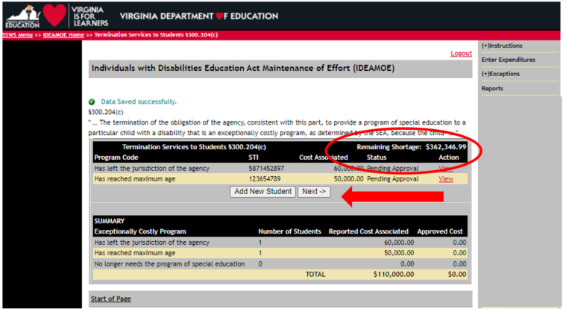

- Figure 25 displays the MOE flexibility provision §300.205 – adjustment to local fiscal efforts in certain fiscal years. The screen will show the auto-generated current year (i.e., SFY 2021-2022 which may also include additional American Rescue Plan Act funding) and previous year (i.e., SFY 2020-2021) 611 flow-through grant award amount and the auto-calculated maximum amount for MOE reduction if applicable (50 percent of excess allocation). For divisions required to set-aside 15 percent of its part B federal allocation for Coordinated Early Intervening Services (CEIS), this exception is not allowed. For divisions choosing to voluntarily set-aside its part B federal funds for CEIS, the set-aside amount may be reduced by the amount of the CEIS reduction taken.

- This provision is only applicable to divisions that receive the “Meets Requirements” on its annual determination. For divisions choosing to use this provision, the division Must spend an amount of local funds equal to the reduction taken for activities that could be supported with Every Student Succeeds Act of 2015 (ESSA) funds regardless of whether the division is using funds under the ESSA for those activities. The freed up funds must also be spent to supplement and not supplant for these activities in the year the adjustment is taken. Note: Divisions taking advantage of this provision is included in the MOE/CEIS Report to the U.S. Department of Education’s Office of Special Education Programs (OSEP) for inclusion in its report to the U.S. Congress. As such, documentations for these specific activities may be requested and must be retained by the division for audit and monitoring purposes.

- This section does not require entries from users since all the information are pre-populated and auto calculated. Further review and discussion with VDOE would be required if this option is chosen. Click the “Next” button to proceed to the next screen.

Figure -25-

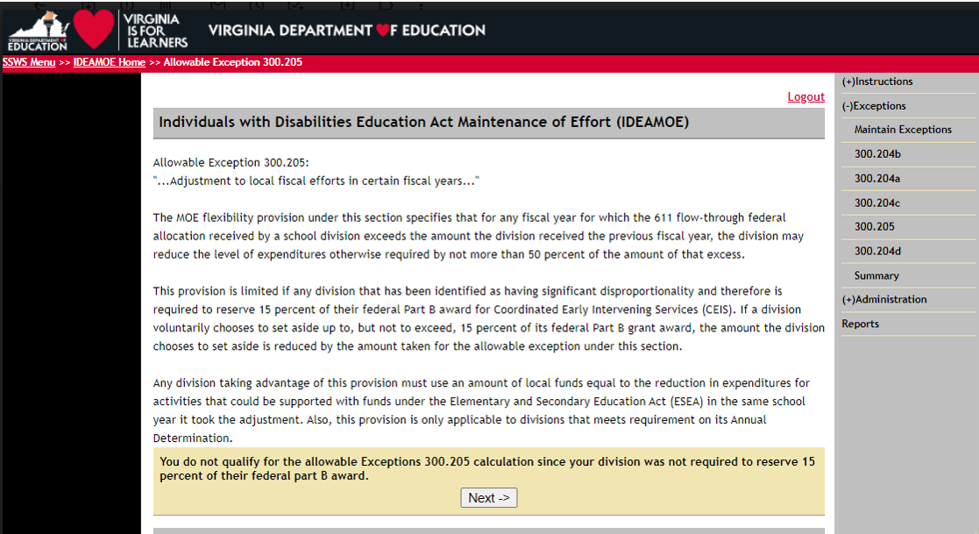
- Figure 26 displays the summary screen for §300.204(d), the termination of costly expenditures. If this is an applicable exception for the division, click “Add New Program” (Refer to Figure 27) to enter expenditures; otherwise click “Next” for the Summary screen (Refer to Figure 29, page 30).
Figure -26-
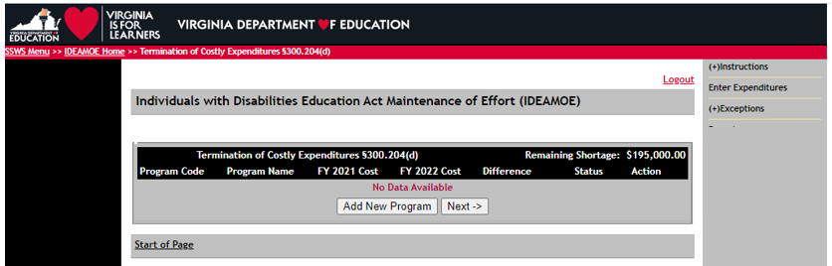

- Figure 27 illustrates the detail screen for §300.204(d). The user must first select the reason for the termination of such costs under the “Program Type” by selecting the drop down box. After selecting the program type, enter all the required information as marked by an asterisk (*) and make sure that the box is checked. If user needs to attach a file, make sure that the file is in a PDF format and the file name cannot exceed 30 characters; otherwise it will not be uploaded. Click the “Save” button when finished. Click the “Add New Program” for each additional entry (Refer to Figure 28); otherwise click “Next” for the Summary screen (Refer to Figure 29, page 30).
Figure -27-
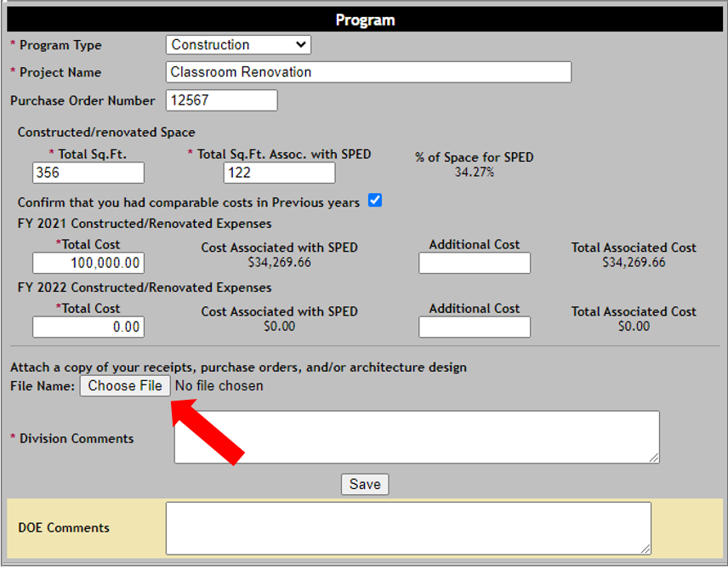

- Figure 28 illustrates the summary screen for §300.204(d) and shows the remaining shortage field as “0.” The division user can either click the “Next” button to proceed to the next screen or select the “Summary” option located on the right side of the screen. If the remaining shortage is a positive number, the application will not allow the user to submit the data and the user will need to adjust the allowable exceptions entered, or to contact VDOE to reduce the amount if the division used the §300.205 adjustment in order to submit. The user can choose to submit with a negative remaining shortage after all allowable exceptions under §§300.204 and 300.205 have been entered and the final determination is either a “Meet” or “Did Not Meet” status. Please refer to Attachment A for additional guidance.
Figure -28-
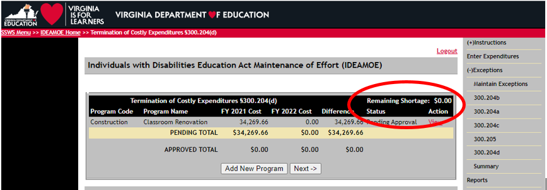

- Figure 29 displays an example of the screen for the MOE four tests and the summary of the allowable exceptions entered. The illustration shows that the division meets MOE pending VDOE approval. The difference between the starting amount and the allowable exceptions entered should show either a “0” or a “negative amount” in order to submit. If the difference is a positive amount, the user will need to adjust the allowable exceptions entered to adjust amounts prior to submission. If the division user is ready to submit, click the “Submit to DOE” button. If the division user is not ready to submit, do not click submit. Once the data are submitted, the application window closes and the division cannot make changes. If revisions are needed, the user will need to contact the VDOE to re-open the collection window.

Note: The submitted information is subject for review and additional information may be required as needed. As such, it is recommended that division users verify the accuracy of the information entered and to ensure supporting documents are kept on file for audit purposes.

Figure -29-

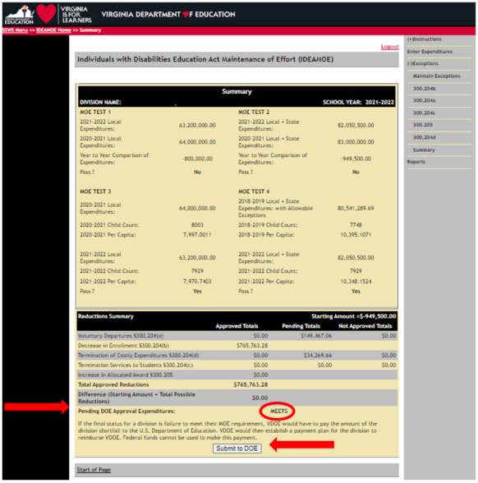
- Figure 30 illustrates the screen when the user selects the “Submit to DOE” button.

Figure -30-

- Figure 31 displays the screen when the division user clicks the “OK” button from the menu above. Once submitted, the collection window closes and the division user cannot make changes. However, the division user can view the information submitted. Note: The web message in green only refers to the users’ verification of data entered after submission and should not be interpreted as being completed. All data submitted are subject for review and approval by the VDOE.

Figure 31

- To assist with the data verification, the user will receive an email to ask the user to verify the accuracy of data and to provide reasons why the IDEA MOE expenses reported agree with or do not agree with expenditures reported under the Annual School Financial Verification Report (ASRFin).

- The division user will receive an email notification when the IDEA MOE information submitted has been “Approved” by the VDOE or a notification stating “Revisions Required.”

- Once an email has been received, return to page 13 and follow the instructions starting under Figure 16.1.

APPENDIX A

Maintain Exceptions Report

Example

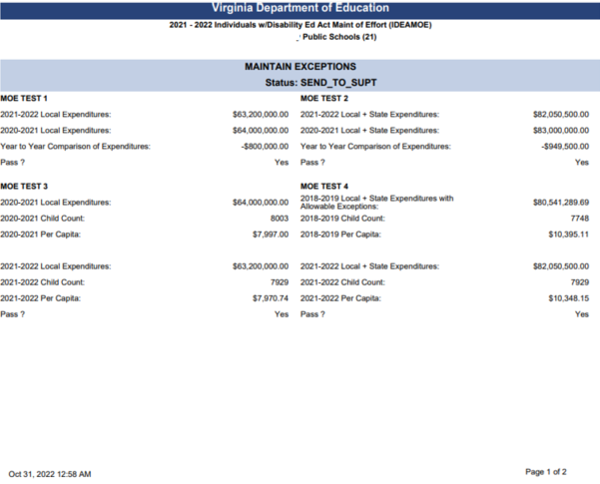
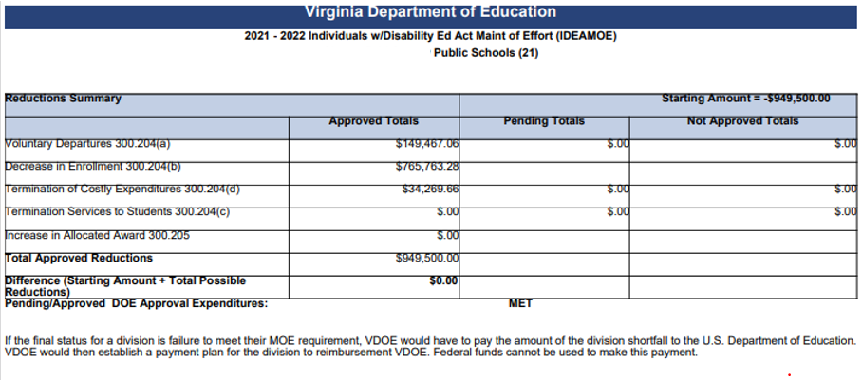

APPENDIX B

Verification Report

Example

