2023 Virginia School Survey of Climate & Working Conditions

Survey Administration Instructions




2023 Virginia School Survey of Climate and Working Conditions
Table of Contents
Overview of the Survey 3
Instructions for the Student Administration 6
Template for the Parent/Guardian Information Letter 7
Student Survey Administration Manual 8
Instructions for the Classroom Instructors and Staff Administration 12
Template for the Classroom Instructors and Staff Information Letter 13
Frequently Asked Questions 14

Overview of the Survey
The Virginia School Survey of Climate and Working Conditions (Virginia School Survey) is being conducted through a partnership between the Virginia Center for School and Campus Safety at the Virginia Department of Criminal Justice Services and the Virginia Department of Education. Participating in this survey fulfills one component of your school’s safety audit requirements. This survey assesses school safety conditions and student safety concerns, and also meets the requirements to measure the working conditions of all licensed personnel in schools.
This instruction packet provides more detail on the three-step process for administering the 2023 Virginia School Survey and summarized in Figure 1.
STEP 1
STEP 3

Provide information to classroom instructors, staff, parents, and guardians.
- Use the information letter templates provided here to notify classroom instructors, staff, parents, and guardians about the survey at least 30 days prior to the start of your selected administration window.
- Communicate the value of the survey and encourage classroom instructors, staff, and students to participate.
Administer the online Virginia School Survey of Climate and Working Conditions to classroom instructors, staff, and students.
- Provide Administration Manuals to those administering the survey to students.
- Provide classroom instructors, staff, and students with the access codes for accessing the survey. Access codes will be emailed directly to the school point-of-contact.
- The goal is an 80% response rate per survey group. Send periodic reminders during the administration period encouraging your classroom instructors and staff to complete the survey.
Look for emails with information on how to access the results from your school.
Reports will be distributed to divisions in May, if your school met the required response rate thresholds.

STEP 2

Figure 1. Survey administration process for the 2023 Virginia School Survey
In 2023, students in grades 6th, 7th, and 8th will take the Virginia School Survey. Licensed classroom instructors and any other individual holding a state professional license (such as those with a Collegiate Professional License, Postgraduate License, Provisional License, or Pupil Personnel Services License) in schools serving Pre-K through 8th grade, regardless of grades served, must also be invited to take the survey. You also may invite other non-licensed staff members to complete the survey. All 6th through 8th grade students should be provided an opportunity to complete the survey, so that your school will have information about the school’s climate from as many students as possible. When reasonable accommodations are needed for students to take the survey, they should be provided. A read-aloud administration manual can be found on the DCJS and VDOE websites. Students have the option to take the survey in English or Spanish, so students identified as having Limited English Proficiency but who speak Spanish should not be excluded from taking the survey. Please work with personnel in your school or division if you wish to administer the survey in a language other than English or Spanish.
All surveys will be completed online through a secure website and can be completed while in the school building or at home with any internet-connected device (e.g., computer, cell phone, tablet, etc.). You will provide each student, classroom instructor, and staff member with a school-specific access code to begin the survey. The access codes will be emailed to the school point-of-contact one week prior to your window opening as well as on the day your window opens. Please note that there are separate access codes for students and the adults in your school. The access codes do not identify individuals but will identify the school. We expect the student survey for grades 6 through 8 will require 25-30 minutes to complete; and the classroom instructors and staff surveys will require 20-25 minutes to complete.
Parents or guardians may decline permission for their student to complete the survey. Provide all parents and guardians of students in grades 6 through 8 with the information contained in the letter template found on page 7, informing them that their child will be asked to participate in the survey. A Spanish version of the template can be found on the DCJS and VDOE websites. Due to the inclusion of student mental health-related questions, schools are required, at a minimum, to notify parents or guardians of this survey at least 30 days in advance of the administration and provide a process for opting their students out of the survey. This notification is required by the Code of Virginia §22.1-79.3. Please also include your school or division’s standard opt out procedure in the informational letter, so that parents have the opportunity to exempt their child from participating in the survey. Students may decline to take the survey once offered at the school.
Students should take the survey in a quiet space. It is important for a classroom instructor or staff member to monitor students while they are taking the survey to ensure students do not confer with one another and to answer any questions that may arise. The adult administering the survey to students should review the Student Survey Administration Manual found on page 8, which describes the survey process, prior to providing students the link and access code for the survey.
Prior to survey administration, provide classroom instructors and staff members the information found in the letter template on page 13, which invites them to participate in the survey. When your survey window opens, provide classroom instructors and staff the survey link and your school’s adult version of the access code. Classroom instructors and staff members can take the survey in a small group setting or individually but should be advised not to confer with one another. Send reminders to your classroom instructors and staff members about the survey throughout the survey window to encourage participation. Classroom instructors and staff may also decline to take the survey.
The higher your school’s response rate, the more likely the results of the survey will reflect the opinions of all students, classroom instructors, and staff in your school. An 80% response rate is the goal for each group participating. Item Level Snapshots and School Survey Summary Reports will not be generated for survey groups with response rates less than 50% and fewer than 10 respondents. Your division and school point-of-contact will have access to real-time response rates for your school.
Each school will receive an Item Level Snapshot and a Measure Level Report, if their response rates meet the indicated threshold. The Item Level Snapshot provides item-level responses aggregated across all individuals (e.g., the percent selecting “Strongly Disagree”, the percent selecting “Disagree”, etc.). These will be available in May, provided the school achieved a response rate of at least 50% per survey group and the number of responses is 10 or greater. Additionally in May, each school meeting that same response rate threshold per survey group will receive a Measure Level Report that presents the school’s scores on the surveys’ measures of climate and working conditions. The Report will facilitate comparisons to other schools in the division, region, and state. Your division point-of-contact will need to download these reports and share them with you.

Instructions for the Student Administration

- Provide information to the parents and guardians of each student in grades 6-8 informing them that students in their child’s grade are participating in the survey. We recommend you use the Template for the Parent/Guardian Information Letter provided on page 7 (Spanish version can be found on the DCJS and VDOE websites). Please ensure that parents or guardians have been notified at least 30 days in advance of your planned administration time frame. They also must be provided instructions for opting their students out of the survey following your division opt-out protocol.

- Aim for a successful completion of the Virginia School Survey with at least 80% of students completing the survey. All students should be given equal opportunity to participate in the survey. Provide reasonable accommodations as needed for students to take the survey. Students should not be excluded on any systematic basis, such as excluding those students with low grades or disciplinary issues.

- Provide the Student Administration Manual, located on page 8 of this document, to all individuals administering the survey to students. A read-aloud administration manual can be found on the DCJS and VDOE websites.

- Provide the link and your school’s access code to all 6th through 8th grade students once your window has opened.

- Questions or concerns regarding the Virginia School Survey of Climate and Working Conditions should be directed to Dr. Nikki Wilcox at vaschoolsurvey@dcjs.virginia.gov or (804) 786-3923. You may also contact Dr. Jess Marcon Zabecki at research@doe.virginia.gov or (804) 225-2963.

Template for the Parent/Guardian Information Letter
Principals/Points-of-contact: Provide the information below to the parents and guardians of all students at your school in grades 6 through 8, at least 30 days prior to the survey administration. When you prepare these letters, be sure to specify the date and process by which parents and guardians may decline to have their child participate, if they choose to opt their child out of the survey.

Dear Parent or Guardian,
Our school, in cooperation with the Virginia Department of Criminal Justice Services and the Virginia Department of Education, is conducting the Virginia School Survey of Climate and Working Conditions. We will survey students in grades 6,7, and 8, classroom instructors and staff, beginning in winter 2023. The purpose of this survey is to measure student support, student engagement, school discipline, and safety conditions in each school. This information will be used to guide educational practices that produce a safe and supportive school environment.
I am writing to provide you with information on the student survey. The survey will be completed online between DATE and DATE. The survey does not ask for your child’s name and all answers are anonymous. No one, including teachers or administrators, will know how your child answered the survey. You will not have access to your child’s survey answers even as their parent or guardian. You may review the questions asked in the student survey at this website: https://tinyurl.com/VaSchoolSurvey.
The survey will ask questions such as how students feel about their school, how students get along with one another and their teachers, how students feel about school rules, and their perceptions of their teachers’ willingness to help them. Students will also be asked what kinds of bullying they may have observed during school and whether they have been bullied themselves.
All students in your child’s grade level are eligible to participate in the survey. Students participating in remote instruction and in-person instruction are both eligible to participate. The survey is voluntary and your child can decide not to participate. No action will be taken against you, your child, or the school if your child does not participate. If you do not wish for your child to participate, please notify the school office by telephone or letter by DATE.
Your child will not receive any immediate benefit from participating in the survey, but the survey will help us to maintain a safe, inviting, and supportive learning environment for your child.
Thank you for your cooperation in this important study of Virginia’s schools.
{Signed by principal}

Student Survey Administration Manual
Principals/Points-of-contact: Provide this manual to all individuals administering the survey to students. A read-aloud administration manual can be found on the DCJS and VDOE websites.

Thank you for assisting in the administration of the Virginia School Survey of Climate and Working Conditions to your students. It is intended to give schools information that can help maintain a safe, inviting, and supportive learning environment.
The administration of the survey is important to engaging students and obtaining valid results. Please communicate to students that this survey is an effort to include their views and opinions to improve their school.
What is the procedure for students to complete the survey? The survey should be administered in a quiet space where students can be monitored – remotely or in person.
In-person: The survey should be administered in a quiet space where students can be monitored and have access to an individual computer or device. The staff member administering the survey should encourage students to complete the survey honestly and to the best of their ability, also inform students that they should not discuss or talk with one another while taking the survey. The staff member should inform the students the survey takes 25-30 minutes to complete.
Remotely: Students taking the survey remotely are encouraged to find a quiet space where they can complete the survey free from distractions and have access to an individual computer or device. The staff member administering the survey should encourage students to complete the survey honestly and to the best of their ability, also inform students that they should not discuss or talk with one another while taking the survey. The staff member should inform the students the survey takes 25-30 minutes to complete.
How do I administer the survey with a read-aloud accommodation? A read-aloud administration manual can be DCJS and VDOE websites.
How do I prepare for and administer the survey? We recommend that you prepare the information that students need ahead of time, including the survey link, the school’s access code for students, and the school and division information.
Your school’s survey link and access code will be emailed to the school point-of-contact one week prior to the survey window opening. Please note that this access code must end in an “S”. If your code does not have this marker, please contact your DCJS or VDOE point of contact. Students must enter this access code to complete the survey. All students in your school will use the same access code. Students will be asked to confirm the name of their school and division, to verify their responses are collected correctly.
Be sure to review the following instructions with all students. These instructions also appear on the welcome page of the survey. Below the text in bold and italics is the narrative you should read aloud as students begin the survey.

SAY: “You may take the survey in English or Spanish. Select English or Spanish from the menu displayed on your screen. The chosen language will be displayed for the entirety of the survey and cannot be changed.”
Students should see the following screen.
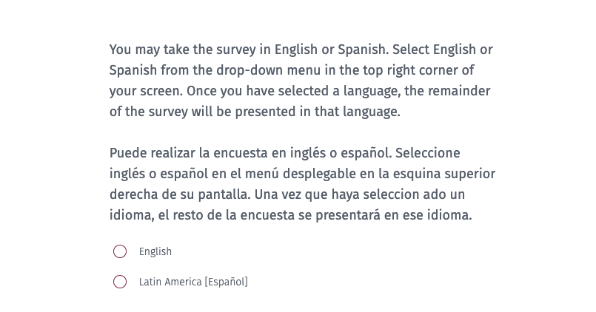

SAY: “Take a moment to read the information on the screen. Once you finished reading, please select the maroon box in the bottom left corner (or continue scrolling) to move forward.”
Students should see the following screen.

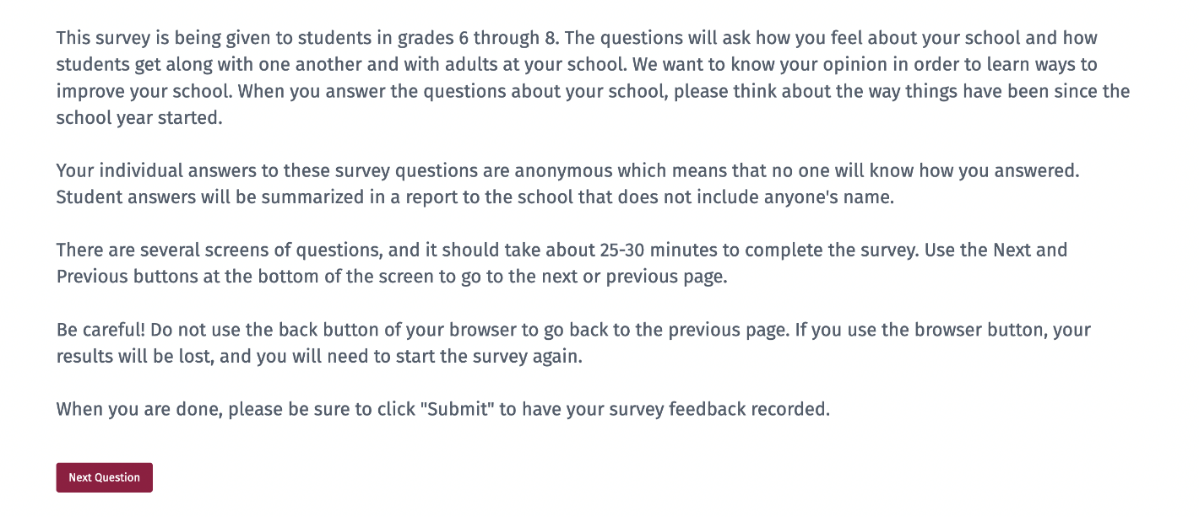

SAY: “The access code is _ _ _ _ _S then select the maroon box that says Next.”
Please write the access code given to you somewhere the students can easily see it. Students should see the following screen.
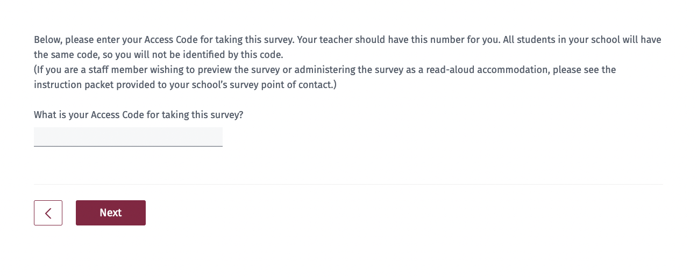
SAY: “You should see our division and school name. If the division and school name are not correct, please raise your hand.” (pause) “If this information is correct, please select ‘Yes’ from the menu displayed and then select ‘Next’ to begin the survey. Remember to answer each question to the best of your ability.”
If the division and/or school name are not correct, have the student select ‘No,’ and assist them with selecting the correct information.

What kind of help can I give to students in taking the survey? You are free to help students who do not understand survey instructions or who need clarification of a term or phrase used in the survey. Encourage students to express their own views and to answer all of the questions. If students attempt to skip a question, the survey will not permit them to continue to the next page. They will remain on the same page until they have answered each question, students should be instructed to answer to their best ability.
Is the survey the same for all students? Almost all of the questions are the same for all students in the same grade. In a few cases, a student who answers one question in a certain way will be asked a follow-up question that will not be asked if a student gives a different answer.
What if students ask about the race and ethnicity questions? Following standard practice, there is a question asking students whether they are of Hispanic or Latino ethnic background (Hispanic and Latino are intended to be interchangeable terms). Some students are unfamiliar with this distinction and may be concerned that there is a separate question about being Hispanic. It is appropriate to explain to students that these questions are following federal guidelines to recognize that people of different races can be Hispanic. Subsequently, they will be asked a question that allows them to report their race.
What if students ask about the gender question? The question that asks students to report their gender provides students with more flexibility in their response to this question. Encourage the students to select the option that best describes their gender.

Questions or concerns regarding the Virginia School Survey of Climate and Working Conditions should be directed to Dr. Nikki Wilcox at vaschoolsurvey@dcjs.virginia.gov or (804) 786-3923. You may also contact Dr. Jess Marcon Zabecki at research@doe.virginia.gov or (804) 225-2963.

Instructions for the Classroom Instructors and Staff Administration

- You must invite all licensed classroom instructors to complete the survey as well as any other individuals holding a state professional license, such as those with a Collegiate Professional License, Postgraduate Professional License, Provisional License, or Pupil Personnel Services License. You may also invite other non-licensed staff members to complete the survey. Inviting all personnel will provide you with the most accurate picture of your school’s climate and working conditions. Use the Template for the Classroom Instructors and Staff Information Letter on page 13 to inform staff of the upcoming survey. We recommend you do so at least two weeks prior to your administration window and share with your employees the reasons why completing the survey benefits your school.

- During your school’s survey administration window, send regular reminders to your classroom instructors and staff members asking them to please consider completing the survey if they have not done so already. Be sure to include in these reminders the survey link and the access code they need to complete the survey. The survey code for employees should end in an “A”. If it does not, please contact your DCJS or VDOE point of contact. We recommend dedicating time for classroom instructors and staff members to take the survey, such as the beginning of a staff meeting, but please consider your building’s bandwidth capabilities.

- Questions or concerns regarding the Virginia School Survey of Climate and Working Conditions should be directed to Dr. Nikki Wilcox at vaschoolsurvey@dcjs.virginia.gov or (804) 786-3923. You may also contact Dr. Jess Marcon Zabecki at research@doe.virginia.gov or (804) 225-2963.

Template for the Classroom Instructors and Staff Information Letter
Principals/Points-of-contact: Please provide the following information to all licensed classroom instructors as well as any other individuals holding a state professional license, such as those with a Collegiate Professional License, Postgraduate Professional License, or Pupil Personnel Services License. You may send it to other non-licensed staff members, if you wish for them to complete the survey. Be sure to specify the survey window dates. Please remind your classroom instructors and staff members periodically about the survey to encourage a high response rate.

Dear ,
Our school, in cooperation with the Virginia Department of Criminal Justice Services and Virginia Department of Education, is conducting the Virginia School Survey of Climate and Working Conditions. We will survey INSERT WHOM YOU WILL BE SURVEYING [students in grades 6, 7, and 8, classroom instructors, and staff], beginning in winter 2023. The purpose of the survey is to measure school-level working conditions and climate; which have shown to impact classroom instructor and staff retention as well as student educational outcomes.
All classroom instructors and staff members are asked to participate in the Virginia School Survey. The survey can be completed on any internet-connected device (e.g., computer, cell phone, tablet, etc.) between DATE and DATE.
The survey asks questions about staff collegiality, work environment, teaching and instruction, student supports, professional development, relationships with students and their families, teacher agency, school leadership, well-being and burnout, and safety. Classroom instructors and staff members will not give their names on the survey and all answers are anonymous. While you will be asked to identify your role in the school, your data will not be reported by role within your school or division results.
Participants will not receive any immediate benefit from completing the survey, but the survey will help us ensure all students, classroom instructors, and staff have access to a safe, healthy and positive environment in which to learn, work, interact, and grow.
Thank you for your cooperation in this important study of Virginia’s schools.

{Signed by principal}

Frequently Asked Questions
1. Who should complete the Virginia School Survey? In 2023, all students in grades 6 through 8 as well as licensed classroom instructors and any other individual holding a state professional license (such as those with a Collegiate Professional License, Postgraduate License, Provisional License, or Pupil Personnel Services License) in schools serving Pre-K through 8th grade, regardless of grades served, must be invited to take the survey. You may also invite other non-licensed staff members to complete the survey. Non-licensed staff members contribute to and experience their school climate and working conditions and it may benefit your school to include and understand their perspectives.
2. How will the survey be administered? All surveys will be completed online through a secure website. You will provide each student, classroom instructor, and staff member with a school-specific access code to begin the survey. The access codes will be emailed to the school point-of-contact one week prior to your window opening as well as on the day your window opens. The access codes do not identify individuals but will identify the school.
3. How long will the survey take? We expect the student survey for grades 6 through 8 will require 25-30 minutes to complete and the classroom instructors and staff surveys will require 20-25 minutes to complete.
4. How did you come up with this survey and why is it that long? Survey questions are based largely on nationally recognized measures of school climate and working conditions. The topics were primarily selected to meet the requirements set forth in the Code of Virginia and in legislation. The Virginia School Survey Team selected well-established survey items that are valid and reliable based on existing research–that is the questions accurately measure what we expect them to measure consistently over time. Additionally, we analyze the data after each administration to ensure the questions continue to be relevant and meet these best practices each year. We chose the best number of questions that represent a key measure, like relationships among students or teacher agency. According to survey best practices, there should be, at minimum, three questions to represent a measure. Ensuring the integrity of our survey practices is critical to providing the most accurate and informative data to schools, school divisions, and leaders in the Commonwealth.
5. How do I contact students and parents/guardians about the survey? Provide all parents and guardians of students in grades 6 through 8 with the information contained in the letter template found on page 7, informing them that their child will be asked to participate in the survey. Please ensure that parents or guardians have been notified of the survey at least 30 days in advance of your planned administration time frame. This notification should also include instructions to parents for opting their students out of the survey following your division’s opt-out procedures. A Spanish version of the template can be found on the DCJS and VDOE websites.
6. How do I contact classroom instructors and staff members to invite their participation? Give classroom instructors and staff members the information found in the letter template provided on page 13. This letter invites them to participate in the survey. Also, consider sharing the reasons why this survey is important to your school and its leadership.
7. How do students, staff and classroom instructors access the survey? You will provide each student, classroom instructor, and staff member with the link to the survey as well as a school-specific access code to begin the survey. The link and access codes for your school will be provided via email to the school point-of-contact. Do not use an access code for a different school. The access code for students should end with an “S” while the access code for adults should end with an “A”. If you do not have the proper access codes, please contact your DCJS or VDOE point of contact. The adult administering the survey to students should utilize the Student Survey Administration Manual found on page 8.
8. What if a student is absent on the day the survey is administered? Students who are absent can take the survey if they return to school before the survey window closes. Providing an additional opportunity for absent students to take the survey is encouraged so that your school’s survey results reflect the experiences of as many students as possible.
9. What can I do to encourage classroom instructors and staff members to respond to the survey? The greater the response rate among classroom instructors and staff members at your school, the more complete your results will be. Communicate the value of survey results to classroom instructors and staff. Also, dedicate time for classroom instructors and staff members to take the survey during the workday, such as at the beginning of a staff meeting. It is essential, throughout your school’s survey window, to regularly remind and encourage your classroom instructors and staff members to complete the survey so that you can achieve a high response rate.
10. What response rate should I achieve on the Student, Classroom Instructors, and Staff surveys? An 80% response rate is the goal for each group participating (students, classroom instructors and staff). Item Level Snapshots and Measure Level Reports will not be generated for survey groups with response rates less than 50% and fewer than 10 respondents. Your division and school point-of-contact will have access to real-time response rates for your school.
11. What results will I receive? Each school will receive an Item Level Snapshot and a Measure Level Report, if their response rates meet the indicated threshold. The Item Level Snapshot provides item-level responses aggregated across all individuals (e.g., the percent selecting “Strongly Disagree”, the percent selecting “Disagree”, etc.). Measure Level Report that presents the school’s scores on the surveys’ measures of climate and working conditions.
12. When will I receive the results of the survey? In May, each school meeting a response rate of at least 50% per survey group and the number of responses is 10 or greater will receive an Item Level Snapshot and a Measure Level Report. These reports will be made available to divisions for download and distribution to schools.
13. How will I receive the results of the survey? Your division point-of-contact will need to download these reports and share them with you.
14. What if I have other questions? Questions or concerns regarding the Virginia School Survey of Climate and Working Conditions should be directed to Dr. Nikki Wilcox at vaschoolsurvey@dcjs.virginia.gov or (804) 786-3923. You may also contact Dr. Jess Marcon Zabecki at research@doe.virginia.gov or (804) 225-2963.

