Considerations for Reporting
Service Time and Regular Class Percent

Primary Considerations
Special education funding, eligibility for intensive support services claims, and State Performance Plan/Annual Performance Report (SPP/APR) data submissions are impacted by the reporting of services and regular class percent of day. It is important to note that, as always, the validity of December 1 Child Count data collection is of the utmost importance to ensure accurate state and federal required reporting. The data submission will also have an impact on data used for re-benchmarking at the state level. The submission of data should reflect the content of the Individualized Education Program (IEP) that will be in effect on the date of the collection (December 1). The Virginia Department of Education (VDOE) provides information to assist local educational agencies (LEAs) with calculating and reporting this data based on traditional face-to-face educational environments. Resources include:
- Overview of Placement and Services
- Calculating Placement & Regular Class Percent
- Calculation Tool for Least Restrictive Environment (LRE)

Calculating Services
The Service calculation is required for all students ages 0-21. In order to accurately calculate services, both the amount of special education and length of instructional week must be calculated for each student.
- School divisions should calculate Length of Instructional Week based on the general education instructional day (direct/indirect, synchronous/asynchronous) offered and any additional special education services offered outside of the typical instructional schedule. This includes hybrid instructional models, with varying length of instructional days (e.g., a child attends four hours on Monday and Tuesday, two hours on Thursday and Friday, and is working asynchronously on Wednesday).
- The Service calculation must be made for each individual student based on the amount of special education and related services provided (determined by the IEP Team), including when services are provided.
  - Length of instructional week (denominator) is adjusted if additional services are provided during hours outside of the instructional plan submitted to VDOE such as special education services delivered outside of the general education instructional schedule (e.g., beyond the bell-to-bell schedule).
  - Calculations for students ages 2-5 (Not K) are calculated the same as school-age students 5-21. The standard instructional day for preschool students is the full instructional day of the elementary school. Do not use a half day for this calculation.

Length of Instructional Week
The VDOE recommends using the length of instructional week (instead of a day) to allow for easier calculation when the length of the school day varies or when additional instructional time is provided to students.
In order to accurately report special education services, the LEA must first identify the length of the instructional day (time devoted to synchronous or asynchronous educational activities). While this calculation has typically been made by school building, length of the instructional day for virtual and hybrid instructional models may vary by grade in addition to by school.
If the LEA offers different educational models by grade level or group (e.g., differing amount of instruction, days for instruction, or combinations of virtual and face-to-face time) the length of instructional day must be calculated specifically for the student’s grade level or group. This calculation should be based on the instructional plan submitted to the VDOE. If the LEA is offering additional instructional time to students with disabilities, this time must be added to the existing instructional time for the school or grade level.
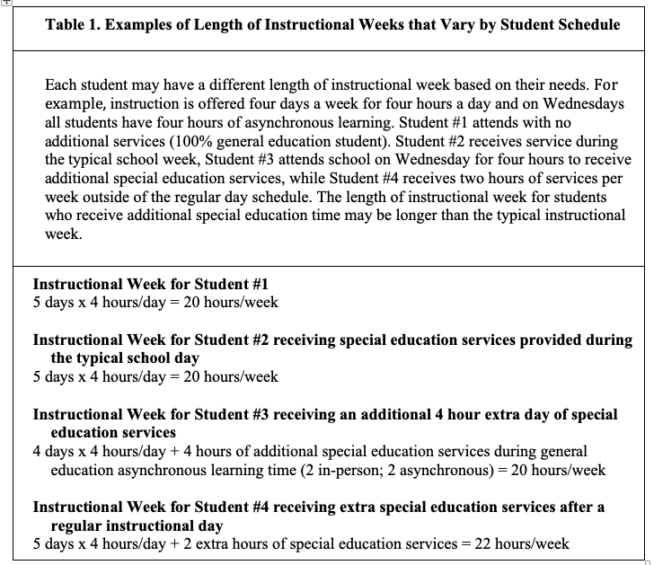
Length of instructional week is not impacted by the individual student’s attendance or participation. For students with reduced-day IEPs, the length of the instructional day is still the entire instructional day for the grade/school/division. Do not reduce times for this calculation.

Calculating Regular Class Percent of Day
The calculation of regular class percent is only computed for school-aged students (ages 5 and in kindergarten to 21). In order to accurately calculate regular class percent, both time in regular education and Bell-to-Bell must be calculated.
- School divisions should calculate Bell-to-Bell based on the general education instructional day (direct/indirect, synchronous/asynchronous) included in the instructional plan submitted to VDOE.
- Calculation of Regular Class Percent is calculated using Bell-to-Bell as determined by the LEA.
  - The IEP continues to determine the amount of time spent with non-disabled peers.

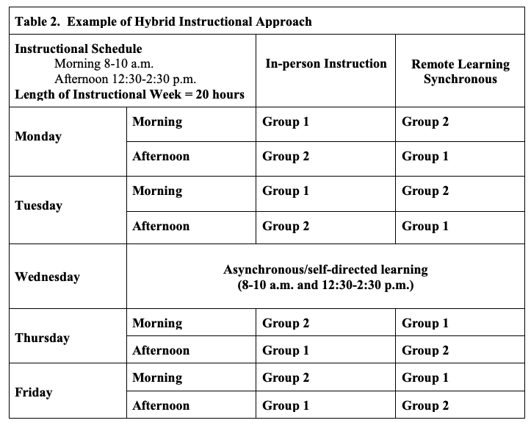
In order to accurately report percent of day in general education, the LEA must first identify the length of the school week (Bell-to-Bell). Length of the school week will likely be different for elementary, middle, and high schools. For students with reduced-day IEPs, the length of the school week is the entire day (bell-to-bell), do not use reduced time for this calculation. In VDOE resources, this traditional face-to-face model is referred to as bell-to-bell.
When LEAs use a virtual or hybrid approach, the determination of when the day starts and ends is the first step. For consistency, VDOE recommends using the same start and end time for all students in school or LEA. It is important to note that the length of the school week is what is offered to all students in the school. This is not impacted by the individual student’s attendance or participation.

Virtual and Hybrid Educational Models
The traditional LEAs educational model, face-to-face instruction for 990 hours per school year, was impacted by the COVID-19 pandemic. Since that time, LEAs have provided services using a fully virtual model or a hybrid approach that combines face-to-face and virtual instruction. LEAs offering virtual and hybrid educational models must determine the length of the instructional day and carefully calculate both service time and percent of day in order to accurately submit December 1 child count data.
The submission of data should reflect the content of the IEP that will be in effect on the date of the collection. For example, December 1 child count data should be calculated to reflect the services being provided to the student as written in the IEP on December 1. If instructional models change prior to December 1, the LEA should adjust calculations accordingly.

Special Education Services
Special education services may be offered as direct to the student, indirect (supporting the student by working with the teacher or parent), or as a combination of both. In a virtual environment, direct services may be offered as either synchronous or asynchronous learning, or a combination of both. The synchronous approach closely models direct instruction in the classroom where students experience learning activities at the same time. Examples of virtual synchronous learning might include a video conference for a morning meeting, a live science demonstration that all students watch together, or the use of tools where content is presented by a teacher and students can interact during a lesson. The synchronous approach puts the student into direct contact with a teacher and usually other peers. This approach is preferred for working with students who need the support of conversation, direct feedback, and in situations where students can work cooperatively and collaboratively. The asynchronous modality affords students time to work on independent learning based on their own schedule. The teacher has designed a sequence of activities for students to work independently, and therefore this work may not be completed in tandem with other students. Asynchronous learning is often completed outside of regular class time. Examples of asynchronous assignments might include reading, watching videos, taking assessments, completing projects, completing homework, or answering questions. Students may need extra support in how to structure their time to complete work within the parameters set by the teacher. Students may also be given options to make choices about how they prioritize their time, which can provide practice in time management. Considerations for instructors include the student’s age, maturity, and evidence of prior success in working on asynchronous assignments, as well as the types of support available at home.

Step-by-Step Calculations
Step-by-Step Calculations for Examples in Table 1.

Student #2 - Attends school 4 days x 4 hours/day and had 4 hours of asynchronous learning on Wednesdays for a total of 20 hours/week. The IEP Team has determined all instruction will be in a general education setting while in person and remote except for 30 minutes per day provided four days per week (days that are identified for synchronous instruction) for special education mathematics instruction in a remote, synchronous, segregated setting. In addition, the IEP Team has determined that 60 minutes of special education services will be provided in mathematics four days a week while in-person.

Steps for Calculating Services

Length of Instructional Week
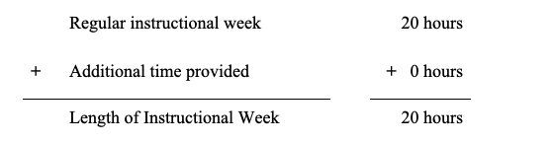

Amount of Special Education Services
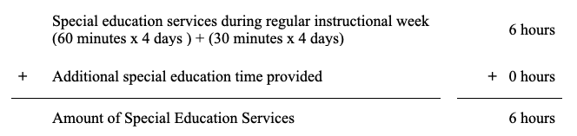

Services Calculate using totals from above and the formula shown.
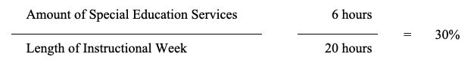

Steps in Calculating Percent of Time in General Education

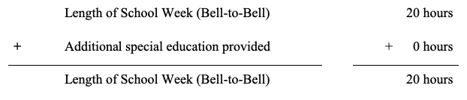

Length of School Week (Bell-to-Bell)
Time in Regular Class per Week

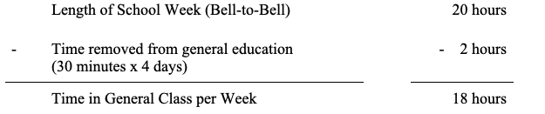

Percent of Time in General Education Calculate using totals from above and the formula shown.
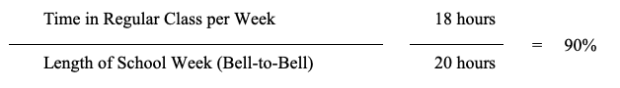

Student #3 - A typical instructional week for Student #3's school is 4 days x 4 hours/day and 4 hours of asynchronous learning on Wednesdays for a total of 20 hours/week. The IEP Team has determined that 60 minutes of special education services will be provided in English/Language Arts daily while in person during a typical general education 4-day hybrid model. Four days per week, the instruction will be in a general education setting while in-person and in asynchronous remote learning. This student requires an additional day of school services in order to receive FAPE. On the fifth day, Wednesdays, rather than asynchronous learning, the student will receive an additional four hours of special education services (2 hours in-person; 2 hours synchronous remote). All instruction on Wednesday will be in a segregated setting.

Steps for Calculating Services

Length of Instructional Week
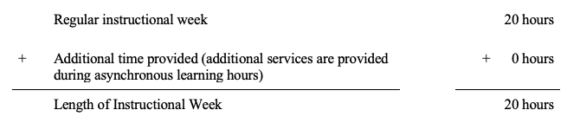

Amount of Special Education Services
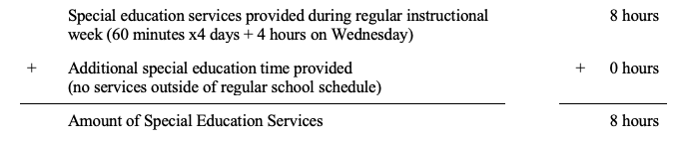
Services Calculate using totals from above and the formula shown.
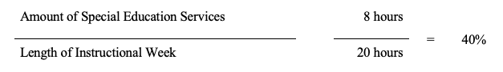

Steps in Calculating Percent of Time in General Education

Length of School Week (Bell-to-Bell)
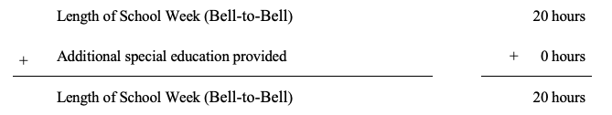

Time in Regular Class per Week
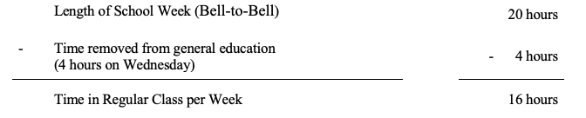

Percent of Time in General Education

Calculate using totals from above and the formula shown.
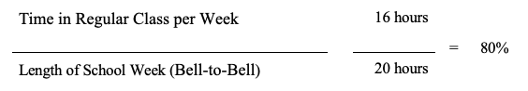

Student #4 - A typical instructional week for Student #4's school is 4 days x 4 hours/day and 4 hours of asynchronous learning on Wednesdays for a total of 20 hours/week. The IEP Team determined that 60 minutes of special education services will be provided in English/Language Arts daily while in person. All instruction during the typical week will be in a general education setting while in person and in asynchronous remote learning. This student requires an additional two hours of instruction one day per week in order to receive FAPE. The extra two hours of instruction will be delivered in person, in a segregated setting, outside of the regular school schedule.
Steps for Calculating Special Education Services

Length of Instructional Week
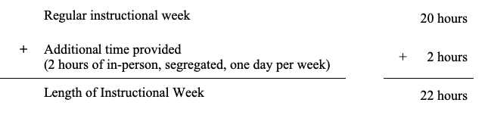

Amount of Special Education Services
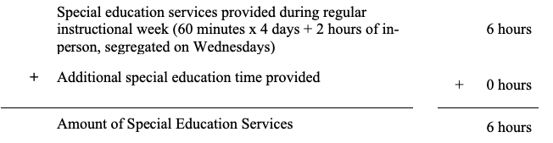

Services Calculate using totals from above and the formula shown.
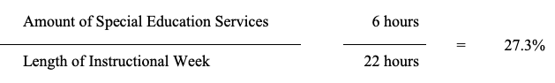

Steps in Calculating Percent of Time in General Education

Length of School Week (Bell-to-Bell)
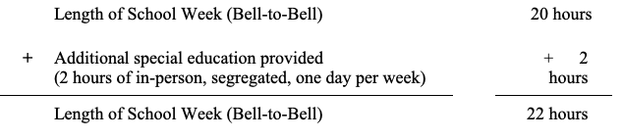

Time in Regular Class per Week
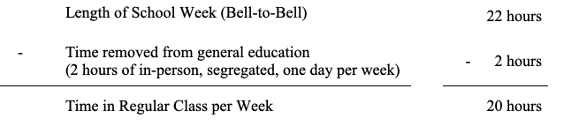
Percent of Time in General Education

Calculate using totals from above and the formula shown.
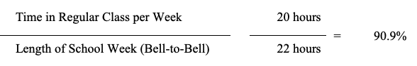

Resources
Online modules
- Overview of Placement and Services
- Calculating Placement & Regular Class Percent

Calculation tools and resources
- Calculation Tool for Least Restrictive Environment (LRE)
- December 1 Child Count Placement Codes (Word)
- Regular Class Percent Chart (Word)

