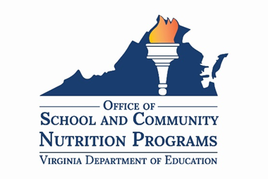

Instructions for Accessing the Virginia Food for Virginia Kids (VFVK) Training Series

Enrollment Instructions
- Go to https://virginialearning.catalog.instructure.com/courses/virginia-food-for-virginia-kids-training-series .
- Click on Enroll.
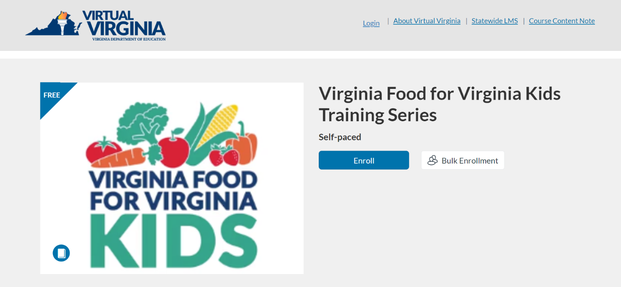
- Under Choose your program, select Virtual Virginia Professional Learning from the dropdown menu, and then click on Login.
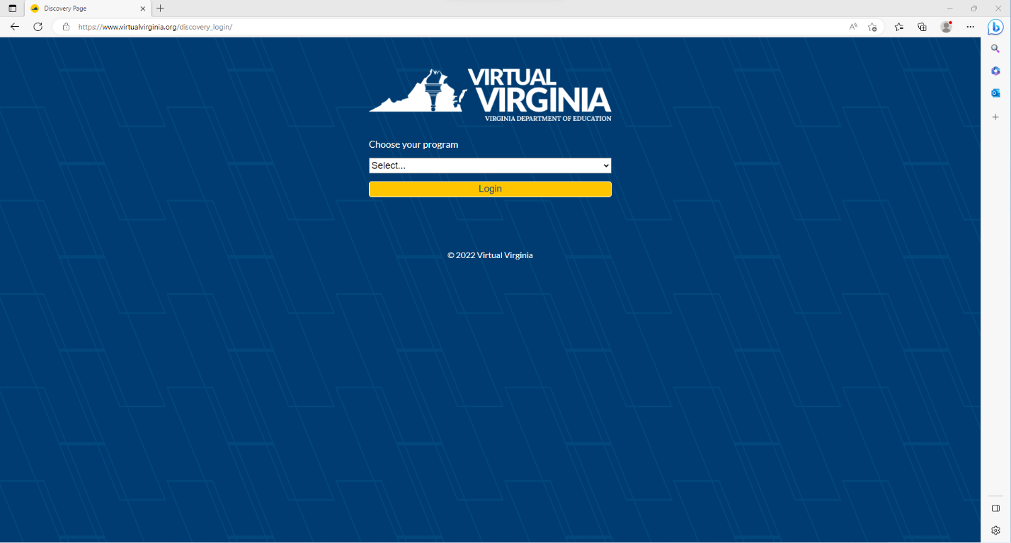
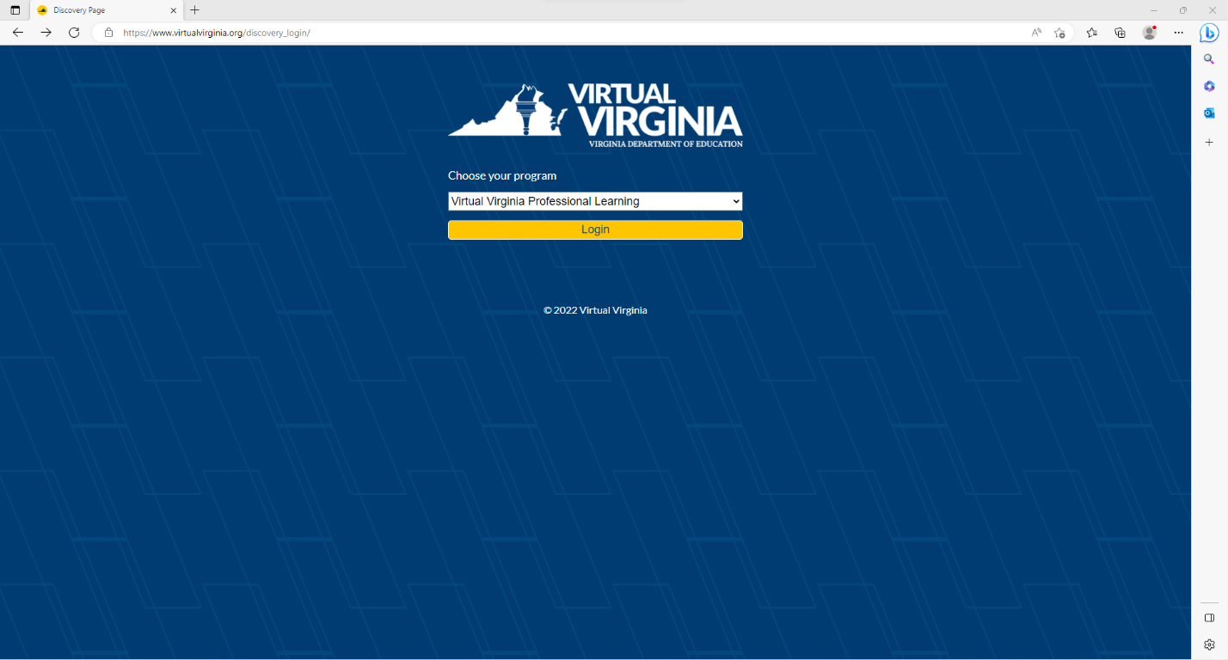
- If you already have a Virtual Virginia account, click on Sign in to Enroll. If you do not have an account, complete the initial registration information, and click on Register New Account.

Login Instructions
- To login to Canvas once you have an account, go to https://virtualvirginia.org/discovery_login/.
  - To reset your password, go to https://virtualvirginia.org/tech-support/.
- Under Choose your program, select Virtual Virginia Professional Learning from the dropdown menu, and then click on Login.
- You will now be on your Virtual Virginia Dashboard. This is where you can access all courses in which you are enrolled. Click on the Virginia Food for Virginia Kids Training Series course card.
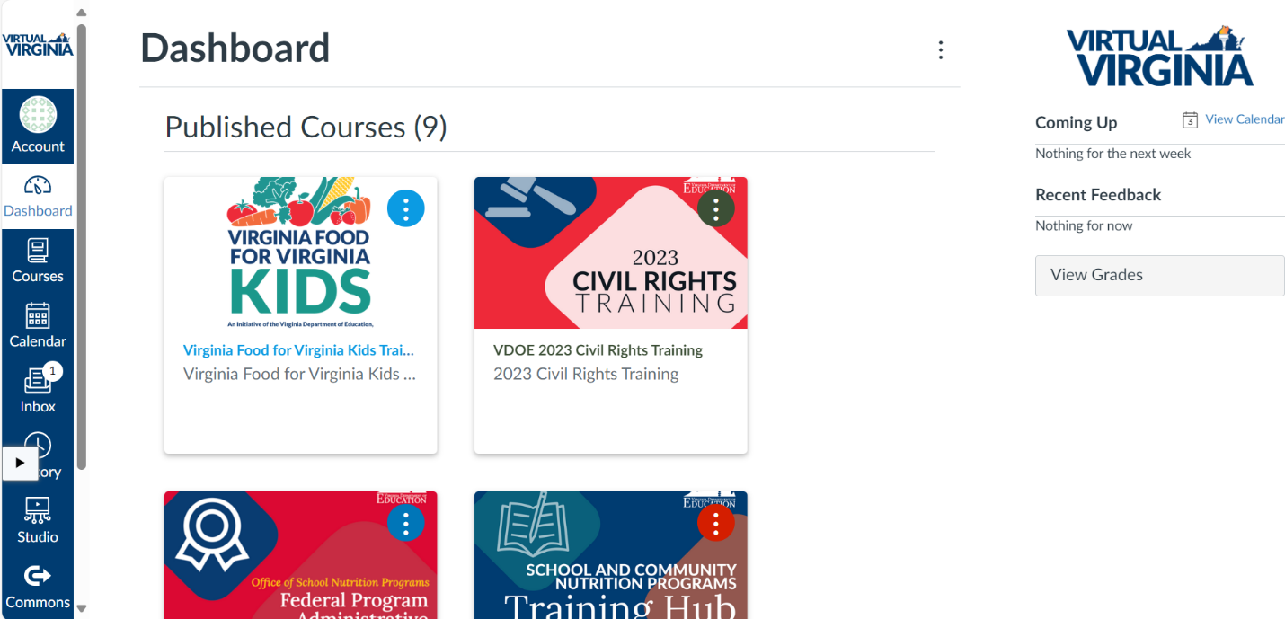
- You can also access the Virginia Food for Virginia Kids Training Series course by clicking on Courses in the lefthand panel of the Virtual Virginia Dashboard.
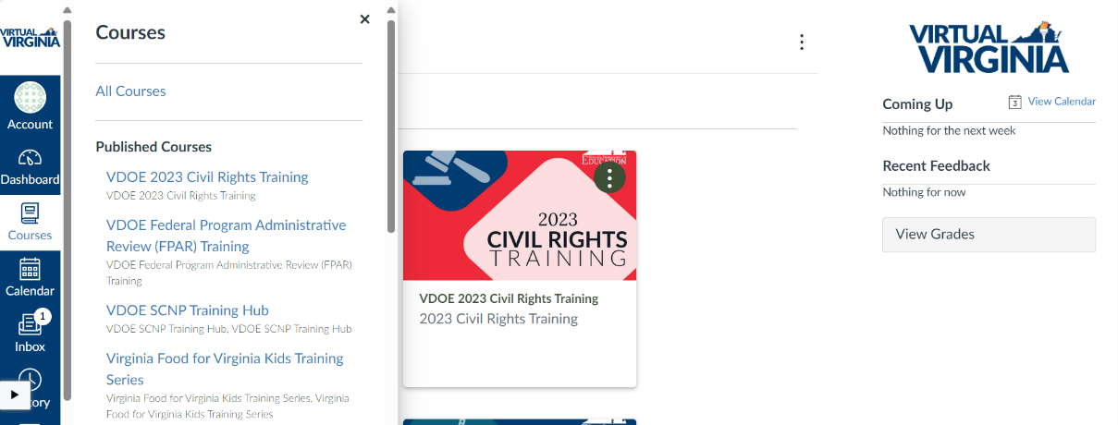
- You will now be on the Home page for the Virginia Food for Virginia Kids Training Series. Read the information on the Home page and then select Begin Course!
Should you have any questions about navigating Virtual Virginia for the Virginia Food for Virginia Kids Training Series, please contact Kiara Christian, SCNP Training Specialist, at Kiara.Christian@doe.virginia.gov.

