Virginia’s System of General Supervision of the Individuals with Disabilities Education Act (IDEA)

Compliance with State and Federal Requirements


Table of Contents
Introduction 1
State Performance Plan/Annual Performance Report 3
State Determinations 3
State Systemic Improvement Plan 4
Policies, Procedures, and Effective Implementation 4
Operating Standards 4
Model Forms 5
Stakeholder Groups 6
Interagency Agreements 7
Integrated Monitoring Activities 8
Comprehensive Reviews 10
Monitoring Activities 10
Other Comprehensive Review Considerations 11
Targeted Reviews 12
SPP/APR Reviews 12
Other Areas of Review 13
LEA Notification, Reporting, and Corrective Action 13
Fiscal Management 14
Supervision and Monitoring Mechanisms and Strategies 15
Online Management of Education Grant Awards (OMEGA) 15
Individuals with Disabilities Education Act Maintenance of Effort Application (IDEAMOE) 16
Special Education Excess Cost Application (Speced-Excess) 16
Special Education Proportionate Set Aside Application (Speced-PSA) 16
State-Funded Special Education Regional Tuition Reimbursement 16
Strategies 17
Data on Processes and Results 17
Improvement, Correction, Incentives, and Sanctions 18
LEA Determinations Enforcement Actions 18
Sanctions 19
Enforcement Actions 19
Effective Dispute Resolution 20
Special Education Dispute Resolution in Virginia 20
Mediation 20
State Special Education Complaint 21
Due Process Hearing 21
Targeted Technical Assistance and Professional Learning 22
VDOE Regions 22
E-Learning 23
The Virginia Tiered Systems of Supports 23
Academy for Aspiring Special Education Leaders 23
Virginia Training and Technical Assistance Centers 24
VDOE’s TTAC Online 25
Specialized Technical Assistance 25

Introduction
States have a responsibility under federal law to establish a system of general supervision to monitor the implementation of the Individuals with Disabilities Education Improvement Act (IDEA) by local educational agencies. An effective model of general supervision depends upon fluid interaction among its components, with an emphasis on accountability at all levels, to Virginia’s children and youth with disabilities served by this system.
The United States Department of Education Office of Special Education Programs (USED OSEP) identified nine interconnected components (Figure 1) that comprise a state’s system of general supervision. Using this system, states are accountable for enforcing requirements and ensuring continuous improvement. The system is designed to a) ensure compliance with federal and state regulations and b) improve services and results for students with disabilities.
Figure 1: Components of General Supervision
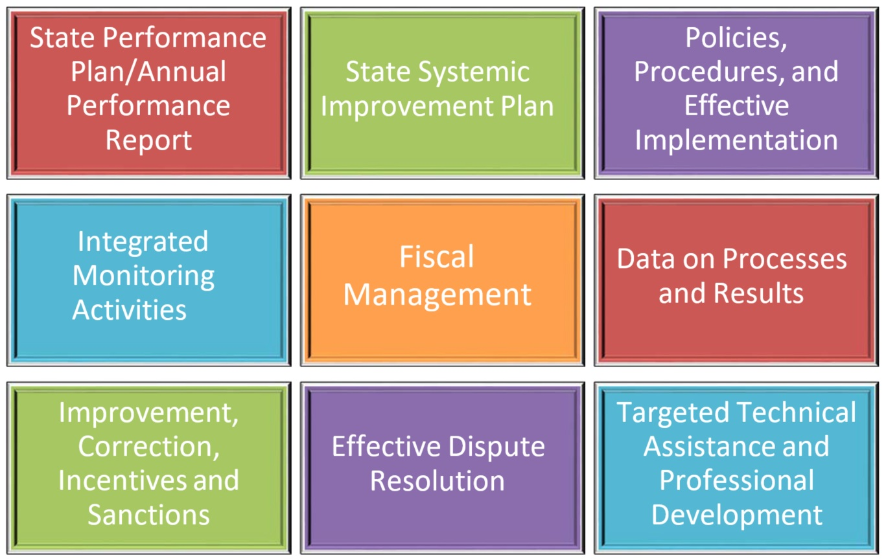
Virginia’s monitoring system for continuous improvement is designed to ensure that all educational entities in Virginia that educate students with disabilities, ages 2-21 inclusive, meet state and federal mandates. The VDOE Office of Data, Monitoring and General Supervision monitors special education in the following facilities: (1) 131 school districts (i.e. local educational agencies (LEAs)) including students with disabilities in local and regional jails, students in special education regional programs, and students in local nursing homes; (2) state-operated programs to include state mental health hospitals, regional and local detention centers, and state specialized children’s hospitals; and (3) other educational facilities to include the following: state training centers, state department of corrections including juvenile corrections and adult corrections, Virginia School for the Deaf and Blind, Wilson Workforce Rehabilitation Center, and private hospitals.
The monitoring process for these schools and facilities follows the same pattern with variations determined by the VDOE Team Lead(s) (i.e., monitoring specialists). Monitoring activities are continuous throughout the year. The method for monitoring can be in the form of a comprehensive review (five-year cycle) or a targeted review (specifically focused and narrow in scope). To determine the review method and to ensure that the VDOE is thoroughly monitoring general supervision, the VDOE obtains information regarding the LEAs from a variety of sources to include the following: parent concerns or inquiries; public media; a history of self-reporting noncompliance; special education complaints; annual local determinations; information reported during previous monitoring reviews; due process findings; inaccurate financial reporting; and issues/concerns and data from other VDOE divisions/offices, parent advocacy groups, and other governmental agencies.
The cornerstone of VDOE’s monitoring system for continuous improvement is the cyclical comprehensive reviews to monitor adherence by all school districts in the state to the Regulations Governing Special Education Programs for Children with Disabilities in Virginia to include integrated monitoring activities, program improvement, and fiscal management. This process allows a rotation of the 131 districts to be monitored no less than every five years (approximately 26 or 27 districts annually). The initial rotation of cohorts was developed based on several determining factors such as the last time the school district was selected for a comprehensive review, review of outcome data, number of complaints and investigations. Now that the rotation is set for Cohort Years 1-5, the order will be repeated in Cohort Years 6-10.
In addition to the comprehensive reviews outlined above that are cyclical in nature, the VDOE conducts targeted reviews that are narrower in scope and more focused on a particular area(s). When concerns, complaints, or credible allegations are brought to the VDOE’s attention regarding an LEA’s or other educational facility’s implementation of IDEA, a targeted review may be conducted. A targeted review is individually designed for the school district or educational facility and is based on the issues presented. Targeted reviews may incorporate activities used during a comprehensive review. The purpose of a targeted review is not only to determine compliance with federal and state laws, but to offer technical assistance and resources to prevent the district from repeating the noncompliance. Occasionally, an LEA or educational facility may request a targeted review, as this may assist it in resolving specific local issues or concerns. The number of targeted reviews will vary annually based on the issues brought to the attention of the VDOE by external sources (e.g., parents, advocates, media). Internal sources are also utilized to initiate targeted reviews such as information noted during comprehensive reviews; tasks that are carried out annually (e.g., Annual Performance Reports, Virginia Alternate Assessment Program Overuse); or noncompliance with specific regulation(s) identified by other means such as dispute resolutions or investigations.
The VDOE continually enhances its IDEA fiscal supervision and monitoring procedures to comply with related distribution and use of IDEA Part B funds and to ensure LEAs are being fiscally prudent and compliant with federal regulations. Virginia’s system of general supervision includes several mechanisms to provide oversight in the distribution and use of IDEA funds at the state level. Some of these mechanisms are reached through the VDOE Single Sign-on Web Systems (SSWS) secure online portal. The IDEA fiscal requirements, grant applications, and budgets and reimbursement processes are designed and embedded with information and instruction on fiscal regulations to assist school divisions in maintaining compliance with oversight by VDOE fiscal staff. The VDOE staff use the interactive applications as direct means of providing supervision, reviewing, communicating, and assisting LEAs in meeting IDEA Part B fiscal requirements for all subgrantees.
The supervision of LEAs is further structured according to tiered levels of risk and need. A risk assessment matrix is used to rate and place an LEA in a tiered level of needed supervision according to its score. The following are a few of the indicators included in the matrix: turnover in program leadership, the amount of award, untimely reimbursement request submissions, results-driven accountability review, history of maintenance of effort issues or failure to meet maintenance of effort, history of late submission of required data or financial information, history of audit findings, history of inaccurate or unverifiable fiscal data reporting, evidence of financial instability, and Coordinated Early Intervening Services/Comprehensive Early Intervening Service (CEIS/CCEIS) status.

State Performance Plan/Annual Performance Report
The Individuals with Disabilities Education Act of 2004 (IDEA 2004) requires each state to have in place a State Performance Plan that serves as an accountability mechanism for state and local educational agencies to implement the requirements and purposes of IDEA. The State Performance Plan/Annual Performance Report (SPP/APR) includes measurable and rigorous targets for eighteen indicators established for IDEA Part B (which address the needs of children and youth with disabilities ages 2 through 21) and states must report its performance on the targets identified in the plan through an APR. Each indicator provides a measurable indication of a state’s performance in specific priority areas under Part B. The VDOE Office of Data, Monitoring and General Supervision solicited broad stakeholder involvement, including input and feedback from Virginia’s State Special Education Advisory Committee (SSEAC), in the development of Virginia’s SPP to set measurable and rigorous annual performance targets for the “results” indicators.

State Determinations
Every year, USED OSEP evaluates each state’s implementation of IDEA requirements and issues state determinations. State determinations are based on data submitted to OSEP by states in their APRs and include compliance indicators as well as outcome measures for children and youth with disabilities. The USED OSEP makes the following state determinations annually:
- Meets requirements;
- Needs assistance;
- Needs intervention; or
- Needs substantial intervention
The IDEA specifically designates enforcement actions based on state determinations. Such actions result from determinations other than “Meets requirements” and can include technical assistance, corrective action plans, and conditions on, or the withholding of, federal IDEA funding. The IDEA requires each state to report to the public on state-level data and individual LEA-level data, including whether the state and the school divisions met state targets described in the state’s special education SPP/APR and make LEA determinations. Refer to VDOE Reports, Plans & Statistics.

State Systemic Improvement Plan
Indicator 17 of the SPP/APR represents the State Systemic Improvement Plan (SSIP). The SSIP is a comprehensive, ambitious, yet achievable plan for improving results for students with disabilities. In order to improve results, states must assess the capacities of their current infrastructure systems and abilities to enhance these infrastructures to increase the capacities of LEAs to implement and sustain evidence-based practices that will result in improved outcomes for children and youth with disabilities. States must select strategic focus areas and identify specific, measurable results for their SSIPs.
The focus of Virginia’s SSIP is on improving the statewide rate of graduation for students with disabilities identified with an Emotional Disability (ED), Intellectual Disability (ID), Other Health Impairment (OHI), or a Specific Learning Disability (SLD) projected to receive a standard or advance studies high school diploma. A Theory of Action was developed, and rigorous targets were established. These targets provide valuable information about the extent to which the implementation of the coherent improvement strategies is producing positive outcomes for students with disabilities, increasing the likelihood of meeting the long-term goal to improve the graduation rate for students with disabilities. The plan was submitted in three phases (Virginia’s Part B SPP/APR).

Policies, Procedures, and Effective Implementation
Virginia has policies, procedures, and implementation strategies that align with and support the implementation of IDEA. Virginia law requires that educational programs for students with disabilities be operated in accordance with procedures, standards, and guidelines adopted by the Virginia Board of Education. The LEAs, state operated programs, the Virginia School for the Deaf and the Blind, and private schools in the Commonwealth that provide special education and related services to children and youth with disabilities will not receive state or federal funds for special education programs unless each is operated in accordance with the provisions adopted by the Virginia Board of Education.

Operating Standards
Virginia’s special education administrative rules, Regulations Governing Special Education Programs for Children with Disabilities in Virginia (The Regulations), were adopted by the Virginia Board of Education on May 28, 2009, and became effective on July 7, 2009. The Regulations were reissued on January 25, 2010, following technical amendments. Minor updates have been added to the Regulations to continue to be in compliance with citations by USED OSEP. These operating standards align with the requirements of IDEA 2004 as well as the federal regulations at 34 CFR §300.199 (a) and (b). The Regulations provide a framework to ensure that all children and youth with disabilities receive a quality education tailored to each student’s unique needs.
In addition to these requirements, the VDOE has advised LEAs that the following statutes and regulations are also applicable to children and youth with disabilities:
- All regulations promulgated by the Virginia Board of Education
- Provisions of the Code of Virginia
- Section 504 of the Rehabilitation Act of 1973 (as amended)
- Americans with Disabilities Act
- Education Department General Administrative Rules (for federal grant requirements)
- The Virginians with Disabilities Act

Model Forms
The VDOE Department of Special Populations and Board Operations provides optional model forms for Virginia schools to use in documenting special education processes from referral to eligibility. These forms include the following:
- Referral Request for a Child Suspected of Having a Disability
- Team Review of Referral and Team Review of Existing Data Summary
- Parental Consent to Evaluate
- Eligibility Summary Form
- Observation
- Prior Written Notice
- Special Education Meeting Notice
- Special Education Meeting Notice Parent/Student Response
- Disability worksheets for the fourteen recognized disability categories in Virginia
These forms can be accessed within the Guidance on Evaluation and Eligibility for Special Education and Related Services.
Additionally, the VDOE launched a statewide online Individualized Education Program (IEP) system, Virginia IEP, during the 2017-2018 school year. Participation in the system is optional for LEAs. The Virginia IEP system provides functionality as an IEP writer and compliance tool that affords educators the functionalities necessary to facilitate IEP meetings, develop IEPs, monitor student progress, and gather and submit data for state reporting purposes. For more information, refer to Virginia IEP.

Stakeholder Groups
The VDOE Office of Data, Monitoring and General Supervision staff work closely with various stakeholders and professional organizations that are involved in or impacted by the provision of special education and related services for Virginia’s children and youth with disabilities.
The SSEAC is organized and functions in accordance with state and federal requirements to provide a broad base of input to the VDOE regarding policies, practices, and issues related to the education of children and youth with disabilities, ages 2-21. The committee includes members representing various agencies and parents of children with disabilities. Committee members:
- define plans for identifying children with disabilities;
- formulate and develop long-range plans that will provide services for children with disabilities;
- determine the unmet needs of children with disabilities within the state;
- develop priorities and strategies for meeting identified needs of children with disabilities;
- review and make public comment on the SSIP, the procedures for the distribution of funds under Part B of IDEA and any rules or regulations proposed by the state regarding the education of children with disabilities;
- review findings and decisions regarding due process procedures for parents and children;
- advise the state in developing corrective action plans to address findings identified in federal monitoring reports; and
- prepare and submit an annual report to the Virginia Board of Education.
Refer to VDOE SSEAC for more information regarding the committee including meeting dates, agendas, and minutes.
Personnel in the VDOE Department of Special Populations and Board Operations meet regularly with, provide updates to, and collaborate with various professional organizations and educational entities, including but not limited to:
- SSEAC
- Parents
- LEA central office personnel
- Other state agencies
- Parent Educational Advocacy Training Center (PEATC) staff members
- Training and Technical Assistance Centers (TTACs) staff members
- Early childhood specialists
- Transition specialists
- Elementary and secondary principals
- Representatives of higher education
- Assessment specialists
- VDOE staff members
- Other persons as needed

Interagency Agreements
The VDOE’s interagency agreement(s) with other state agencies include:
- Interagency Agreement for Service Delivery for Children with Disabilities and Their Families Between United States Department of Health and Human Services, The Administration for Children and Families, Head Start Bureau - Region III and the Migrant Branch and The Virginia Department of Education and The Virginia Department of Mental Health, Mental Retardation, and Substance Abuse Services (currently known as the Virginia Department of Behavioral Health and Developmental Services) (December 1999)
- Virginia Interagency Memorandum of Agreement Among the Agencies Involved in the Implementation of Part C of the IDEA Infant and Toddler Connection of Virginia
(May 2013)
- Parties to the agreement include:
- Virginia Department of Education
- Virginia Department of Behavioral Health and Developmental Services
- Virginia Department of Health
- Virginia Department of Medical Assistance Services
- Virginia Department of Social Services
- Virginia Department for the Deaf and Hard of Hearing
- Virginia Department for the Blind and Vision Impaired
- State Corporation Commission Bureau of Insurance
- The purpose of this agreement is to ensure collaboration and coordination in the implementation of Virginia’s statewide, comprehensive, family-centered system of Part C early intervention supports and services for infants and toddlers with disabilities and their families. The intent is to ensure optimal use of resources and prevent duplication of effort by detailing each participating agency’s commitment and financial responsibility related to Part C systems components (e.g., public awareness, child find, data collection, training) and provision of Part C early intervention supports and services.
- The VDOE Division of Early Child Care and Education supports birth through age five programming, which includes preschool services as noted in IDEA Part C; however, the Virginia Department of Behavioral Health and Developmental Services (DBHDS) is the lead agency for Part C in Virginia and oversees early intervention services for children, from birth through age two, under IDEA
Part C. The VDOE Department of Special Populations and Board Operations oversees programming for children, ages 2-21, as part of Virginia’s IDEA Part B responsibilities. The VDOE and DBHDS work together on Part C to Part B systemic transition issues, Part C program monitoring, and a coordinated service delivery system under Part C. The transition agreement between the VDOE and DBHDS is noted in Section VII of the agreement.
- The Memorandum of Agreement must be upheld by the local Infant and Toddler Connection and LEA as each party works to transition children from Part C to Part B.
- The LEAs must develop written interagency agreements with early intervention programs (Part C) in their counties to ensure timely and effective transition to preschool services.
- In addition, LEAs must take part in transition conferences, consider early intervention data when determining eligibility, and implement an IEP by the child’s third birthday for any child found eligible for Part B services.
- Both the VDOE and the Virginia Department of Aging and Rehabilitative Services (DARS) provide services for students and young adults with developmental disabilities. The VDOE has an agreement with DARS on statewide implementation and support of Employment First in Virginia, Cooperative Agreement Between Virginia Department of Education and the Department for Aging and Rehabilitative Services (February 2017).
- The agreement provides the avenue by which cooperation and coordination between the agencies are achieved. It is designed to facilitate the transition of students with disabilities, found eligible under IDEA and Section 504 of the Rehabilitation Act, from receipt of educational services to the receipt of vocational rehabilitation services offered by DARS. The services offered by DARS assist students in the areas of competitive and integrated employment, postsecondary education, training, and community living.
- The VDOE has an agreement with the Department of Medical Assistance Services (DMAS) to outline DMAS responsibilities and VDOE responsibilities for Medicaid and school billing.

Integrated Monitoring Activities
The monitoring of general supervision in Virginia is an extensive process. It involves the oversight for compliance in 131 school divisions and multiple other facilities that provide special education to students with disabilities. To ensure that the state is thoroughly monitoring general supervision, the VDOE obtains information regarding the LEAs from a variety of sources to include the following: parent concerns or inquiries, public media, a history of self-reporting noncompliance, special education complaints, annual local determinations, information reported during monitoring reviews, due process findings, inaccurate financial reporting, issues/concerns and data from other VDOE divisions/offices, parent advocacy groups, and other governmental agencies.
To ensure that all LEAs correct any identified compliance deficiencies, not to exceed one year from identification (OSEP QA 23-01 under State General Supervision Responsibilities under Parts B and C of IDEA), the VDOE has implemented a tracking system to monitor the correction of the noncompliance findings. The VDOE also tracks correction of program improvement findings, with the expectation that the findings be completed within a reasonable timeframe based on the LEA’s corrective action plan.
Virginia’s Monitoring System consists of:
- Comprehensive Reviews and
- Targeted Reviews
Figure 2: Image of Comprehensive Monitoring Components
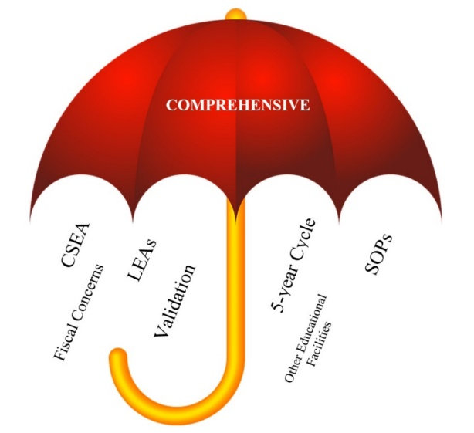
Figure 3: Image of Targeted Monitoring Components
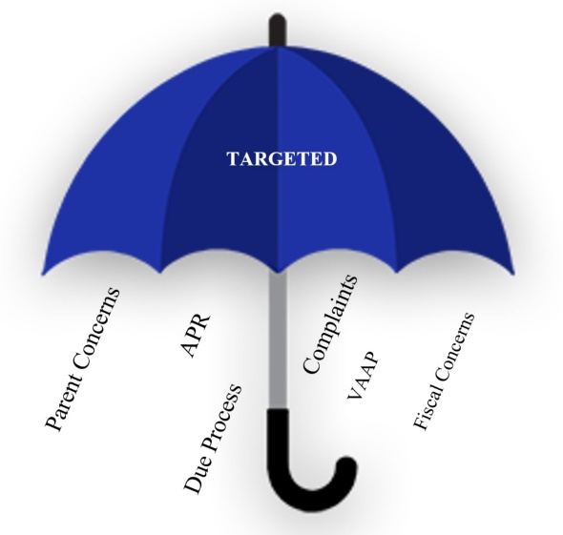

Comprehensive Reviews
A comprehensive review is cyclical and involves multiple activities to ensure that all educational facilities that operate as LEAs are monitored every five years, at a minimum. Monitoring activities encompass IDEA compliance as well as improving educational results and outcomes for all children and youth with disabilities. In Virginia, a comprehensive review is accomplished via a five-year cyclical review process. Approximately 20% of Virginia’s 131 school divisions and other educational entities will receive comprehensive reviews annually. Examples of other entities include state operated programs (e.g., detention centers, hospital education); juvenile and adult corrections; Virginia School for the Deaf and Blind, Wilson Workforce Rehabilitation Center; private hospitals; and nursing homes.
[Note: State operated programs and private residential facilities are also monitored through the state’s Interdepartmental Regulation Program which is a joint effort of the VDOE, Virginia Department of Juvenile Justice, Virginia Department of Behavioral Health and Developmental Services, and Virginia Department of Social Services.]
A comprehensive review begins with LEAs and educational facilities completing, as applicable, a document entitled, “the Core Special Education Assessment (CSEA).” The next step is data validation. This is conducted by VDOE monitoring specialists. Validation is carried out remotely, face-to-face, or a combination of both to include a review of policies, procedures, and practices as well as student record reviews. The VDOE monitoring specialists are only charged with validating a sampling of items in the CSEA; however, at their own discretion, they may request additional documents including data regarding current practices in an LEA related to the achievement of students with disabilities, ages 2-21, inclusive. This additional information could include data relating to program improvement as well as compliance.

Monitoring Activities
Monitoring activities may include parent interviews; general and special education faculty and staff interviews; classroom walkthroughs; collection of artifacts (e.g., teacher licenses, lesson plans, student work samples, teacher caseloads); review of student transcripts; discipline data; and attendance.
During a comprehensive review, VDOE staff members examine a vast array of documents to monitor compliance with IDEA and state special education regulations. This includes, but is not limited to, monitoring compliance of the following: timelines, parents’ and students’ receipt of special education procedural safeguards, eligibility and reevaluations, discipline processes, student transfers, termination from related services and special education services, preschool services, and postsecondary transition. Areas of program improvement that may be monitored by way of record reviews include attendance and discipline patterns, course and verified credits documentation, and retention and promotion history.
Depending on the facility, documents examined during comprehensive reviews may include:
- Local policies and procedures for special education
- Special education forms utilized by the LEA
- Student files chosen by a random selection process that represents:
- ages 2-21, inclusive;
- all grade levels proportionately (e.g., preschool, elementary, middle, and high school students especially secondary transition-aged students);
- all schools within the LEA, including alternative educational settings;
- placements in settings outside of the public schools including private residential and day schools, regional programs, nursing homes, homebound instruction, home-based instruction, and jails;
- all disability categories, proportionately;
- various case managers; and
- various educational settings (e.g., segregated, inclusive).
- Special education teacher roster including name, endorsement, and teaching assignment
- List of related service providers and their assignments
- Organizational administrative chart for the LEA
- Master schedules for each school in the LEA with number of students with disabilities noted per class
- Special education teacher schedules
- School maps with classroom numbers and teacher locations noted

Other Comprehensive Review Considerations
Other considerations during the comprehensive review include:
- Decision-making process for making least restrictive environment decisions, as documented in an IEP
- Child Find process
- Delivery of services and alignment with IEPs
- Evaluation and placement process for children and youth with disabilities
- Accuracy of data reported to VDOE
- Compliance with statutory requirements for IEPs, child studies, eligibilities, and discipline
- Fulfillment of IDEA Part B fiscal requirements
- Other issues as identified through analysis of the LEA’s School Quality Profile, as well as from complaint resolution activities

Targeted Reviews
A targeted review is narrower in scope and more focused by nature. When concerns or complaints are brought to VDOE’s attention regarding an LEA’s or other educational facility’s implementation of IDEA, a targeted review may be conducted. A targeted review is individually designed for the LEA or educational facility and is based on the issues presented.
Targeted reviews may incorporate activities used during a comprehensive review. The purpose of a targeted review is not only to determine compliance with federal and state laws but also to offer technical assistance and resources to prevent the LEA from repeating the noncompliance. Occasionally, an LEA or educational facility may request a targeted review, as this may assist them in resolving specific local issues or concerns.
The number of targeted reviews will vary annually based on the LEA-related issues brought to the attention of the VDOE by external sources (e.g., parents, advocates, media). Internal sources are also utilized to initiate targeted reviews (e.g., information noted during comprehensive reviews; tasks that are carried out annually, such as the APR and VAAP overuse; or concerns shared via the VDOE Interoffice Communication Form).

SPP/APR Reviews
One aspect of targeted monitoring is the annual SPP/APR reviews:
- Indicator 4: Discrepancies in suspension/expulsion rates between students with disabilities and students without disabilities
- Indicators 9 and 10: Disproportionate representation in special education of racial/ethnic groups due to inappropriate identification and disproportionate representation of racial/ethnic groups in specific disability categories due to inappropriate identification
- Indicator 11: Timely completion of initial evaluations
- Indicator 12 Timely transition from Part C to Part B services with an IEP implemented by the child’s third birthday
- Indicator 13: Secondary transition planning for students with disabilities ages sixteen and above
- Indicator 18: General Supervision – accurate and timely data reporting
The VDOE analyzes year-end data for these indicators. Each LEA that serves students with disabilities receives an annual Special Education Performance Report from the VDOE. These documents contain a summary of the LEA’s performance on all SPP/APR indicators and identify whether or not the LEA meets the state targets described in the state’s special education SPP/APR. Based on the submitted APR data, the VDOE uses a rubric to create the LEA’s local determination to conclude whether the LEA meets one of the four categories: Meets Requirements, Needs Assistance, Needs Intervention, or Needs Substantial Interventions.
Data submitted by LEAs are validated on a cyclical cycle. The LEAs identified as noncompliant for specific indicator(s) may develop corrective action plans that include strategies to ensure correction as soon as possible, but no later than one year from the notification of noncompliance. As part of the review process, VDOE examines student records to ensure correction of individual cases of noncompliance, reviews additional student records selected at random to ensure systemic correction, and verifies that data reported are accurate.

Other Areas of Review
A targeted review of a specific regulation(s) identified by other means such as dispute resolutions or investigations results in a notification letter of noncompliance. A corrective action plan is required. The VDOE ensures the following: correction of individual cases of noncompliance; review of additional student records to ensure compliance (student-specific corrections); verification that policies, procedures, and practices are compliant (systemic corrections) (OSEP QA 23-01); and closure of noncompliance within one year of notification.

LEA Notification, Reporting, and Corrective Action
A final report is developed by the VDOE monitoring specialist to summarize the findings from each area of the review then sent to the LEA. The summary report identifies, as needed, the following topics: Review Statistics/Demographics, Identified Strengths of the Special Education Programs, Emerging Improvements in Need of Improvement (Capacity Building), Areas of Focus for Program Improvement, and Corrective Action of Individual and General Supervision Compliance Findings with IDEA and state special education regulations. Tracking of noncompliant findings resulting from VDOE’s review begins from the issue date of the review summary report.
Whenever a finding of noncompliance is identified, the LEA is required to develop a corrective action plan that addresses identified areas of noncompliance and include improvement strategies and timelines to ensure correction. To verify correction of noncompliance, LEAs submit documentation of its correction. The LEAs must demonstrate that correction of noncompliance has occurred in accordance with the OSEP QA 23-01. This means that LEAs must demonstrate correction according to OSEP’s “two-pronged test” for correction. Both prongs (student-specific and systemic) of correction must be completed as soon as possible, but no later than one year from the notification of noncompliance.
During the review, if the VDOE finds that an LEA has not completed correction of previously identified noncompliance, it will conduct one or more follow-up activities. If it is determined that noncompliance continues, the VDOE may require periodic progress reports and may also follow-up through additional frequent visits and/or telephone contacts. Often during monitoring activities, areas of program improvement are found. Program improvement includes issues related to student behavior, instructional management, instructional materials, teacher-student interactions, positive classroom environment, ambiguity in teacher and staff roles and responsibilities, parent communications, and professional development opportunities. Findings of program improvement create a pathway for special education administrators and key instructional leaders to collaborate on the strengths and weaknesses of the provision of educational and support services for students with disabilities.
When addressing areas for program improvement, the LEA’s timeline for completion is determined in its corrective action plan, but not more than three years. In some cases, VDOE continues to work with an LEA after the LEA has corrected the noncompliance in order to ensure compliance and/or focus on continuous improvement.
For closure of the CAP, the LEA must verify improvements in its educational programming as outlined in the goals within its CAP. The CAP is reviewed, discussed, and verified for completeness through various means with the VDOE. The LEA must produce documents and data to demonstrate that change has occurred. Additional classroom walk-throughs or follow-up interviews with staff, students, and parents may be conducted as well.

Fiscal Management
The VDOE is awarded funds by USED OSEP to provide for the excess cost of special education and related services for students with disabilities. The IDEA funds are intended to supplement and not supplant state, local, or other funds. The VDOE Office of Special Education Finance and Budget (SPED-FAB) must ensure fiscal accountability at each phase in the distribution and use of IDEA funds. This involves multiple facets of review, evaluation of risk and need, and mechanisms for monitoring to ensure LEAs receive the intensity of supervision required to be successful in maintaining compliance.
The VDOE SPED-FAB has developed specific procedures and processes to ensure compliance with Section 2 of CFR §200.331(b):
“…pass-through entities [VDOE] must evaluate each sub-recipient’s [LEAs] risk of noncompliance with Federal statutes, regulations, and the terms and conditions of the sub-award for the purpose of determining the appropriate monitoring actions.”
The VDOE continually enhances its IDEA fiscal supervision and monitoring procedures to comply with related distribution and use of IDEA Part B funds and to ensure LEAs are being fiscally prudent and compliant with federal regulations. The supervision of LEAs is structured according to tiered levels of risk and need. A risk assessment matrix is used to rate and place an LEA in a tiered level of needed supervision according to its score. The following indicators are included in the matrix: turnover in program leadership, the amount of award, untimely reimbursement request submissions, results-driven accountability review, history of maintenance of effort issues or failure to meet maintenance of effort, history of late submission of required data or financial information, history of audit findings, history of inaccurate or unverifiable fiscal data reporting, evidence of financial instability, and CEIS/CCEIS status.
There are three tiers of supervision and financial monitoring provided by the VDOE SPED-FAB. These include:
- Tier One (Universal Level): The risk assessment matrix is completed by the VDOE SPED-FAB staff members using available data submitted to VDOE for review, approval, and monitoring through online applications. Training in IDEA fiscal management is made available for all LEAs at conferences, regional meetings, and other professional developments (e.g., New Directors of Special Education Academy). Technical assistance is provided during data reviews and resources are available online.
- Tier Two (Targeted Level): The LEAs at this level require targeted supervision and monitoring as determined by the risk assessment matrix tool and other indicators. Tier Two LEAs may participate in all the Tier One (Universal Level) activities and receive targeted support to address the low-scoring indicators. In addition, the technical assistance is usually conducted via online applications, emails, phone consultation, or teleconferencing.
- Tier Three (Intensive Level): These LEAs require the most intense level of supervision and have multiple indicators with a high-risk assessment score. This level of supervision includes supports provided in levels one and two, more frequent and intense review and technical assistance, and is individualized to meet the needs of the LEA.
The tiered range of level intensity ensures LEAs receive the appropriate supervision needed to enable continued success in being compliant with federal fiscal requirements.

Supervision and Monitoring Mechanisms and Strategies
Virginia’s system of general supervision includes several mechanisms to provide oversight in the distribution and use of IDEA funds at the state level. Some of these mechanisms are reached through the VDOE SSWS secure online portal. The applications are designed and embedded with information and instruction on fiscal regulations to assist LEAs in maintaining compliance. The VDOE SPED-FAB staff use the interactive applications as direct means of providing supervision, reviewing, communicating, and assisting LEAs in meeting IDEA Part B requirements. The mechanisms include:

Online Management of Education Grant Awards (OMEGA)
The VDOE uses the OMEGA interactive online system for all federal flow-through program application submissions, approvals, awards, and financial tracking. The LEAs submit their Special Education Annual Plan / Part B Flow-Through Application for Federal Funding workbook for IDEA Part B funds using OMEGA. Instructions and requirements of the IDEA annual plan are built into the interactive system to provide ongoing guidance and automated calculations. In order to receive an award, each LEA must show evidence of eligibility for IDEA Part B funds in this workbook for the upcoming fiscal year in compliance with
34 CFR §§ 300.200-213, 300.224. The application is reviewed and approved by authorities at the LEA level and then by several different reviewers at the VDOE. The application is accepted only when all reviewers approve it.

There are three sections in the workbook that LEAs must complete:
- Section I: Submission Statements
- Section II: Assurances and Certifications
- Section III: Description of Use of Funds, which includes the plan for CCEIS and jails.
Also, OMEGA is used to process grant expenditure reimbursements and budget transfers. Reimbursements and/or transfers have the same requirement of authorized level approvers at the LEA and VDOE levels. The reviewers are able to deny the approval and request improvement. This is a foundational construct of the interactive OMEGA processes. Thus, it also serves as a mechanism for ongoing communication. Any request must be authorized by all level approvers at the LEA and VDOE levels.

Individuals with Disabilities Education Act Maintenance of Effort Application (IDEAMOE)
This application is used by LEAs to enter information that will be used to determine whether or not the LEA has met its federal IDEA Maintenance of Effort (MOE) requirement
(34 CFR, Part B, §300.203). This collection reports the outcomes of the four methods used to determine the amount of local and state expenditures that must be maintained by LEAs in providing special education and related services. The submission is reviewed by VDOE SPED-FAB staff. Communication and assistance are provided with LEAs that were not approved until reconciliation is complete which could involve payment to USED.

Special Education Excess Cost Application (Speced-Excess)
The IDEA Part B funds may be used only to pay for the excess costs of providing special education and related services to children and youth with disabilities (34 CFR, Part B §300.202). The LEAs use this application to determine the excess cost amount they must spend for the year. The VDOE SPED-FAB staff review, provide consultation and assist LEAs in making corrections, and obtain approval using this application.

Special Education Proportionate Set Aside Application (Speced-PSA)
This application is used by LEAs to report their proportionate set-aside calculations. Each LEA is mandated to spend a proportionate amount of its IDEA Part B Sections 611 and 619 allocations on providing special education and related services (including direct services) to home-schooled or parentally placed private school children with disabilities (CFR 34, Part B §§300.129-300.144). Each LEA uses this application to calculate the required set-aside amounts. Once submitted the report is reviewed. The VDOE SPED-FAB staff communicate and assist school divisions needing support until it is corrected and approved. Additionally, the use of these funds is monitored through the reimbursement process in OMEGA.

State-Funded Special Education Regional Tuition Reimbursement
Regional tuition reimbursement funding provides for students with low-incidence disabilities who can be served more appropriately and less expensively in a regional program than in more restrictive settings. A joint or partnering LEAs operate regional special education programs. These programs accept eligible children with disabilities from other local LEAs.

Strategies
Strategies for providing supervision include consultation, technical assistance, in-service presentations, training at conferences, guidance documents and resources on the VDOE website, agreed upon procedures for monitoring/auditing engagement, and remote and face-to-face reviews by VDOE SPED-FAB staff. Furthermore, the SPED-FAB tracking system monitors timely submission of required data and reports.

Data on Processes and Results
As part of the state’s general supervision responsibilities, data are used at the state level to drive decision-making about program management and improvement. The VDOE routinely examines multiple sources of data to track LEA performance and target technical assistance and resources that will assist LEAs and the state in meeting SPP targets. The VDOE’s procedures for collecting data are intended to ensure the usefulness, timeliness, accuracy, and comparability of education data that inform key policy decisions in Virginia. Most data collections are related to specific requirements of state and federal law. Virginia collects and stores data aggregated for the SPP and APR using the state Educational Information Management (EIM) system. The EIM files comprise the source data for Virginia’s accountability and funding systems. The LEAs report data to the VDOE through SSWS, designed to increase accuracy while lessening administrative burdens on educators at the local level. The state EIM office provides data verification reports that provide LEAs with feedback about the validity of their data with opportunities for data correction during each reporting window. The LEAs are required to submit information and data for reporting, monitoring, and compliance purposes. These data are summarized in the Report to the Public. The Report to the Public indicates whether the state and the school divisions met state targets described in the state’s special education SPP/APR. Refer to VDOE Reports, Plans & Statistics web page.
Virginia’s accountability system, as required in both the Elementary and Secondary Education Act (ESSA) and the Virginia Board of Education’s revised Regulations Establishing Standards for Accrediting Public Schools in Virginia (SOA), supports continuous improvement for all schools and for college, career, and civic readiness for all students. Virginia public schools receive annual state and federal accountability ratings based on the performance of students on state assessments in English, mathematics, and science and on other measures of quality and performance. The School Quality Profile is used to report ESSA and state accreditation ratings to the public. School Quality Indicators include academic achievement, achievement gaps, student engagement and outcomes, a snapshot of student assessment results, student growth on state assessment, and chronic absenteeism data. For high schools, student engagement is also measured by graduation index and dropout rate. The School Quality Profiles account for various subgroups of students including economically disadvantaged students, students from major racial and ethnic groups, students with disabilities, and students with limited English proficiency. Each LEA has an online School Quality Profile which displays the assessment data and results. Refer to VDOE School Quality Profiles.
The Virginia Longitudinal Data System provides Virginia citizens, researchers, and policymakers with a single point of access to educational and workforce-training data from multiple, independent sources while protecting the privacy of students. Refer to the Virginia Longitudinal Data System.

Improvement, Correction, Incentives, and Sanctions
Supporting improvement and ensuring correction through incentives and sanctions are critical components of Virginia’s general supervision system. The enforcement of regulations, policies, and procedures is required by IDEA and state regulations. State guidelines and directives also steer the technical assistance provided to ensure the correction of noncompliance and, ultimately, to meet state and local targets.

LEA Determinations Enforcement Actions
The VDOE is required, pursuant to IDEA 2004 at 34 CFR §300.600(a)(2), to make determinations for each LEA based on their submitted APR data. The determination categories are as follows: Meets Requirements, Needs Assistance, Needs Intervention, or Needs Substantial Intervention. Based on these regulations, the table below displays the enforcement actions required by VDOE for determinations other than “Meets Requirements.”
Table 1: Local Determinations Enforcement Actions
Category | VDOE Enforcement Actions
Needs Assistance | The VDOE will inform the LEA of the availability for targeted technical assistance (TA), or professional development (PD), based on this annual special education determination. Targeted TA/PD related to identified areas of need may include:  - Priority access to TA/PD opportunities; and/or  - Requiring engagement with the Office of Data, Monitoring and General Supervision to address identified areas of need or as part of Tiered Focused Monitoring activities; and/or  - Requiring participation in specified TA/PD activities.
Needs Intervention | Enforcement actions related to identified areas of need may include those interventions for LEAs with a Needs Assistance determination as well as:  - Require individualized training and TA from the Office of Data, Monitoring and General Supervision specific to identified areas; and  - May withhold, in whole or in part, any IDEA Part B funds; and/or  - Require completion of specific corrective actions before release of funds.
Needs Substantial Intervention | Enforcement actions related to identified areas of need may include those interventions for LEAs with other determination levels as well as:  - Withhold, in whole or in part, any IDEA Part B funds; and  - Require completion of specific corrective actions before release of funds.

Sanctions
An effective means of ensuring timely correction of noncompliance is through a range of sanctions. The VDOE oversees corrective activities as part of Virginia’s monitoring system and has a progressive sanctions policy that communicates how and when sanctions can be imposed.
The LEAs identified as noncompliant with a federal or state requirement receive written notification from VDOE describing the noncompliance and corrective action(s) required. Noncompliant LEAs are required to correct all individual instances of noncompliance as well as to demonstrate that the LEA is now correctly implementing the regulatory requirement. Required corrective action may include the following:
- Educational records review to verify correction and correct implementation of regulatory requirements;
- Professional development and technical assistance for LEA personnel, including records of these activities and documentation that LEA practices have been corrected;
- Fiscal records review; and/or
- Recovery of funds by VDOE to address misappropriation of either state or federal funds.

Enforcement Actions
The VDOE has utilized various enforcement actions with LEAs that demonstrate noncompliance, including (1) conducting more frequent face-to-face visits and making telephone contacts, (2) requiring continued progress reports, (3) calling or meeting with the local superintendent, and (4) returning for another comprehensive review. Additional sanctions can be more extreme when an LEA or other educational facilities that operate as an LEA does not complete the required corrective activities within the established timeline.
The VDOE staff members could take the following steps:
- The VDOE Executive Director of Data, Monitoring and General Supervision will send the LEA a signed letter documenting its failure to comply with its corrective action plan. The letter will provide a revised benchmark date for completing the remaining items. The letter also will indicate whether specific applicable funds (state and/or federal) will be delayed should the revised benchmark dates not be met. Should the LEA again fail to meet the benchmark date, it will receive a second letter, which comes from VDOE Associate Superintendent of Special Populations and Board Operations. The letter will indicate which funds (state and/or federal) will be delayed and will include steps the LEA must take to secure release of these funds.
- Subsequent noncompliance will result in VDOE withholding or recovering additional LEA funds after providing the opportunity for a hearing with the State Superintendent of Public Instruction.

Effective Dispute Resolution

Special Education Dispute Resolution in Virginia
The USED OSEP has “encourage[d] parents and local educational agencies (LEAs) to work collaboratively, in the best interests of children, to resolve the disagreements that may occur when working to provide a positive educational experience for all children, including children with disabilities. To this end, the IDEA and its implementing regulations provide specific options for resolving disputes between parents and public agencies, which can be used in a manner consistent with our shared goals of improving results and achieving better outcomes for children with disabilities.”
More specifically, IDEA and its implementing regulations and Virginia’s Regulations Governing Special Education Programs for Children with Disabilities set forth three special education dispute resolution options to address disagreements regarding the identification, evaluation, educational placement and services of their child, or the provision of free appropriate public education (FAPE). These options include (i) parents and the school division enter into mediation to resolve the dispute; (ii) file a complaint that the school division has erred in meeting its special education obligations; and (iii) the parent or local school division files a request for a due process hearing to have a hearing officer determine the appropriate outcome for the child.
In Virginia, the VDOE Office of Dispute Resolution, within the VDOE Department of Special Populations and Board Operations, (i) administers these three federally-mandated special education dispute resolution options; (ii) provides technical assistance to parents and school divisions regarding special education laws and regulations; (iii) develops and updates various special education resource materials; (iv) provides trainings to school divisions regarding regulatory compliance; (v) assists in the development and revision of Virginia Board of Education regulations as may be requested; and (vi) works collaboratively with other offices within the VDOE Department of Special Populations and Board Operations, as appropriate.

Mediation
To assist all parties in finding a collaborative means by which to address any disagreements, the VDOE Office of Dispute Resolution facilitates the Virginia Special Education Mediation System. The use of mediation is available to LEAs and parents when consensus cannot be achieved through the IEP Team process. Mediation is a free, voluntary, state-administered process that involves a meeting facilitated by an impartial, state-trained mediator to assist parents and school staff in their negotiations with each other. The meeting—which often can be scheduled fairly promptly, depending on the respective parties’ schedules—is designed to clarify issues, focus on the child’s needs, and explore and evaluate possible solutions in a confidential setting. Mediators do not take the role of an advocate, but instead provide support and assist everyone in the negotiation process. Refer to the VDOE Special Education Mediation web page for more information.
An additional tool in assisting parents and LEAs in their efforts to come to an agreement in the best interests of the student is the facilitated IEP meeting. The VDOE Office of Dispute Resolution has initiated, on a pilot basis, a facilitated IEP process wherein local school divisions and parents can seek assistance from an impartial facilitator to lead IEP meetings in cases where relationships have become strained.

State Special Education Complaint
A complaint is generally an expression of some disagreement with a procedure or a process regarding special education programs, procedures, or services. A formal complaint is considered a request that the VDOE Office of Dispute Resolution investigates an alleged violation of a right of a parent and/or child with disabilities who is eligible, or believed to be eligible, for certain services based on special education laws and regulations. The complaints process involves the following: a 60-day investigation period that includes the submission of a written complaint by an individual, the issuance of a Notice of Complaint identifying the allegations to be investigated by the VDOE Office of Dispute Resolution, a response from the LEA, an opportunity for both parties to submit additional information, and the issuance of a Letter of Findings by the VDOE Office of Dispute Resolution. The Letter of Findings explains why the LEA is or is not in compliance with the law. If the LEA is found to not be in compliance, the VDOE Office of Dispute Resolution may request the school division to complete a corrective action plan. The VDOE Office of Dispute Resolution then monitors the corrective action plan to ensure its timely implementation. The state special education complaint process addresses alleged violations occurring within the last 365 days. Refer to VDOE Special Education Complaints for information regarding the complaint process.

Due Process Hearing
A parent or a school division may request a due process hearing, a dispute resolution option that incorporates an informal administrative hearing process before an impartial hearing officer to resolve disagreements over such issues as related to a child’s eligibility for special education and related services, evaluation of a child with a disability, appropriateness of a child’s services and/or placement, or any other matter under FAPE including disciplinary matters. The hearing may address matters arising in the last two years. Refer to VDOE Special Education Due Process Hearings for more information.
The VDOE Office of Dispute Resolution conducts required training for hearing officers, mediators, complaints specialists, and facilitators on IDEA and state requirements and dispute resolution procedures. The VDOE Office of Dispute Resolution is in the process of completing a self-assessment and will make revisions to procedures and data collection process, as appropriate.

Targeted Technical Assistance and Professional Learning
The VDOE provides technical assistance that is linked directly to the indicators and improvement activities established in the SPP/APR. Through this assistance, the VDOE uses a variety of means, at varying levels of intensity, to build capacity throughout the state. The Regulations Governing Special Education Programs for Children with Disabilities in Virginia provide state operating standards for LEAs.
Accompanying guidance document:
- The Virginia Family’s Guide to Special Education

VDOE Regions
The VDOE Office of Data, Monitoring and General Supervision staff, within the Department of Special Populations and Board Operations, conduct monitoring review activities based upon LEA data. These responsibilities are assigned by VDOE Region.
Figure 4: VDOE Regions
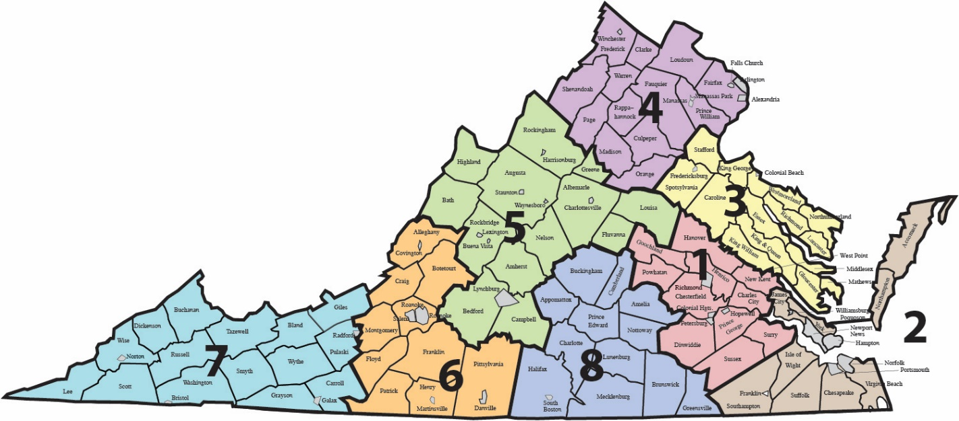
The VDOE Department of Special Populations and Board Operations staff are assigned to regional teams including one representative from each of the following offices on each team:
- Instructional Services
- Dispute Resolution
- Data, Monitoring and General Supervision
- Special Education Family Support and Special Facilities
Regional teams provide guidance for addressing the regulatory requirements and instructional elements needed for a student’s FAPE.

E-Learning
The VDOE’s special education E-Learning modules provide an opportunity for individuals to increase knowledge and skills in a variety of areas such as:
- Special Education Evaluation and Services
- Prior Written Notice
- Calculating and Reporting Placement and Services
- Back to Basics

The Virginia Tiered Systems of Supports
The Virginia Tiered Systems of Supports (VTSS) is a data-informed, decision-making framework for establishing the academic, behavioral, and social-emotional supports needed for a school to be an effective learning environment for all students. The VTSS systemic approach allows LEAs, schools, and communities to provide multiple levels of supports to students in a more effective and efficient, clearly defined process. Implementing the VTSS requires the use of evidence-based, systemwide practices with fidelity to provide a quick response to academic, behavioral, social, and emotional needs. The practices are progress-monitored frequently to enable educators to make sound, databased instructional decisions for students.
Figure 5: VTTS
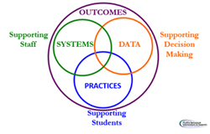

Academy for Aspiring Special Education Leaders
The Aspiring Special Education Leaders Academy is a program established to assist LEAs and state-operated programs with succession planning and is designed to help prepare potential leaders for future administrative positions in special education. This yearlong program includes workshops, seminars, observations, assignments, and field experiences. Participants have opportunities to gain knowledge, skills, and experiences that will help them excel in positions of special educational leadership. Refer to VDOE Leadership Academies for more information.

Virginia Training and Technical Assistance Centers
The VDOE supports eight Training and Technical Assistance Centers (TTACs) located at universities across the Commonwealth to improve educational opportunities and contribute to the success of children and youth with disabilities (birth to 22 years). The VDOE determines the scope of work for the TTACs, which is outlined in an annual agreement holding TTACs responsible for the regional delivery of school improvement, special education, early learning, and school readiness services to LEAs. The performance agreement details specific responsibilities in the work of TTACs with local divisions and schools, organized by priority areas.
The TTACs provide varying levels of technical assistance and professional development in these areas, based on LEA’s SPP/APR performance and compliance indicator data. The TTACs use multiple years of SPP/APR data to identify patterns of strengths and weaknesses within each LEA and across LEAs located in their regions. The TTACs also provide information and services regarding IDEA to parents and families of children with disabilities and those at risk of being identified as having a disability.
At each TTAC, consultants provide technical assistance and professional development to support identified regional issues related to SPP/APR results to those LEAs requiring special attention because of performance below SSP/APR targets. The TTACs also provide technical assistance and professional development related to early childhood programs, secondary transition, parent services, autism and low-incidence disabilities, and assistive technology.
Figure 6: Regional TTACs
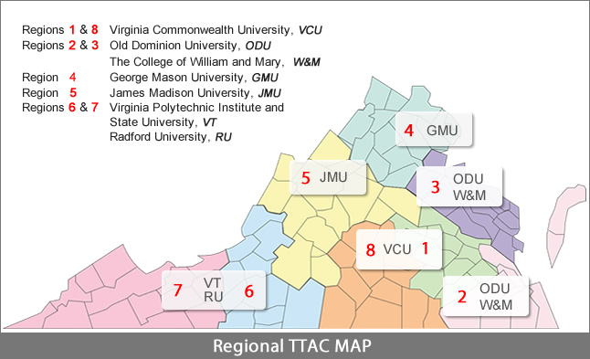

VDOE’s TTAC Online
The VDOE’s TTAC Online is a resource for professionals and family members of children and youth with disabilities (birth to 22). The website offers a wide range of resources; events (trainings, conferences, and webinars/webcasts); and free online training opportunities. Online trainings cover various topics such as assistive technology, behavior, curriculum and instruction, and secondary transition.

Specialized Technical Assistance
Virginia provides technical assistance and professional development designed to improve special education services and results for students with disabilities within specialized areas. With funding from VDOE, the following centers serve families, educators, and professionals working with students with disabilities (birth to 22).
- Accessible Instructional Materials Center of Virginia (AIM-VA) provides accessible instructional materials to eligible Virginia K-12 students who have an IEP) and are unable to access traditional print.
- Virginia Commonwealth University’s Autism Center for Education (VCU-ACE) is a university-based technical assistance, professional development, and educational research center for Autism Spectrum Disorder in the Commonwealth of Virginia.
- The Center on Transition Innovations (CTI) is a project of the VDOE to maintain a centralized statewide portal for information, resources, demonstration, and research for educators and other stakeholders in the transition of youth with disabilities. The CTI at Virginia Commonwealth University provides evidence-based resources and information along with emerging practices in the field.
- The I’m Determined project, a state-directed project funded by the VDOE, focuses on providing direct instruction, models, and opportunities to practice skills associated with self-determined behavior.
- The Assistive Technology (AT) Network of Virginia addresses priorities of VDOE with coordination, implementation, and dissemination of information about the laws that define AT devices and services, the process of AT Consideration by IEP Teams, AT assessment, Augmentative and Augmentative Communication (AAC), and AT resources.
- The Center for Family Involvement is funded by VDOE and other agencies such as the Administration on Intellectual and Developmental Disabilities (AIDD) and the Virginia Department for Aging and Rehabilitation Services (DARS). The Center works with families to increase their skills as advocates, mentors, and leaders.
- Virginia’s Parent Resource Centers (PRCs) are committed to a positive relationship between parents and schools. The PRCs assist parents with questions and planning, as well as provide resources and training sessions.

VDOE Special Education Grants & Funding web page
Federal regulations: 34 CFR Part 80 Uniform Administrative Requirements for Grants and Cooperative Agreements to State and Local Governments; 34 CFR §§80.40, 80.26, 300.149, and 300.600 Uniform Administrative Requirements, Cost Principles; and Audit Requirements for Federal Awards (Uniform Guidance) 2 CFR Part 200. §§200.328, 200.331 a-h, 200.425, and 200.521.

