Volume and Surface Area of Rectangular Prisms and Cylinders
Strand: Measurement and Geometry
Topic: Find the volume and surface area of rectangular prisms and cylinders
Primary SOL: 7.MG.1 The student will investigate and determine the volume formula for right cylinders and the surface area formulas for rectangular prisms and right cylinders and apply the formulas in context.
a) Develop the formulas for determining the volume of right cylinders and solve problems, including those in contextual situations, using concrete objects, diagrams, and formulas.
b) Develop the formulas for determining the surface area of rectangular prisms and right cylinders and solve problems, including those in contextual situations, using concrete objects, two-dimensional diagrams, nets, and formulas.
Materials
- Exploring Surface Area with Nets activity sheet (attached)
- Student Notes and Understanding the Formulas activity sheet (attached)
- Applying the Formulas activity sheet (attached)
- Various cylinders and rectangular prisms
- Scientific calculator

Vocabulary
base, cylinder, faces, height, length, rectangular prism, surface area, volume, width, net

Student/Teacher Actions: What should students be doing? What should teachers be doing?

- Distribute the Exploring Surface Area with Nets activity sheet. Students should label the dimensions of each face, then find the area of each face and the total surface area for each figure.
- After students have labeled the dimensions and determined the surface area, facilitate a discussion about what dimensions are needed to determine the surface area of each figure. Continue the discussion by noting the formulas that students may generalize.
Students should generalize that the surface area for a cube can be found by finding the area of one face, then multiplying by six because a cube has six congruent square faces.

Students should generalize that the surface area for a rectangular prism can be found by adding the area of the top and bottom faces, left and right faces, and front and back faces. Students should make the connection that opposite faces on a rectangular prism are congruent and there is only the need to find that area once, then double it as part of finding the total surface area of the rectangular prism.

- Distribute the Student Notes activity sheet to each student. Students should fill in the boxes/blanks throughout the discussion.
- Activate prior knowledge by discussing the characteristics of a rectangular prism and a cylinder. Be sure to include discussions about the number of faces and the base of each object.
- Ask students to provide real-world situations where volume and surface area would be used. Review how to find the volume of a rectangular prism. Ask students to consider what dimensions of a rectangular prism are needed to determine volume as well as how a rectangular prism and a cylinder are similar.
- During the discussion, students should formalize the generalizations previously discussed to the following formulas:
Rectangular Prism | Cylinder
S.A. = 2lw +2lh + 2wh  V = lwh  V = Bh | S.A. = 2πr² + 2πrh  V = πr²h  V = Bh
- Help students explore the formulas needed to determine the surface area and volume of each object. Include discussions about volume being measured in cubic units and surface area in square units.

Assessment

Questions
- How do you determine the surface area and volume of a cylinder?
- How do you determine the surface area and volume of a rectangular prism?
- How are volume and surface area related? How are they different?
- What is volume? Why is volume measured in cubic units?
- What is surface area? Why is surface area measured in square units?

Journal/writing prompts
- Describe to another student what surface area is and how to find it.
- Explain how surface area differs from the volume of a rectangular prism.
- Ask students to write about how surface area is used in the real world.
- Describe a practical example of when you would need to find the volume of a rectangular prism or cylinder.
- Describe a practical example of when you would want to know the surface area of a rectangular prism or cylinder.
- Pretend that you are painting a cylinder-shaped water tank. Explain how the formula would change if you do not need to paint the bottom of the tank.

Other Assessments
- Provide real-life items and ask the students to determine the volume and surface area (e.g., soft drink can, potato chip can, oatmeal container, cereal box, shoe box). Students can use a ruler to determine the measurements.
- Create nets on graph paper, and ask students to measure and determine the volume and surface area of the given shapes.
- Distribute the Applying the Formulas activity sheet and have students complete it.
- Additional practice: Ask the students to find the volume and surface area for various objects around the room (e.g., can, book, box).

Extensions and Connections (for all students)
- Have students create posters showing the surface area and volume of cylinders and rectangular prisms. Posters should include definitions, diagrams, and examples.
- Have each student construct a cylinder and ask a partner to find the surface area and volume. Have students compare their cylinders.
- Given five rectangular prisms, have students put them in order from least to greatest according to volume and surface area.
- Have students design their own label for a cylinder.
- Provide the formula and ask students to find the surface area and volume for a triangular prism.
- Have each student create a rectangular prism and ask a partner to solve for the surface area.
- Ask students to create a Venn diagram that compares volume with surface area.

Strategies for Differentiation
- Place the net of the cylinder or rectangular prism on grid paper.
- Begin with prisms that have attributes that are whole numbers less than 10. Give plenty of practice building prisms with the cubes. Allow students to find the volume and surface area by counting the cubes.
- Relate the base of the prism to the classroom floor.
- Make a T-chart with length, width, and height to assist in calculating the surface area of a rectangular prism.
- Have the students create practical problems involving volume and surface area of rectangular prisms and cylinders.
- Provide worked examples on the recording sheet for some students, if necessary.
Note: The following pages are intended for classroom use for students as a visual aid to learning.

Exploring Surface Area with Nets
Directions: Label the dimensions and find the area of each face in the nets below.
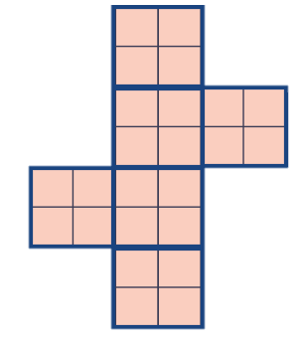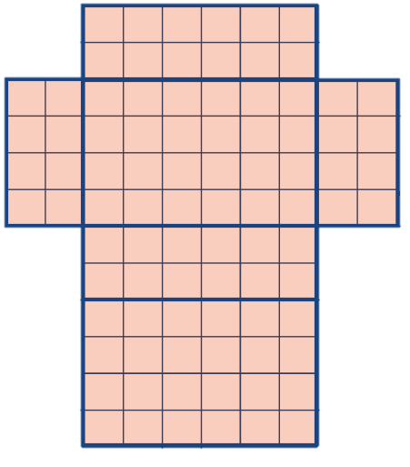
Total Surface Area = _____________ Total Surface Area = _____________
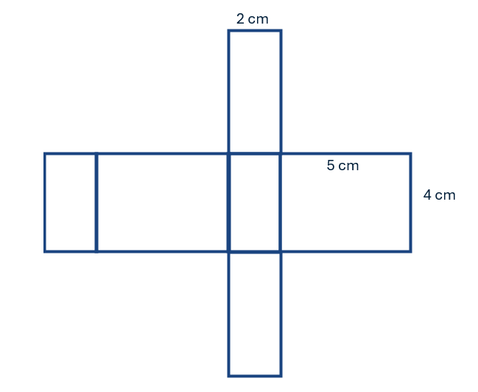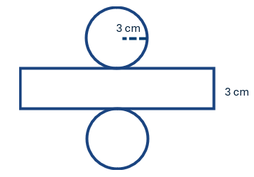
Total Surface Area = _____________ Total Surface Area = _____________

What dimensions do you need to know to determine the surface are of each figure?

How could this be generalized to a formula?
Student Notes
Characteristics of a Rectangular Prism  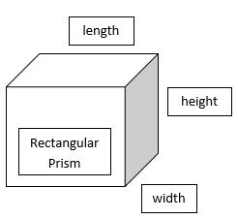 | Characteristics of a Cylinder  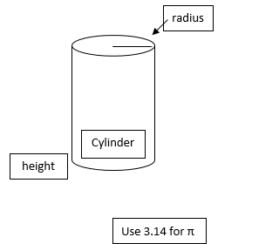
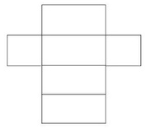  Surface Area  SA=_____________________________  Volume  V=____________ | 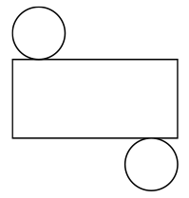  Surface Area  SA=_____________________________  Volume  V=____________

Practical Situations where Volume  is used  Volume represents filling up an object | Practical situations where surface area  is used  Surface Area represents covering an object

Applying the Formulas
Directions: Find the volume and surface area for the following shapes.
-Write the formula -Substitute the values -Find the answer
