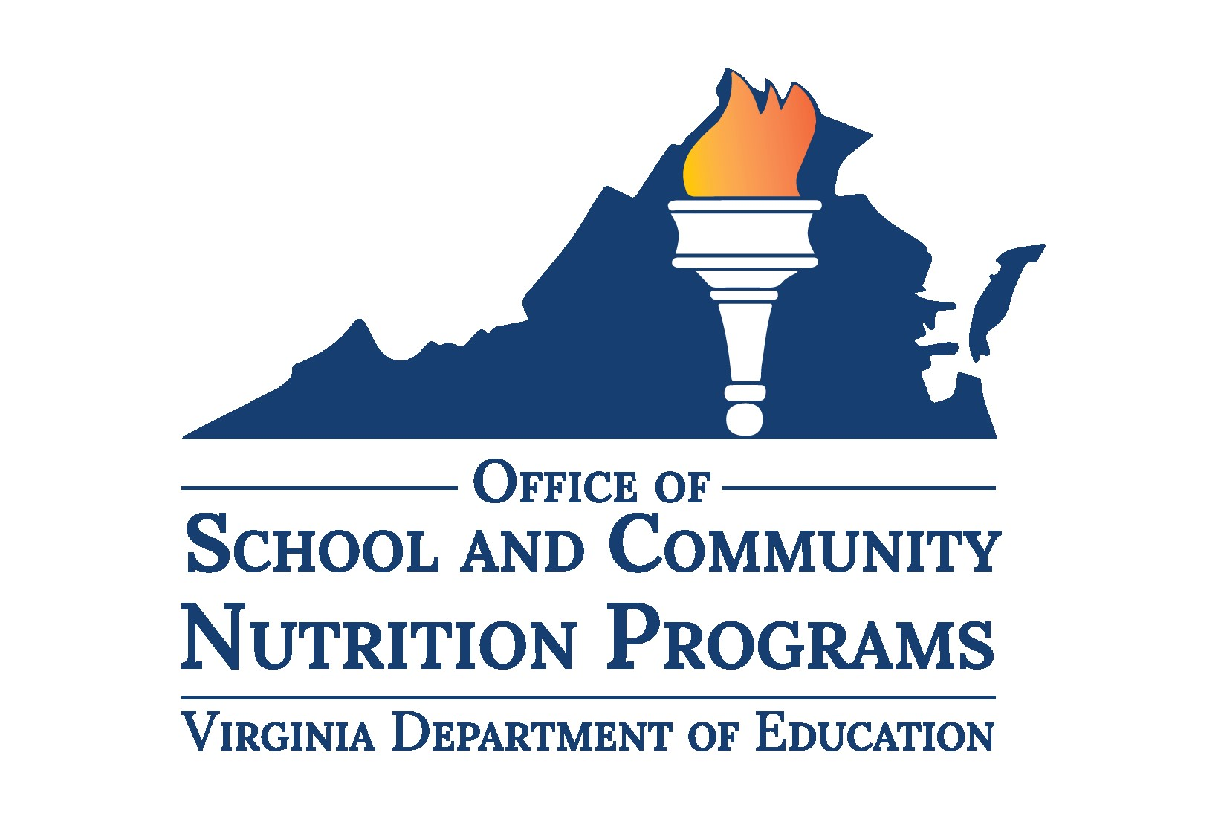

Local School Wellness Policy Checklist
Instructions: Complete this checklist to ensure your Local School Wellness Policy (Wellness Policy) complies with United States Department of Agriculture Food and Nutrition Service (USDA-FNS) 7CFR210-31 and the Virginia Code 8VAC20-740 requirements. For additional resources, reference the Virginia Department of Education, Office of School and Community Nutrition Programs (VDOE-SCNP) website.

USDA-FNS Requirements
☐ Leadership- Designate the position or individual responsible for Wellness Policy oversight.
For example, "The school wellness coordinator and the School Health Advisory Board (SHAB) shall implement and ensure compliance with the policy by leading the review, update, and evaluation of the policy.”
☐ Public Involvement – Notify the public of their ability to participate in the development, implementation, and review of the wellness policy.
For example, “The division will involve a diverse group of stakeholders in developing, implementing, and regularly reviewing and updating the policy. This group may include parents, students, teachers, school health professionals, the school board, school administrators, the public, and representatives of the school food authority. The public will be notified on the division website.”
☐ School Meals – Serve school means that follow USDA-FNS meal regulations and include language about these requirements in their Wellness Policy.
For example, "All meals served to students meet or exceed current nutrition requirements established under the Healthy, Hunger-free Kids Act of 2010 (7CFR210.10 and 7CFR220.8). (National School Lunch Program Meal Pattern Chart | Food and Nutrition Service)"
☐ Foods Sold Outside of School Meals Programs – Sell only USDA Smart Snacks compliant foods and beverages outside of the school meals program.
For example, "All food and beverages sold outside of the school meal programs shall meet the standards established in USDA's Nutrition Standards for Smart Snacks rule (https://www.fns.usda.gov/school-meals/tools-schools-focusing-smart-snacks). The school day is defined by USDA as the period from midnight the night before to 30 minutes after the end of the instructional day."
☐ Foods Provided, Not Sold – Set division guidelines for foods provided, not sold, including at celebrations, given as rewards, or classroom snacks.
For example, "Foods and beverages offered on the school campus must meet or exceed the USDA Smart Snacks nutrition standards including those provided at celebrations or classroom snacks. Non-food celebrations will be promoted, and a list of ideas is available to staff and family members. Foods and beverages will not be used as a reward or withheld as punishment."
☐ Marketing – Market or advertise only food and beverages that meet Smart Snack guidelines, and this must be stated in the Wellness Policy.
For example, "Schools will restrict food and beverage marketing or advertising to only those foods and beverages that meet the USDA's Smart Snacks rule."
☐ Nutrition Education – Include at least one evidence-based goal for nutrition education.
For example, “The division will provide at least 140 minutes of nutrition education and exceed the expectations of the Virginia Department of Education (VDOE) Health Standards of Learning (SOLs) by integrating nutrition concepts and skills into mathematics, language arts, social science, and elective courses throughout the school year.”
☐ Nutrition Promotion – Include at least one evidence-based goal for nutrition promotion.
For example, “Staff shall integrate farm to school experiential activities—such as school gardening, cooking demonstrations, or farm tours—into existing curricula at all grade levels.”
☐ Physical Education/Physical Activity – Include at least one evidence-based goal for physical education and/or physical activity.
For example, “The division will provide every student with physical education that exceeds the expectations of the VDOE Physical Education SOLs; teaching the skills needed to achieve and maintain a health-enhancing level of personal fitness and develop the knowledge, attitudes, behaviors, and confidence needed to be physically active for life.”
☐ Other Activities that Promote Student Wellness – Include at least one evidenced-based goal for other activities that promote student wellness.
For example, “Using the Collaborative for Academic, Social, and Emotional Learning (CASEL), schools will provide students with instruction to increase self-awareness, self-management, social awareness, relationship skills, and responsible decision-making.”
☐ Triennial Assessment – Complete a Triennial Assessment and notify the public
For example, “The division will evaluate compliance with the Wellness Policy by completing a Triennial Assessment at least once every three years. The assessment will review how well each school follows the division Wellness policy, the progress made towards achieving the policy’s goals, and how the Wellness Policy compares to the model policy." Triennial Assessments for this cycle were due June 30, 2024.
☐ Public Update and Information –Specify how the public will be informed about the implementation and content of the policy.
For example, "Annually, the division will inform the public about the content of and/or any updates to the Wellness Policy through the division or school website."

Virginia Code Requirements
☐ Compliant Fundraisers –Permit only Smart Snack compliant food and beverage fundraisers. LEAs may choose to allow up to 30 school-sponsored food and beverage fundraisers per site per school year to be exempt from Smart Snacks guidelines. Schools are not required to allow exemptions and can set stricter guidelines in their Wellness Policy.
For example, “All school-sponsored fundraisers must meet the USDA Smart Snacks rule.” OR “Schools may allow up to 30 school-sponsored food and beverage fundraisers per site during the school year to be exempt from Smart Snack Standards.”
☐ Fundraiser Times – Prohibit any food or beverage fundraisers during mealtimes.
For example, “Any fundraiser that sells food or beverages may not be conducted during school meal service times. This includes from 6:00 a.m. to the end of the breakfast period and from the beginning of the first lunch period to the end of the last lunch period.”
☐ Fundraiser Designee – Designate an individual at the division or school level to monitor and ensure compliance with exempt school sponsored fundraisers. This person cannot be part of the school nutrition staff and the designee’s name or position must be included in the division’s Wellness Policy.
For example, “Exempt fundraisers are tracked and monitored by the school principal and records are kept on file in the Main Office.”

(Optional) Additional Recommended Wellness Topics
☐ Scratch cooking
☐ Student inspired meals/recipes
☐ Farm to school activities
☐ Alternative breakfast models
☐ School health advisory board or similar
☐ Social and emotional health
☐ Active transportation
☐ Longer mealtimes
☐ Physical activity breaks in the classroom
☐ Active academics
☐ Community partnerships
☐ Sustainability activities
☐ Staff health and wellness programs
☐ Healthy hydration

