2026 Virginia Governor’s World Language Academies

User Guide for Navigating the Survey Monkey Apply Application System


2026 Virginia Governor's World Language Academies
User Guide for the Survey Monkey Apply Application System


Table of Contents
Overview of GWLA Application Process 3
Section 1: Setting up the Application (Tasks 1 – 5) 4
Review the Guide for Students and Parent/Guardians. 4
Create an Account 5
Student Registration 5
Starting the Application 5
Task List 6
Task 1 Check Eligibility 6
Marking a Task Complete 6
Confirming Task is Complete 7
Task 2 Download Application Planning Form 7
IMPORTANT NOTES ABOUT EMAIL ADDRESSES 7
Task 3 Confirm School Notification 8
Error Messages 8
Correcting information after task completion 9
Task 4 Complete the Student Information Form 9
Considerations 10
Agreements 10
Signature 11
Task 5(a) Inviting a Parent/Guardian to the application 11
Task 5(b) Parent/Guardian Approval 12
Section 2: Student Application Questions (Task 6) 14
Task 6(a) Background and Motivation 14
Task 6(b) Character and Dispositions 14
Task 6(c) Essay for Applicants to the Japanese and Latin Academies. 15
Section 3: Recommendations and Request for Nomination (Tasks 7-10) 15
Task 7 Request Transcripts from School Counselor 15
Task 8 Request Recommendation from World Language Teacher 16
Task 9 Request Recommendation from 2nd Adult 16
Task 10 Request Nomination from School Principal or Designee 17
School Decision 17
Section 4: Language Testing and Submit Application (Task 11) 17
Task 11 Confirm Language Testing and Submit Application 18

Overview of GWLA Application Process
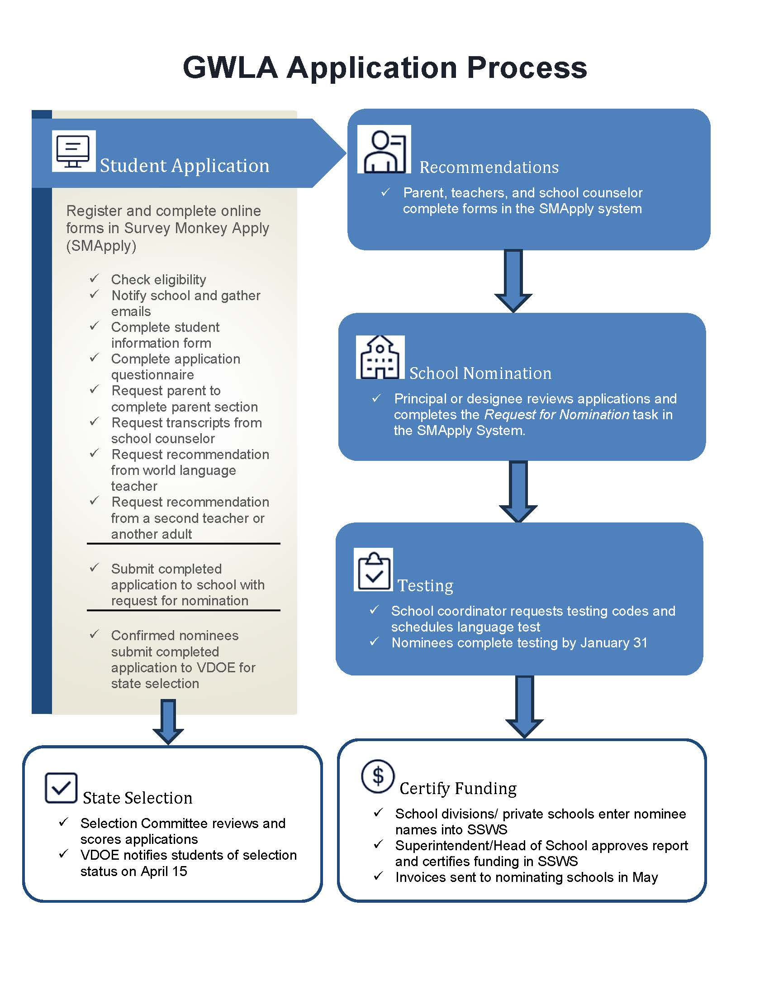

Navigating the Application Process in Survey Monkey Apply

This guide provides detailed instructions and screenshots of the application process in the SMApply System. The application guide is divided into four sections:
- Section 1: Setting up the application
- Section 2: Student application questions
- Section 3: Recommendations and Request for Nomination
- Section 4: Language Testing and Submission of Application to the State

Section 1: Setting up the Application (Tasks 1 – 5)
In this section, the student applicant will:
- create their account on the SMApply Application system,
- gather information needed to complete the application,
- inform the school of their intent to apply,
- enter contact information, and
- have a parent/guardian approve participation in the application process.

In Task 5, the student will invite the parent/guardian to approve their participation in the application process. The parent must complete this task before the student can continue with the application process.

Application Task | Screenshot
Review the Guide for Students and Parent/Guardians.  Note: Dates in this Guide reflect the VDOE deadlines. Check with your local school division to see if they have any earlier local deadline. | 
Create an Account  Student creates an account on the Survey Monkey Apply Platform (Parent/Guardian will create their account later in the process.)  - First time users: Click on the green Register button in the upper right corner of the screen.  - Returning users: Click on the Log In button.  - Help: To get help with logging in, click on the i button in the black circle and complete the support request form. | 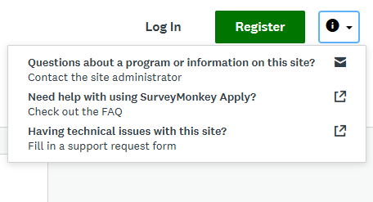
Student Registration (Parent/Guardian will register later in the process.)  Notes:  - Use the student’s legal first and last names as used to register for school to enable record matching.  - A personal email usually works better than a school-based email.  - Check with your school IT staff before completing the online registration if you want to use a school-based email. Refer IT staff to the Guide for Schools, page 10 for notes about emails from SMApply.  - Do NOT use the register with Google link as it will cause a conflict when logging in. | 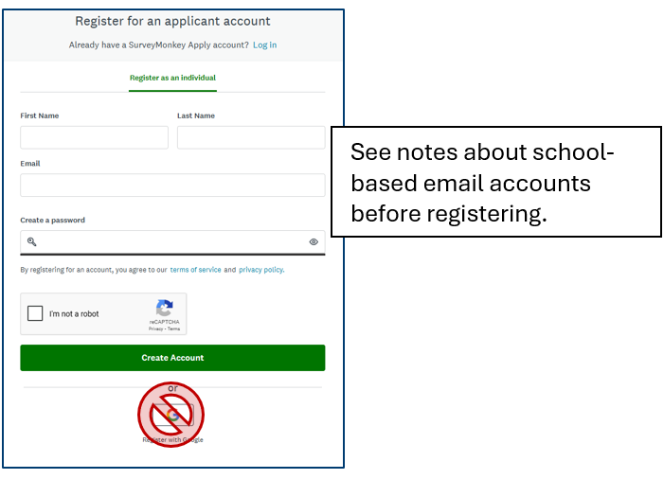
Starting the Application  Access the GWLA application on the Survey Monkey Apply Platform and click the green Apply button.  Direct link to application portal: https://vdoe.smapply.us/prog/GWLA2026/ | 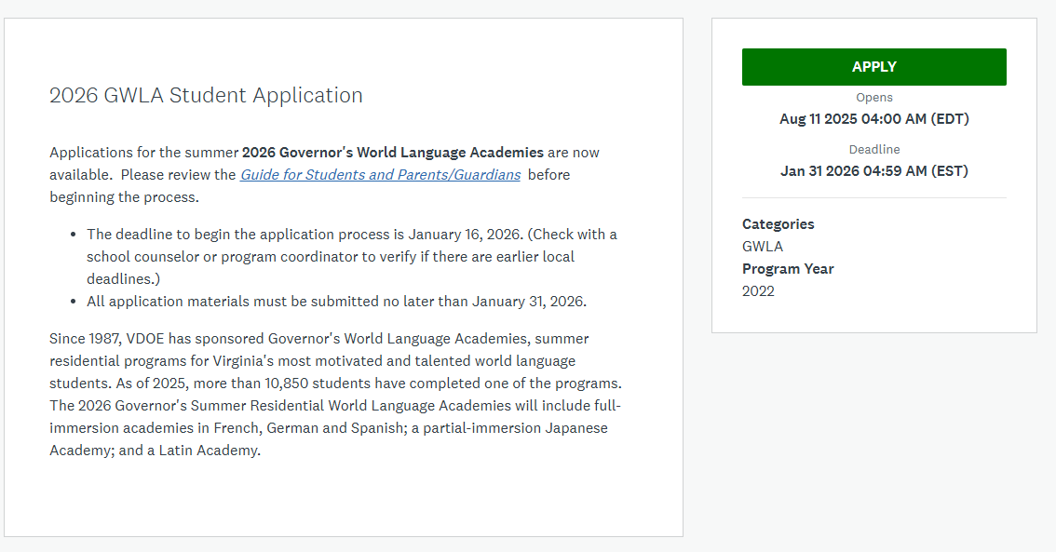
Task List  Your application will now show as a list of tasks to be completed.  - When a task is started, it will show as a half-filled green circle.  - You will need to complete Task 1, Check Eligibility, before you can do anything else in the application. | 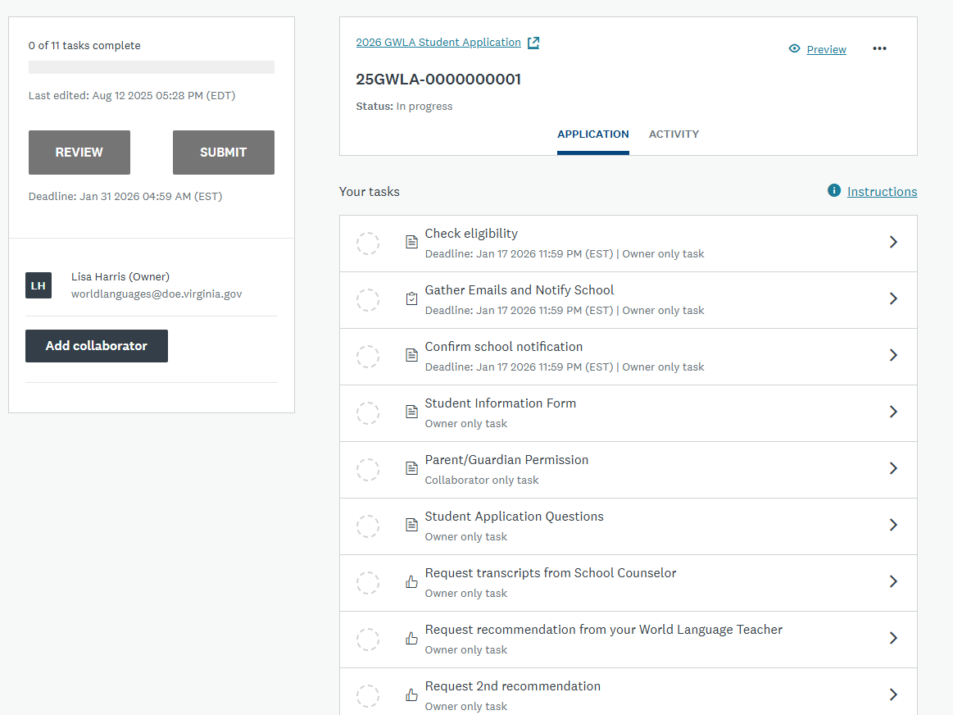
Task 1 Check Eligibility  Before continuing, complete the Eligibility Quiz.  - If you meet the eligibility requirements, you will move on to the next task.  - If you do not meet the requirements, your application will be closed, and you will receive an email notification indicating that you are not eligible for the program.  Important Note: Read each question carefully to ensure you are not disqualified in error by marking the wrong response. | 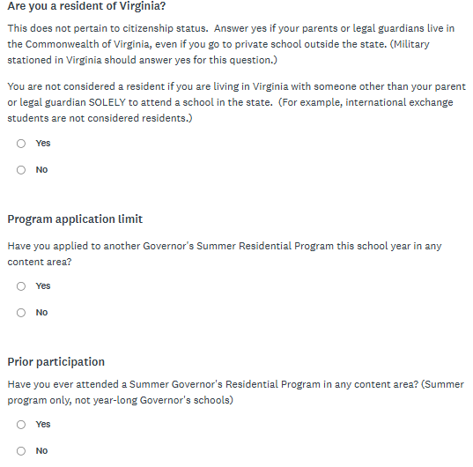  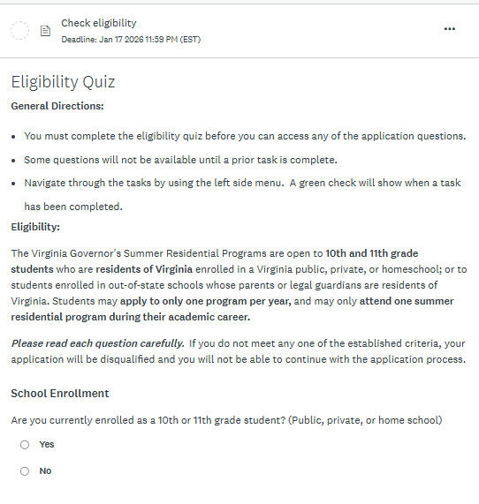
Marking a Task Complete  When you have finished answering all questions in the task, click on the green Mark as Complete button at the bottom of the page. | 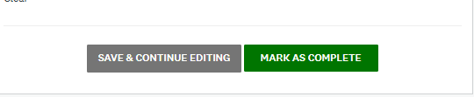
Confirming Task is Complete  When you mark a task complete, the circle next to that item in your application task list will now show as a green circle with a checkmark.  You can now click on the next item in the list to begin that task. | 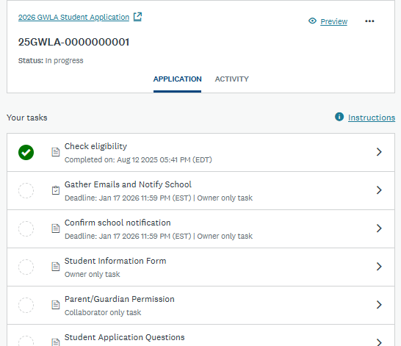
Task 2 Download Application Planning Form  - Download the planning form.  - Mark the task complete.  - You do not need to enter any notes in the comment box.  - Use the form to gather the information you will need to complete the application before continuing to the next task.  Important Notes about Email Addresses  - It is very important that you obtain and enter the correct email address for your recommendations.  - Some teachers have dedicated personal emails they use for recommendations, such as Teacher.Name.Recommendations@gmail.com.  - Some schools have two types of accounts. Be sure to send all requests to the email that can receive messages from outside your school system.  - If you are not sure, check with your school's IT staff to confirm the email address that should be used. | 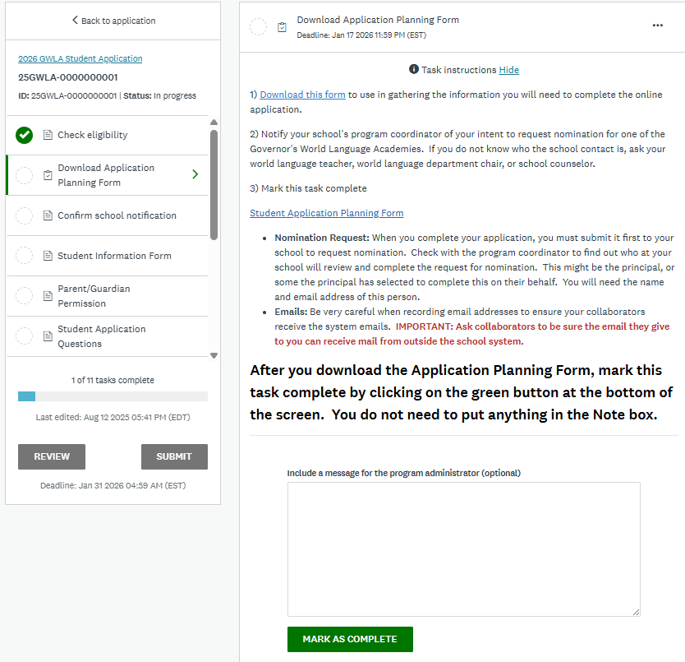
Task 3 Confirm School Notification  - Enter the name and information for the school’s GWLA coordinator whom you have notified of your intent to apply.  - Confirm who will approve nomination requests.  - If the principal has named a designee to approve nominations, list the name and email of designee. | 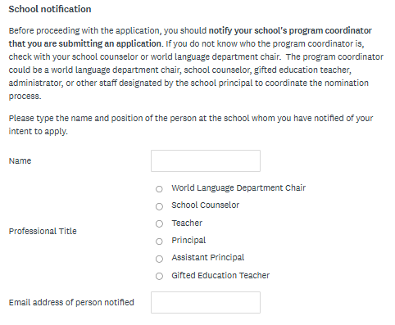  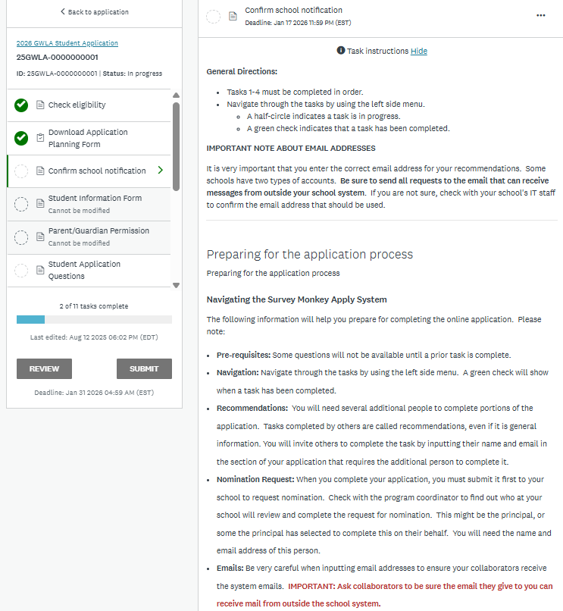
- Check off each item in the list to confirm you have the necessary emails.  - Mark the task as complete.  When this task is marked as complete, an email notification will go to the person listed as the program coordinator. | 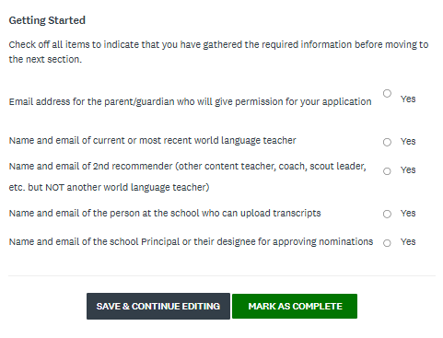
Error Messages  If you miss a question or enter information that is not recognized, you will get an error message on the task and the circle next to the task name will show as incomplete. Review the error message and make corrections, then hit the Mark as Complete button again. | 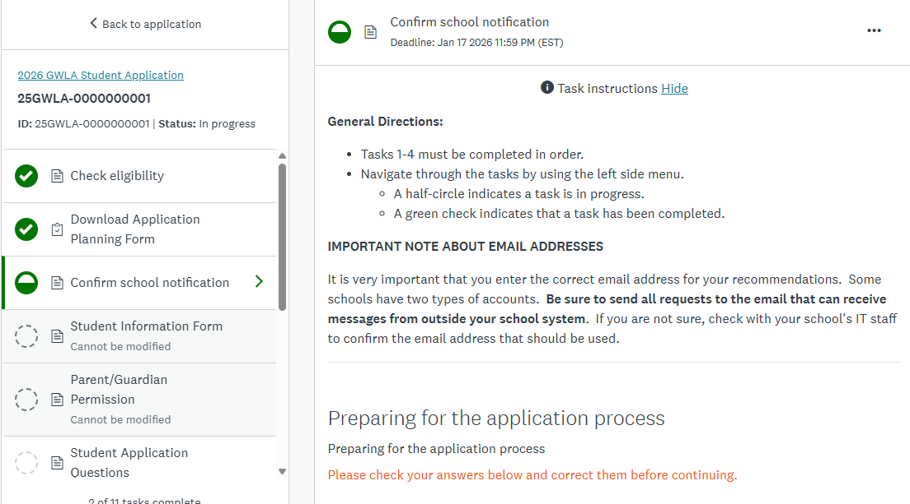
Correcting information after task completion  If you find an error after marking the task as complete,  - Open the completed task by clicking on the name in the task list.  - Click on the three dots in the upper right corner of the task screen and select “edit” from the drop down list.  - This will re-open the task so you can make changes. | 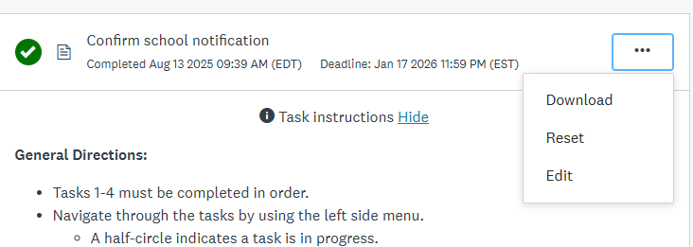
Task 4 Complete the Student Information Form  Enter the first and last names that are used on your school records.  If you do not have a middle name, you can enter a (-) as a placeholder so the field shows as completed. | 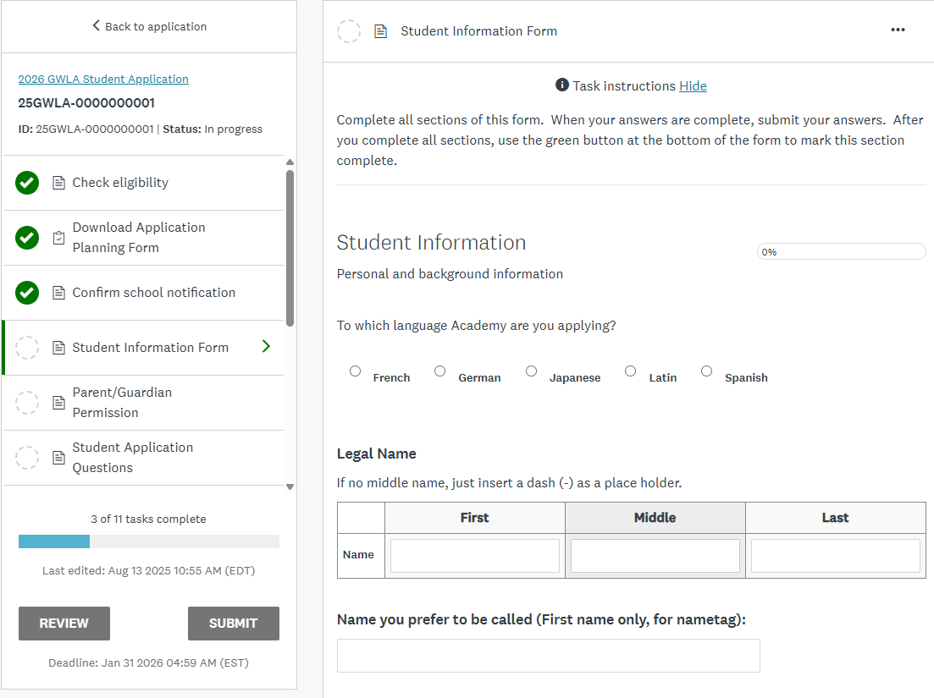
Enter the information for the parent/guardian who will be the primary contact person.  This is the person whom you will invite in Task 5 to join the application to give parental approval. | 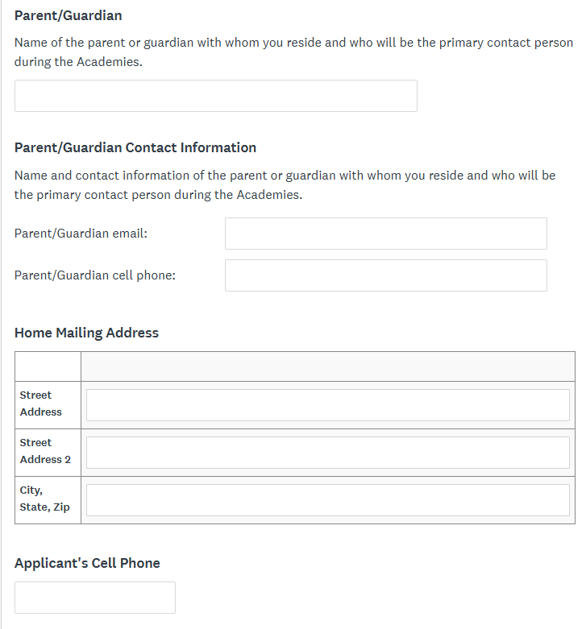
Enter your school information, then click on the green Next button at the bottom of the page. | 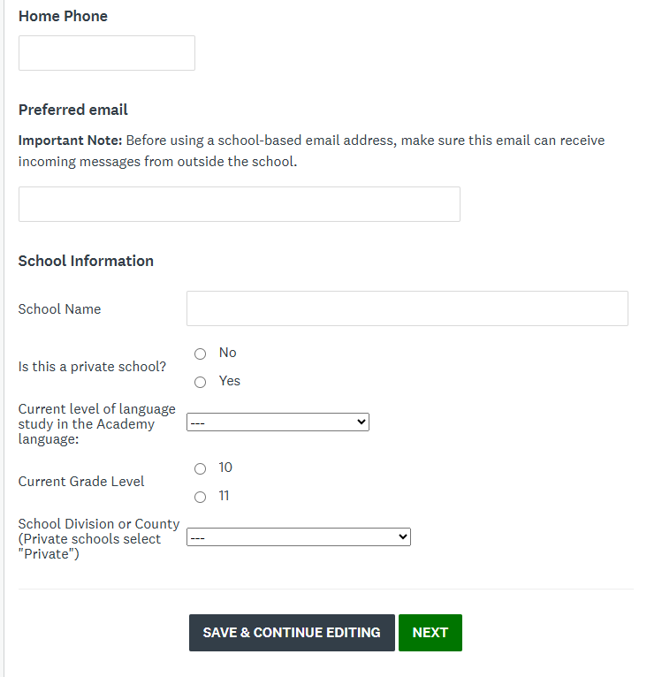
Considerations  Consider each item carefully to decide if the Academies are a good fit for you, then mark your answer to each item. | 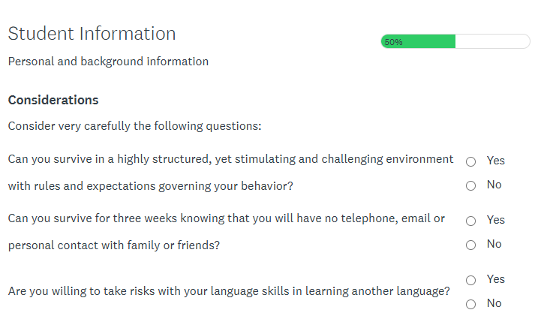
Agreements  Consider each item carefully to decide if the Academies are a good fit for you, then mark your answer to each item. | 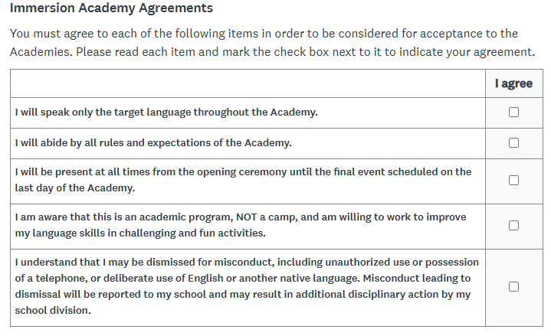
Signature  Use your mouse or touch screen to sign the form.  When you have finished, click on the green Mark as Complete button at the bottom of the page. | 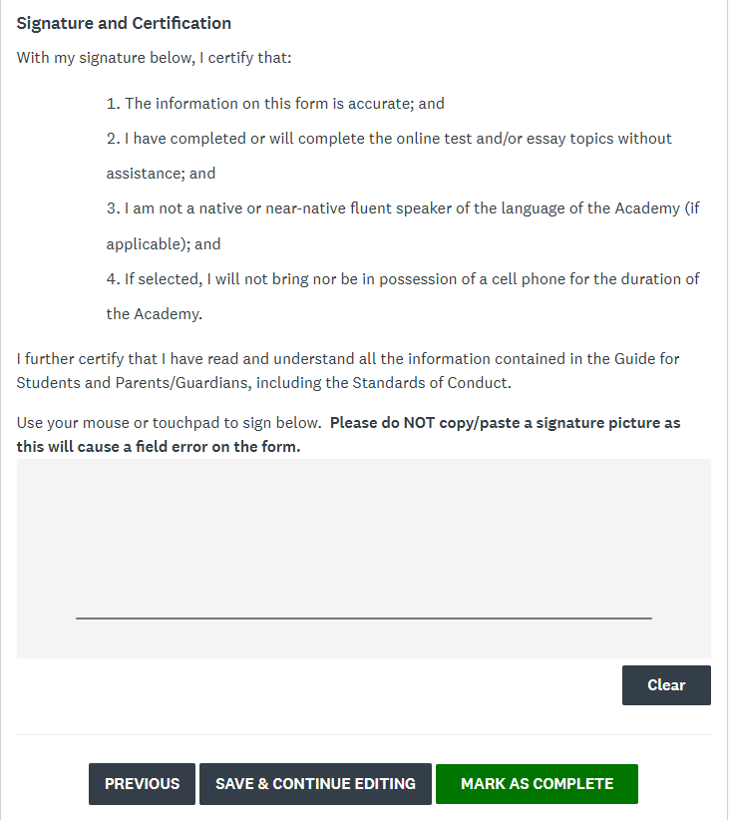
Task 5(a) Inviting a Parent/Guardian to the application  The student must invite a Parent or Guardian to complete Task 5.  Open Task 5 and click on the Add Collaborator button to invite a parent/guardian to complete the task. | 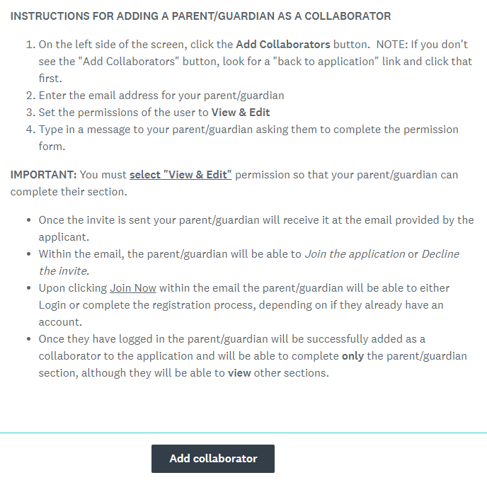
On the pop-up screen, enter the email for the parent/guardian who will approve your participation, then click on the green Send Invite button.  - Be sure to check the email address with your parent/guardian as this will be the email they use as a login name and where all notifications will be sent.  - Advise your parent/guardian to look for the email and search their SPAM or junk folder if they don't see it. | 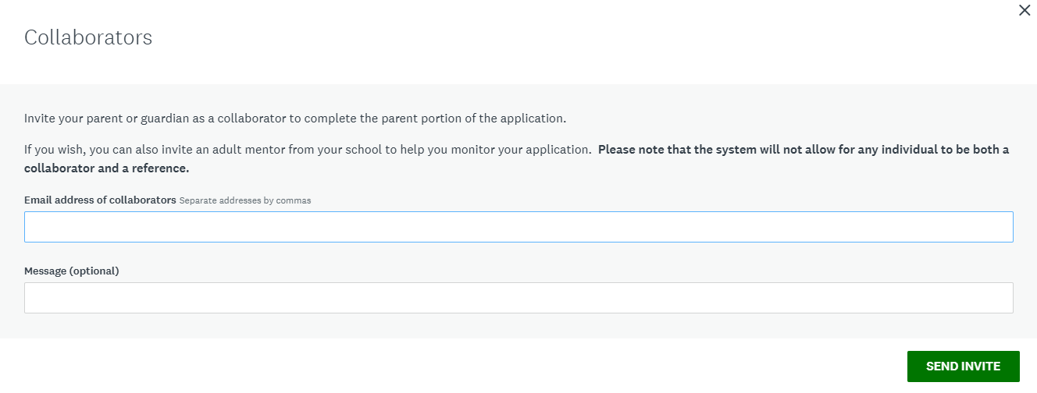
On your main application page, you will now see your parent listed as a collaborator.  At this point, you can also invite a teacher, counselor, or other advisor to join the application as a collaborator to assist you in monitoring progress on the application.  If you need to edit access or resend the invitation to a collaborator, click on the three dots next to their email address. | 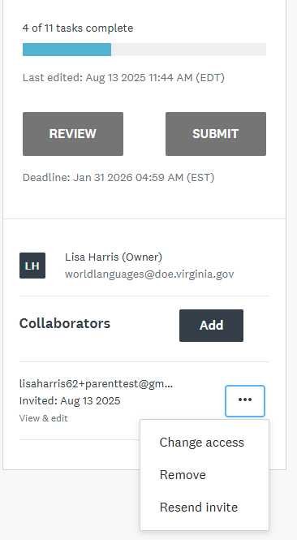
Task 5(b) Parent/Guardian Approval  The parent/guardian will receive an email inviting them to join the application.  Parent/Guardian: Click the green Join Now button in the email to accept the invitation and complete Task 5. | 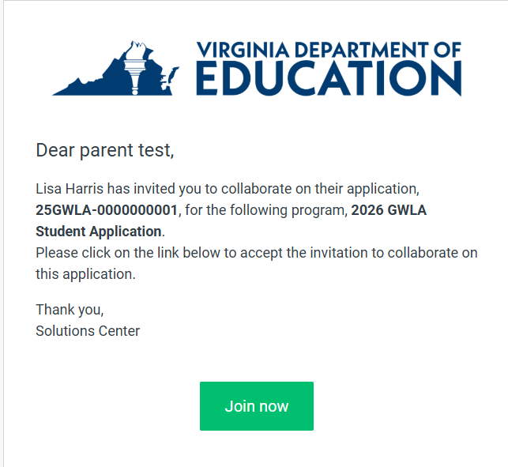
Parent/Guardian: On the Log in screen, click on the Register button in the upper right hand corner.  X - Do not use the Login with Google button as this may cause a conflict in the system that doesn’t link your account to the student’s application. | 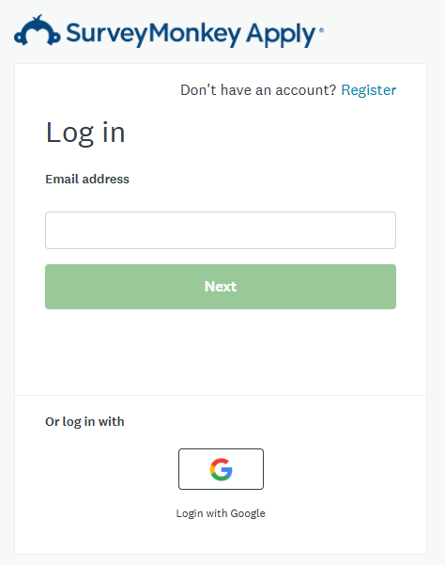
Parent/Guardian: Enter your name and email address, and create your password.  Important Note: Enter the exact email address where the student sent the invitation. If you use a different email, it will not link your account to the student application.  You will receive an email asking you to verify the email address. Follow the instructions on the email to login to the SMApply site. | 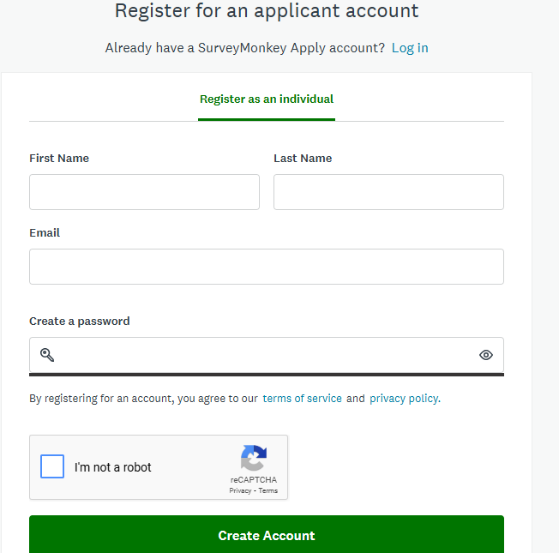
Parent/Guardian: When you click the link in the verification email, you will get this message. Click on the green Continue to application button to see the student’s application. | 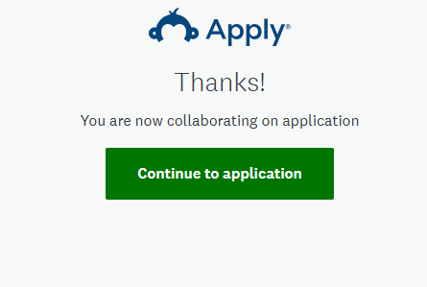
Parent/Guardian: In the center of the application screen, or on the left side application menu, click on Parent/Guardian Permission. | 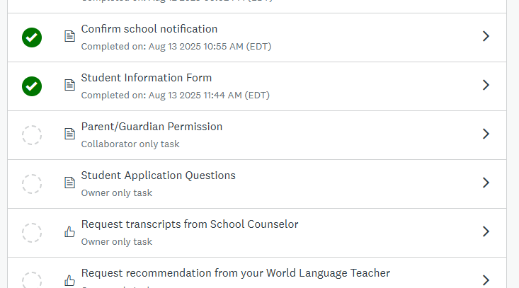
Parent/Guardian: Complete the information fields, then use your mouse or touch pad to sign the form.  When finished, click the green Mark as Complete button at the bottom of the page.  After you complete Task 5, inform the student they may log in and continue with the application.  The parent/guardian will continue to have view access, but only the student can complete the remaining tasks. | 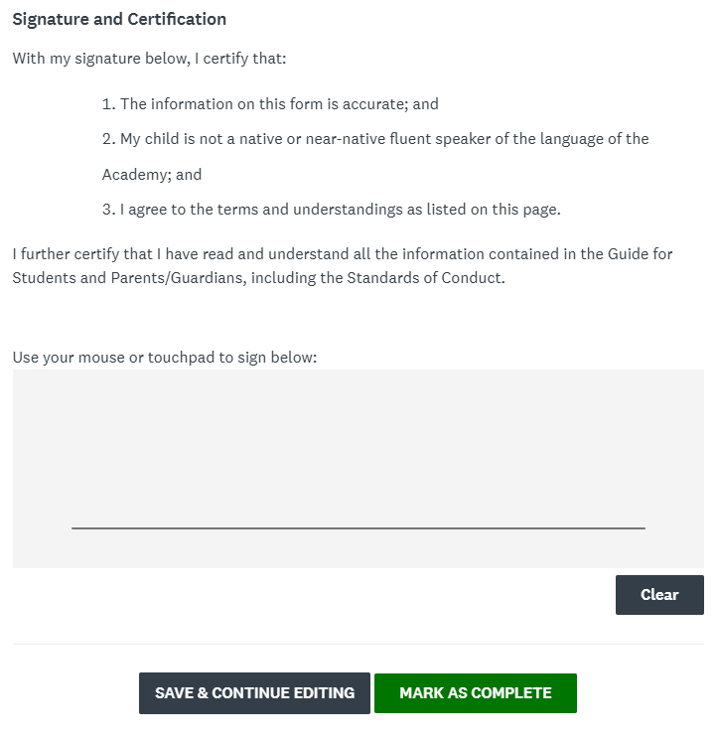

Section 2: Student Application Questions (Task 6)
In this section, the student applicant will:
- Answer questions about their background and motivation for attending the Academies,
- Reflect on their dispositions and expectations, and
- Write an essay in English (Latin and Japanese applicants only. French, German, and Spanish applicants will respond to writing prompts in the target language as part of the STAMP test.)

Application Task | Screenshot
Task 6(a) Background and Motivation  In questions 1-10 applicants will share information about their language and academic background, and their reasons for wanting to attend the Academy. When you have finished all questions on this page, click the green Next button at the bottom of the screen.  - If you are not finished with section, you can click the black Save and Continue Editing button to save your work and return later.  - You will not be able to move forward until you have answered all questions on this page. | 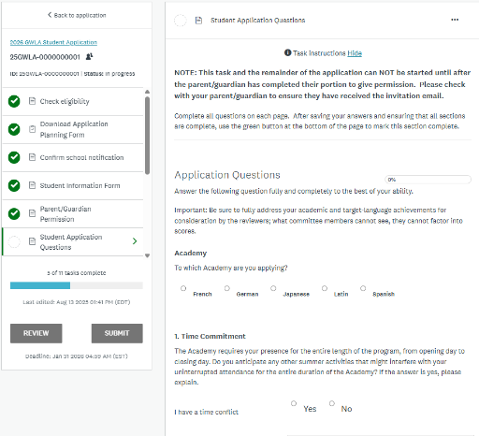  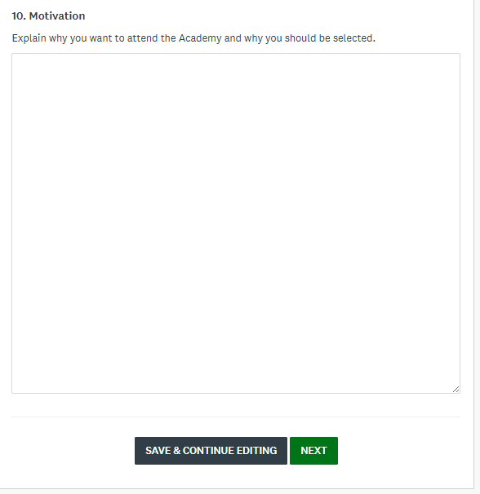
Task 6(b) Character and Dispositions  In questions 11-19 applicants will share information about their interests, talents, adaptability, and personal traits. When you have finished all questions on this page, click the green Next button at the bottom of the screen.  - In addition to the Save and Continue, and Next buttons, on this page you can also use the Previous button to go back to the previous section. | 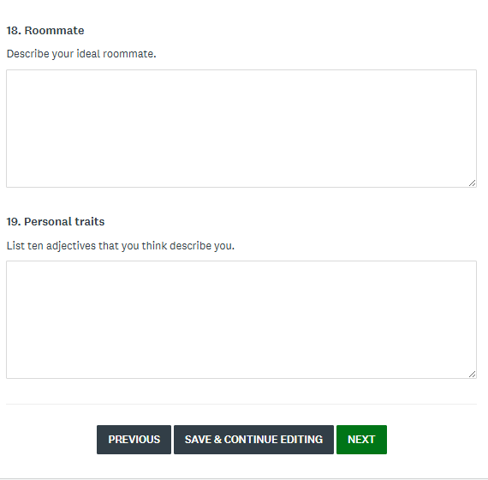  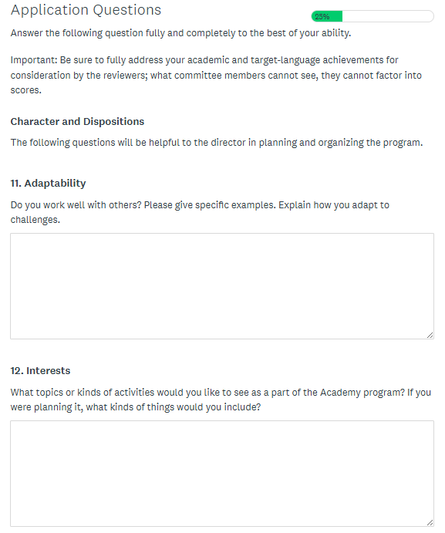
Task 6(c) Essay for Applicants to the Japanese and Latin Academies.  This task will only show if you have selected Japanese or Latin as the Academy on the opening page of this section as shown in the screenshot for Task 6(a).  - The essay prompt will show after you click on the Next button in Task 6(b).  - The essay prompt will generate based on the language you selected and differs for each language.  - Your response is limited to 500 words written in English.  - The essay must be your own work. All responses will be verified through a content checking website. | 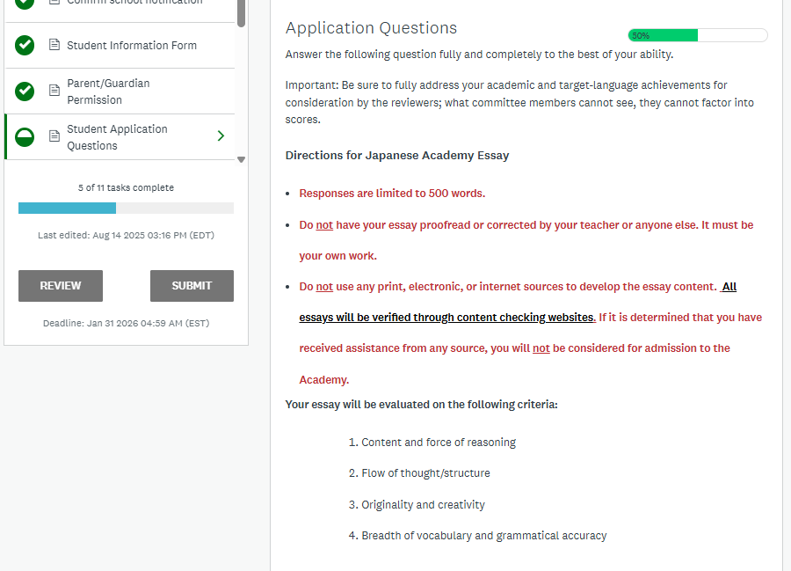

Section 3: Recommendations and Request for Nomination (Tasks 7-10)
In this section, the student applicant will:
- request for transcripts to be uploaded by a school counselor,
- request a recommendation from the current or most recent world language teacher,
- request a recommendation from a 2nd teacher or other adult, and
- request nomination from the school principal or their designee.

Application Task | Screenshot
Task 7 Request Transcripts from School Counselor  - Click on Task 7 in the application menu to initiate the recommendation request to the school counselor.  - In the task screen, click on the green Request a Recommendation button.  - In the pop up screen, enter the name of the school counselor, and the email address. Remember to use only an email that has been confirmed to accept mail from outside the school district.  - Enter a message to counselor asking them to accept the request so they can upload your transcripts.  - The task screen will now show a half-filled circle to indicate the request has been sent.  - When the recommender completes their part of the task, the circle will change to a solid fill with a check mark.  - You will not be able to see the contents of the recommendations.  - If you need to resend the request, click on the three dots next to the date.  - When the recommender completes their part, you will see the date it was submitted on your task screen. | 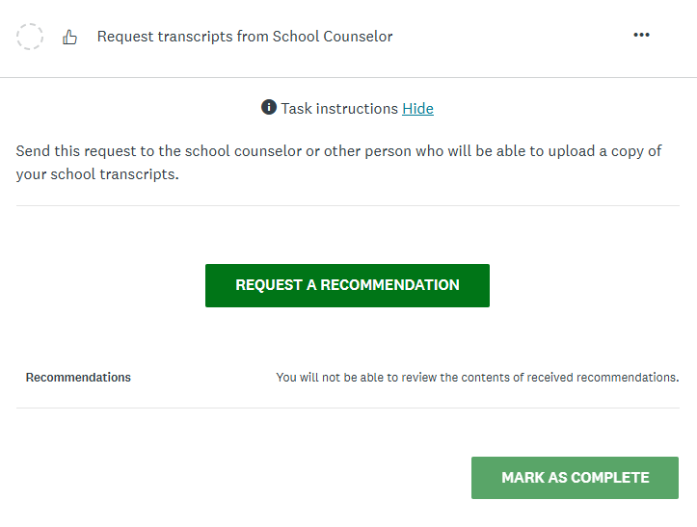  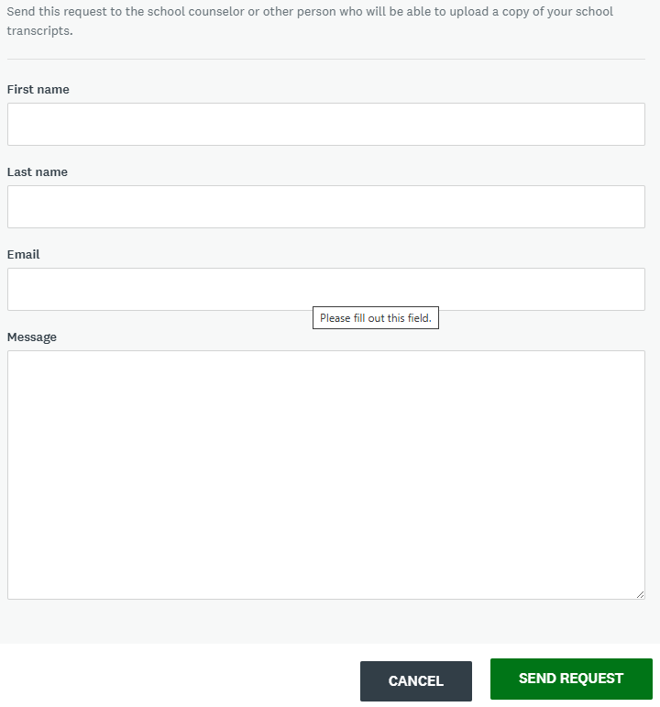  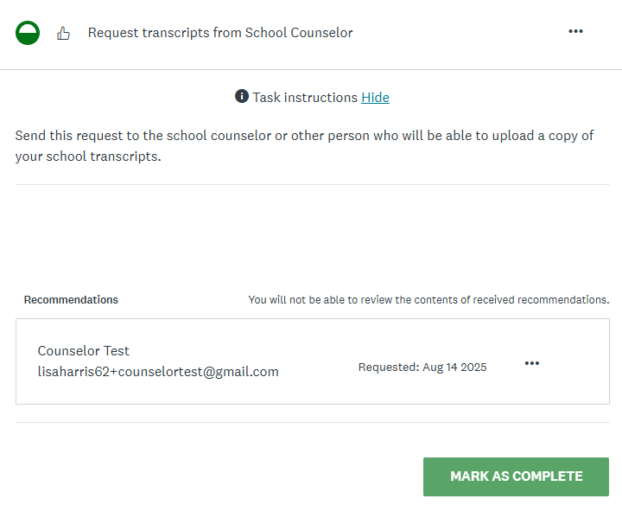  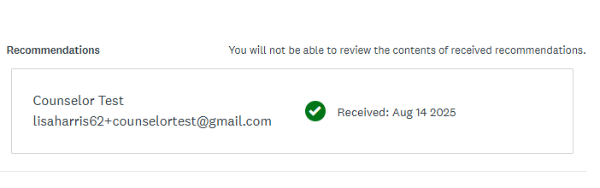
Task 8 Request Recommendation from World Language Teacher  - Click on Request recommendation from your World Language Teacher in the application task list.  - Repeat the same steps as listed in Task 7 to submit the recommendation request. | 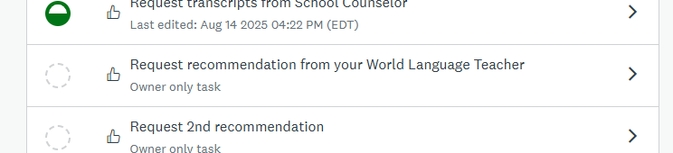

Task 9 Request Recommendation from 2nd Adult
- Click on the Request 2nd recommendation in the application task list.
- Repeat the same steps as listed in Task 7 to submit the recommendation request.
Task 10 Request Nomination from School Principal or Designee  This task will not be available until all previous tasks have been completed by the applicant.  When all recommendations have been received and tasks 1 – 9 show as complete, you can submit your request for nomination.  - Click on Request nomination from school principal/headmaster or designee.  - Repeat the same steps as listed in Task 7 to submit the nomination request.  - Remember to submit the request to the person you listed on your planning form. This may be the school principal, or someone else they have designated to complete this task. | 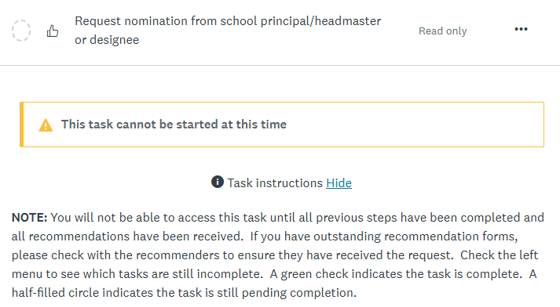  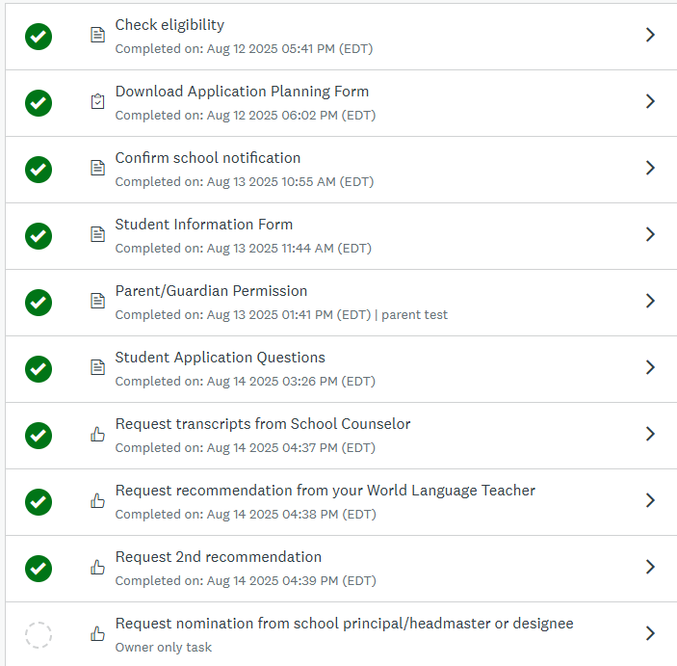
School Decision  After the principal or designee reviews and decides on which applications to move forward, you will receive an email notification indicating if you have been selected as a school nominee. | 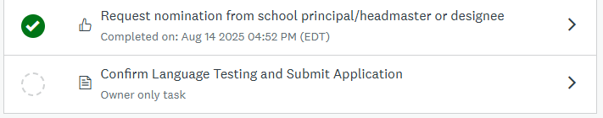  Applications approved to move forward as a local nominee will now have the final task enabled.

Section 4: Language Testing and Submit Application (Task 11)
In this section, the student applicant will:
- Confirm language testing, and
- Submit the application to the state for review by the Selection Committee.

Application Task | Screenshot
Task 11 Confirm Language Testing and Submit Application  This is the final task in the initial application. In this task, the student will mark the box that confirms they have scheduled their language test with the school.  Note that the application can be submitted before the testing is completed. Applicants have until January 31 to complete and submit the language test through the test vendor website.  Once the test is scheduled, you can now mark this task complete. This will submit the application to the state and lock it from further editing. | 