VDOE Sample Science Performance Assessment

Topic: Simple Machines
Course: Third Grade Science

Content Standards:
Science (2018)
3.2 The student will investigate and understand that the direction and size of force affects the motion of an object. Key ideas include
- simple machines increase or change the direction of a force; and
- simple and compound machines have many applications.

English Connections
3.W The student will compose various works for diverse audiences and purposes, linked to grade three content and texts.
3.W.1 Modes and Purposes for Writing
C. Write informative/explanatory texts to examine a topic that develops the topic with facts and details.
D. Write opinion pieces on topics or texts, supporting a point of view with facts and reasons.
E. Write in response to text(s) read or heard to share thinking using supporting details from the text.
3.W.2 Organization and Composition
- Engage in writing as a process to compose a well-developed paragraph.
3.W.3 Usage and Mechanics
- With guidance and support from peers and adults, develop and strengthen writing as needed by revising for quality of ideas, organization, sentence fluency, and word choice.

Computer Science Connections
3.AP.1 The student will apply computational thinking to design algorithms to extend patterns, processes, or components of a problem.
- Identify a pattern in an algorithm, process, or a problem.
- Decompose a problem or task into a subset of smaller problems.
- Design an algorithm to extend either a pattern, process, or component of a problem.
3.DA.3 The student will create models that can represent a physical object or process.
- Create a model to represent a physical object or process.

Connection to Profile of a Graduate:
- Critical & Creative Thinking
- Communication

Essential Science Skills and Processes:
3.1 The student will demonstrate an understanding of scientific skills and processes by
- asking questions and defining problems
- define a simple design problem that can be solved through the development of an object, tool, process, or system
- planning and carrying out investigations
- use tools and/or materials to design and/or build a device that solves a specific problem
d) constructing and critiquing conclusions and explanations
- describe how scientific ideas apply to design solutions
- developing and using models
  - develop a model (e.g., diagram or simple physical prototype) to illustrate a proposed object, tool, or process
- obtaining, evaluating, and communicating information
- communicate scientific information orally and/or in written formats, including various forms of media as well as tables, diagrams, and charts
- communicate design ideas and/or solutions with others

Performance Task:

Scenario:
Your aunt built a treehouse in your backyard that is 2 meters off the ground. Your aunt has provided you a ladder to access the treehouse and she has made a rule that you must use both hands to go up and down the ladder. You and your friends want to have a party in the treehouse to celebrate your new space. Your aunt gave you supplies for the treehouse. She left the supplies at her house, which is down the street. You need to take items from her house up to your treehouse for the party.

Task:
Your task is to determine which simple machines you can use to get all of the items from her house into your treehouse safely. You will also need to describe how the simple machine you chose helped you transport the objects into your treehouse.
Items to put in your tree house include:
- you and your friends
- chairs
- telescope
- rug
- party snacks

Common Rubric Categories:
- Developing and using models
- Obtaining, evaluating, and communicating information
- Content

Lesson Overview and Preparation:

Safety and Preparation | Lesson Information
BEFORE:  Preparing students for the task  Resources Needed:  - student handouts  - sample simple machines available for students to examine while they are designing their plan | Students should have background knowledge and be able to:  The performance assessment should be completed with a partner. Students should have had opportunities for guided and independent practice with design challenges.  The assessment is dependent upon knowledge of simple machines. Students should be aware of the six types of simple machines (level, pulley, inclined plane, wedge, screw, & wheel and axle) as well as their uses. Students should also understand that a simple machine makes work easier by reducing the force needed to move an object over a distance.  Students should be able to:  - Design a plan, using at least one simple machine that could be used transport materials and lift them to a tree house.  Pre-teaching Suggestions:  - Allow students the opportunity to manipulate physical samples of simple machines.  - Review types of simple machines and their purpose.  Questions to Consider:  - What are the six types of simple machines?  - How do simple machines make work easier?  - What simple machines do you use or see being used by to others in your daily life?  - Distribute a task description to each student. Read the task description together.
DURING:  Supporting students with the task | Circulate and help student by asking probing questions.  You may want to delete the answers in the first row of the table and determine the answer as a class.
AFTER:  Reflecting with students after the task | Reflection questions to consider and discuss:  After the task, the teachers should ask students to explain their design to the class.  - How many simple machines did you use in your plan?  - Does a higher number of simple machines lead to a better plan?  - Based on the observations made of the different designs and the class/group discussion, would you revise your design? If so, how?

Accessibility:

Accommodations/Modifications
- Give students a word bank to use for the different tasks.
- Give students sentence stems to help complete their written report.

Extensions:
- Students create a Plus-Minus-Interesting chart for the different tools proposed to lift each type of object results.
- Ask students to describe how the knowledge of simple machines helps engineers as they construct new devices.

Tree House Party
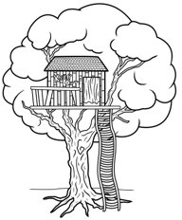
Scenario:
Your aunt built a treehouse in your backyard that is 2 meters off the ground. Your aunt has provided you a ladder to access the treehouse and she has made a rule that you must use both hands to go up and down the ladder. You and your friends want to have a party in the treehouse to celebrate your new space. Your aunt gave you supplies for the treehouse. She left the supplies at her house, which is down the street. You need to take items from her house up to your treehouse for the party.
Task:
Your task is to determine which simple machines you can use to get all of the items from her house into your treehouse safely. You will also need to describe how the simple machine you chose helped you transport the objects into your treehouse.
Items to put in your tree house include:
- you and your friends
- chairs
- telescope
- rug
- party snacks

In the space below, draw a picture of the tools you would use to transport the items from your aunt’s house and lift them into the treehouse. Please label the simple machine(s) in your drawing.

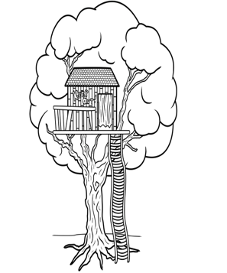

Sequence
List the steps, in order, that you would take to get all of the items from your aunt’s house into the treehouse. If you need more steps, add them on a separate page.
1.

2.

3.

4.

5.

Fill in the chart below listing the simple machines you used and how those simple machines helped you get the items into the treehouse. The first one has been filled in for you.
Item | Simple machine used | How you used the simple machine and how it helped you
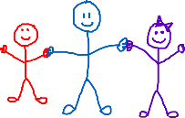 | inclined plane | The ladder is an inclined plane. We climbed the ladder. It made it easier for my friends and me to get up to the treehouse.
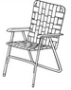

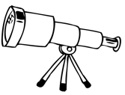
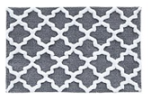
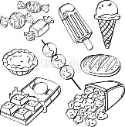

After learning about what your classmates did, how would change your plan?

_________________________________________________________________________________________________________________________________________________________________________________________________________________________________________________________________________________________________________________
_________________________________________________________________________________________________________________________________________________________________________________________________________________________________________________________________________________________________________________
_________________________________________________________________________________________________________________________________________________________________________________________________________________________________________________________________________________________________________________

