Attachment B

Superintendent’s Memo #118-22

June 10, 2022


Instructions for the 2022-2023 Community Eligibility Provision Schedule in SNPWeb

SNPWeb Community Eligibility Provision Schedule
A School Food Authority (SFA) applying to participate in the Community Eligibility Provision (CEP) must complete the CEP Schedule in the Application Packet for the corresponding school year.

Step 1: Create the CEP Schedule
To create a CEP Schedule in the Application Packet, select the new school year (e.g. 2022–2023). Select Applications>Application Packet and select Modify next to the SFA Application.
Scroll to Question 25 in the Eligibility Information section of the SFA Application, Will any of your sites be participating in the Community Eligibility Provision (CEP) for the National School Lunch Program? Select Yes.
If the division will participate in CEP for all schools, divisionwide, Yes must also be selected in the second part of Question 25.
Save the SFA Application to complete this step.

Figure 1: SFA Application Question 25
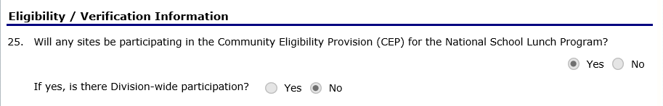

Step 2: Add Schools to the CEP Schedule
To add participating CEP schools to the CEP schedule, Select Applications>Application Packet and scroll down to Site Applications>School Nutrition Program. Select School Nutrition Program to see a list of schools that participate in the National School Lunch Program (NSLP).
For each school that will apply to participate in CEP, select Modify. Scroll to Question 3, Pricing Information. In the dropdown box next to NSLP, select Non-Pricing CEP. In the dropdown box next to School Breakfast Program (SBP), select Non-Pricing CEP.
Save the site application to complete this step. Repeat for all schools that will be included in the CEP application.

Figure 2: Site Application Question 3
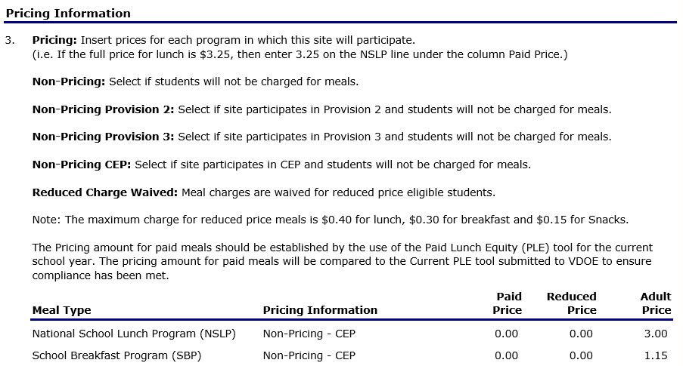

Note:
The CEP Schedule will only display sites that have Non-Pricing-CEP selected as the response to Question 3, Pricing Information, in the Site Application for both NSLP and SBP. If any CEP schools are missing from the CEP Schedule, repeat Step 2 above.

Adding the CEP Schedule to the Application Packet
- On the blue toolbar, select Applications to access the menu screen.
- Select Application Packet. The Application Packet screen will display.
- Select Add next to the CEP Schedule.

Figure 3: Application Packet Screen – Add CEP Schedule

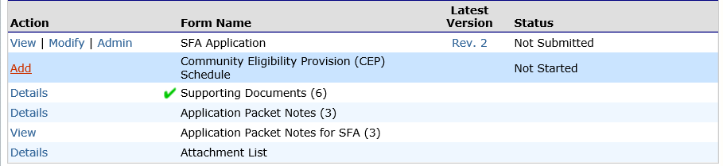
- The CEP Schedule screen will display.

Figure 4: CEP Schedule Screen
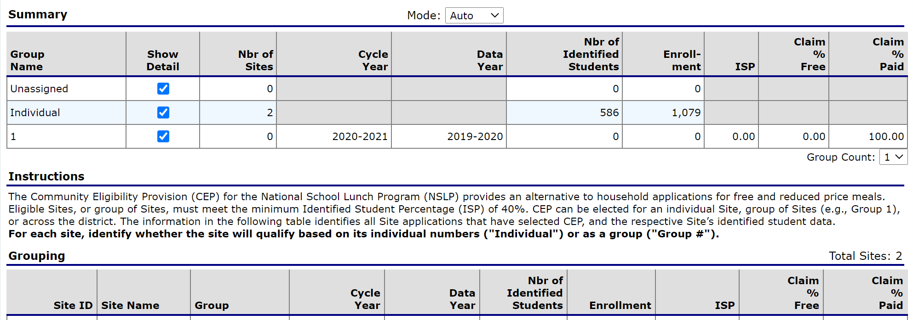

Defining the CEP Schedule
- On the blue toolbar, select Applications to access the menu screen.
- On the menu, select Application Packet. The Application Packet screen displays.
- Select Add to begin or Modify (if the CEP schedule was previously added) next to CEP Schedule. The CEP Schedule screen will display.
Note: The CEP Schedule will only display sites that have Non-Pricing CEP selected as the response to Question 3, Pricing Information, in the Site Application for both NSLP and SBP. If any CEP schools are missing from the CEP Schedule, repeat Step 2 on page 2, above.
- Scroll down to the Grouping chart. Next to each Site ID under the Grouping heading, the Number of Identified Students, Enrollment, and ISP data is retrieved from the CEP Site Eligibility Report data for April 1, of the year prior to first year (YPFY) as submitted by the LEA. For example, the April 1, 2022, data reported by the LEA will display in the CEP Schedule as Data Year 2021–2022 and Cycle Year 2022–2023 for new CEP schools/sites.
- For each school/site, under the Group column, select whether the school/site will participate based on its own data by selecting Individual or, if the site will participate by being grouped with other sites, by selecting the group number. If the SFA is participating as divisionwide, all sites must be assigned to Group 1. If there are multiple CEP groups in the LEA, each group of schools must have a separate group number.
- All sites must be identified as Individual or assigned to a group to complete the CEP Schedule.
Note: The Cycle Year, Data Year, and ISP for each defined group of CEP schools will display in the Summary chart at the top of the page along with the group’s free and paid claiming percentages. The Cycle Year, Data Year and ISP for individual CEP schools, along with the school’s free and paid claiming percentages, will display in the Grouping chart.
- Select Save to complete this step.

Adding a Site to an Existing CEP Schedule
- On the blue toolbar, select Applications to display the menu screen.
- On the menu, select Application Packet. The Application Packet screen displays.
- Select Modify next to CEP Schedule. The CEP Schedule screen displays.
- The new site will be identified as Unassigned under the Group column. Select the group to which the site should be associated or select Individual if the site qualifies based on its own student data.
- Select Save to receive a confirmation. Select Edit to return to the CEP Schedule screen or select Finish to return to the Application Packet screen.

